*Florida International University*

*School of Computing and Information Sciences*

CIS 4911 - Senior Capstone Project

Software Engineering Focus

Final Deliverable

BOLO Flier Creator Version 5

**Team Members:**

Burke, John

Gonzalez, Emmanuel

Medina, Jorge

Munoz, Nilton

**Product Owner(s)**:

Samuel Ceballos

Jason Cohen

**Mentor(s)**:

Juan Caraballo

Robert Loredo

**Instructor**: Masoud Sadjadi

The MIT License (MIT)

Copyright (c) *2016 <copyright holders>*

Permission is hereby granted, free of charge, to any person obtaining a copy of this software and associated documentation files (the "Software"), to deal in the Software without restriction, including without limitation the rights to use, copy, modify, merge, publish, distribute, sublicense, and/or sell copies of the Software, and to permit persons to whom the Software is furnished to do so, subject to the following conditions:

The above copyright notice and this permission notice shall be included in all copies or substantial portions of the Software.

THE SOFTWARE IS PROVIDED "AS IS", WITHOUT WARRANTY OF ANY KIND, EXPRESS OR IMPLIED, INCLUDING BUT NOT LIMITED TO THE WARRANTIES OF MERCHANTABILITY, FITNESS FOR A PARTICULAR PURPOSE AND NONINFRINGEMENT. IN NO EVENT SHALL THE AUTHORS OR COPYRIGHT HOLDERS BE LIABLE FOR ANY CLAIM, DAMAGES OR OTHER LIABILITY, WHETHER IN AN ACTION OF CONTRACT, TORT OR OTHERWISE, ARISING FROM, OUT OF OR IN CONNECTION WITH THE SOFTWARE OR THE USE OR OTHER DEALINGS IN THE SOFTWARE.

***Abstract***

*The Pinecrest Police Department wish to bring policing into the future by combining technology with their vast domain knowledge. The current system for the distribution of BOLO's is lethargic and inefficient. For these reasons the Pinecrest Police department has employed the assistance of the college of engineering and computer science at Florida International University along with IBM Bluemix to implement their innovative idea.*

*This document provides a solution in the* ***BOLO 5.0*** *system, a user-driven approach that allows law enforcement agents to instantly publish BOLOs. This document contains an extensive list of implemented user stories. It also provides a detailed plan of execution that includes hardware and software specifications. System design is explained through specific diagrams. System validation is also discussed. A glossary with essential domain terminology can also be found. Finally, the last chapter contains a series of appendices with UML samples, screenshots, and progress reports.*

Table of contents goes on this page

Table of Contents

Introduction 6

Current System 6

Purpose of New System 6

User Stories 7

Implemented User Stories 7

Sprint 1 7

Sprint 2 7

Sprint 3 9

Sprint 4 11

Sprint 5 12

Project Plan 14

Hardware and Software Resources 14

Development Environment 14

Deployment Requirements 14

Sprints Plan 16

Sprint 1 16

Sprint 2 19

Sprint 3 25

Sprint 4 32

Sprint 5 38

System Design 41

Architectural Patterns 41

System and Subsystem Decomposition 41

Deployment Diagram 42

Design Patterns 43

System Validation 44

Appendix 126

Appendix A – UML Diagrams 126

Static UML Diagrams 126

Sprint 1 126

Sprint 2 133

Sprint 3 142

Sprint 4 151

Sprint 5 159

Dynamic UML Diagrams 162

Sprint 1 162

Sprint 2 166

Sprint 3 175

Sprint 4 185

Sprint 5 196

Appendix B – User Interface Design 198

Appendix C – Sprint Review Reports 222

Appendix D – Sprint Retrospective Reports 226

References 229

# Introduction

BOLO 5.0 is a web application that allows police to distribute electronic BOLOs (Be on the Lookout) flyers so that other officers in the area can have instant access to them. This is meant to enhance the current system, which uses the following strategies to create and disseminate BOLOs: alerts over police radio, computer-aided dispatch that is dependent on antiquated hardware, and paper printed posters for manual distribution.

This introductory section has the purpose of describing the Current System used by Pinecrest Police Department to distribute BOLOs, it also provides an overview of the new approach provided by current project and the advantages of its use in order to reduce crime within our communities.

## Current System

The current approach used by Pinecrest Police Department to create “Be On the Look Out” (BOLO) flyers is not efficient. Several hours may pass before a paper report is distributed to all officers on duty. Alerts over police radio, computer-aided dispatch and paper printed posters are not enough to achieve the goal of keeping all officers up to date with the recent BOLOs.

Besides been slow, the current system has high costs due to the number of people and resources required to share the BOLOs. In order to fight crime as effectively as possible the current system needs to be redesign and updated using new technologies.

## Purpose of New System

BOLO 5.0 was designed to be accessed using the devices most used by police officers: in-patrol computers and mobile devices. It takes advantage of new cloud-based technologies to reduce downtime of this important application.

The system allows officer to quickly access all active BOLOs and to create and distribute new flyers via email. The system also allows users to attach images to the BOLOs, which are quickly distributed within the BOLO flyer.

Another advantage of the current system is the ability to efficiently search inactive BOLOs without having to go over thousands of paper reports.

# User Stories

This is a comprehensive list of the user stories that were implemented for the fifth version of BOLO. All the user stories compiled here were requested by the product owner and delivered on time.

## Implemented User Stories

### Sprint 1

(05/23/2016 - 06/05/2016)

**User Story #887** Remove unnecessary data from email alert

* As a user, I would not like to see unnecessary information in the BOLO alert

**User Story #892** Expire passwords in 90 days

* As a System Administrator I would like for user passwords to expire every 90 days so that I can increase the security of the system.

**User Story 882** Implement WildCard search field

* As an Officer I would like to use a wildcard field when searching BOLOs, so the search can be expanded to cover all fields at once

**User Story #888** Open PDF documents in new tab

* As an officer I would like PDFs to open in a new tab so there is no need to click the back button on the browser.

**User Story #894** Update all Pages to Bolo v5.0

* As the System Administrator I would like the application to reflect its current version (5.0) so it is up to date with the new release

**User Story #895** Create template for Theft-Boat BOLO

* As a user, I would like to be able to select a template for a Theft-Boat BOLO, so the data according to this category will be shown

**User Story #881** Create template for Theft-Auto BOLO

* As a user, I would like to be able to select a template for a Theft-Auto BOLO, so the data according to this category will be shown

### Sprint 2

(06/06/2016 - 06/19/2016)

**User Story #893** Authenticate password reset confirmation

* As a User I would like for it to be required to use the password confirmation authentication when resetting my password so that I can confirm I have entered the password I believe I have entered.

**User Story #919** Adjust timeout session

* As a user of the system I would like to have the system give me a five more minutes to work with other documents on a case without timing out me out so frequently.

**User Story #930** Send email notification after password has been reset

* As a user I would like to receive an email notification when my password is reset so that I know if someone else has reset my password.

**User Story #879** Confirm BOLO via email after creation

* As a System Administrator I would like for officers to confirm a BOLO creation via email before the BOLO is created so that we ensure that officers who are let go cannot create any further BOLOs since their email account will be disabled.

**User Story #891** Prevent password from displaying in url

* As a user I would not like my password to be displayed in the address bar after purging.

**User Story #880** Send feed of BOLOs as JSON documents

* As a System Administrator I would like all BOLOs to be sent to subscribed entities as JSON documents so they may be exported to other systems

**User Story #920** Compress images upon upload

* As System Administrator I want the application to compress all images loaded into the system to decrease the size of emails sent to users

**User Story #896** Create specific Bolo for Theft-Auto

* As a user, I would like to be able to create a specific Theft-Auto BOLO, so the data according to this category will be shown

**User Story #932** View Bolo Details for Theft-Auto

* As a user, I would like to be able to view details for Theft-Auto BOLO, so the view will be shown

**User Story #933** Edit bolo for Theft-Auto

* As a user, I would like to be able to edit the bolo for Theft-Auto BOLO, so changes will be updated automatically

**User Story #936** Create specific Bolo for Theft-Boat

* As a user, I would like to be able to create a specific Theft-Boat BOLO, so the data according to this category will be shown

**User Story #937** View Bolo Details for Theft-Boat

* As a user, I would like to be able to view details for Theft-Boat BOLO, so the view will be shown

**User Story #938** Edit Bolo for Theft-Boat

* As a user, I would like to be able to edit the bolo for Theft-Boat BOLO, so changes will be updated automatically

### Sprint 3

(06/20/2016 – 07/03/2016)

**User Story #934** Remove empty fields from PDF bolo for display

* As a user I would like to have the empty fields removed from each bolo for displayed as a PDF for reading because it will reduce the amount of searching for the needed information.

**User Story #935** Add drop down menu for links such as settings, user guide, logout and others to be added at a later time

* As a user I would like to have some of the items on the menu bar combined in a drop down where it is less busy and easier to find things of the same nature. Features such as setting, user guide, and logout can be combined within a drop down.

**User Story #1006** Add a user guide page for each tier

* As a user I would like to have a user’s guide specific to each level of user because it will make using the application easier

**User Story #1046** Add an about us page

* As a user I would like to have an about us page because it will nice to know the history of the BOLO flyer

**User Story #1011** Filter BOLOS by author and reformat the dropdown

* As a user I would like to filter BOLOS by the ones I created, zipcode, and by bolos created by multiple agencies so that I can have a better global view of BOLOS.

**User Story #1009** Automate database creation via scripts

* As a developer I would like to have a solution to implement the automation of the database initialization in order to save developer time.

**User Story #1008** Prevent user email domain from being something other than their agency's domain

* As as a system administrator I would like to limit my officers to having only their work email registered in the system in order to increase the security of the system

**User Story #889** Change bolo email to noreply

* As a user I would like to receive emails from an email called [noreply@boloflyer.com](mailto:noreply@boloflyer.com) in order to prevent users from trying to email back the sending address.

**User Story #931** Create script to reset DB Schema

* As a System Administrator I would like to have a script to update the schema of the database so data is not lost every time the database is updated.

**User Story #985** Enhance ImageService

* As a System Administrator I would like to change the behavior of the Image Service so the style and quality of the BOLO flyer is enhanced

**User Story #986** Unsubscribe from BOLO emails

* As an officer I would like to be able to unsubscribe from BOLOs from a particular agency so I do not receive any future alerts from that agency in the future

**User Story #1001** Implement routes with authentication

* As a System Administrator I would like to keep original URLs when non-authenticated users access the system so users do not need to navigate to the pages after login

**User Story #1007** Redesign Filter by Agencies in Home page

* As a System Administrator I would like to reformat the Filter by Agency so it shows only BOLOs related to the particular agency selected and the number of pages is accurate.

**User Story #1033** Fix several bugs

* As a System Administrator I would like to have the all bugs solved so they do are not replicated on the Production environment.

**User Story #990** Redesign and add validations for General Bolo Template

* As a user, I would like to use a redesigned page with field validation for General Bolo, so the new view will be shown

**User Story #981** Implement Search for New Bolo Templates

* As a user I would like to use a search for the new Bolo Templates, so the search can be used for Theft-Auto and Theft-Boat Bolo’s

**User Story #991** Redesign and add validations for Theft Auto Template

* As a user, I would like to use a redesigned page with field validation for Theft-Auto Bolo, so the new view will be shown

**User Story #992** Redesign and add validations for Theft Boat Template

* As a user, I would like to use a redesigned page with field validation for Theft-Boat Bolo, so the new view will be shown

**User Story #1030** Delete the Ongoing Status from Bolo

* As a user, I would like that old bolos do not show the ongoing status, so that status will be blank

### Sprint 4

(07/04/2016 – 07/17/2016)

**User Story #1010** Create a front end page for root to customize system settings

* As root I would like to have access to change our agency domain where I do not manually have to create a new agency and transfer information to the new agency if our agency name changes, in addition I would like to have access to change other features like timeout session and brute force attempts against the email login.

**User Story #1096** Implement a link to download a PDF of the user's guide based on user's tier

* As a user I would like to get the user’s guide as a PDF so I can download it and read it later without logging back into the system.

**User Story #1097** Implement an About Miami Dade County Association of Chief of Police (MDCACP) page

* As an potential financial investor of the BOLO flyer, I would like to have a way to learn details of the MDCACP who are the main sponsors of the BOLO flyer so I can make an acquitted decision for investing in BOLO flyer.

**User Story #1098** Create an about us page for Florida International University's (FIU) contribution

* As a potential financial investor of the BOLO flyer, I would like to have a way to learn details of FIU’s contribution who are the developers of the BOLO flyer so I can make an acquitted decision for investing in BOLO flyer.

**User Story #1099** Create an about us page for IBM's contribution

* As a potential financial investor of the BOLO flyer, I would like to have a way to learn details of IBM’s contribution, who are the Mentors and what products of IBM are used for the BOLO flyer so I can make an acquitted decision for investing in BOLO flyer.

**User Story #1100** Create a page where root can retrieve data for analysis

* As root, I would like to retrieve the information about different crimes and to run analysis on them to compare against today’s system before BOLO

**User Story #1014** Lock user account after 10 incorrect login attempts

* As a system administrator I would like to lock user accounts after they have tried to incorrectly login to the system 10 amount of times in order to prevent against brute force attacks.

**User Story #1038** Filter by multiple agencies in bolo list page

* As a User I would like to filter bolos by any combination of the agencies they belong to so that I can easily see the bolos in neighboring agencies.

**User Story #890** Implement Watermarks for agencies

* As a System Administrator I would like all agencies to have the option of adding watermarks to their BOLOs so the flyers’ style are unique by Agency

**User Story #1037** Allow Tier 3 users to control Agency settings

* As a System Administrator I would like Agency Administrators to be able to edit the information for their own Agency so the Agency Management does not require Root intervention.

**User Story #1081** Prevent Tier 3 users from granting Root access

* As a System Administrator I would like to prevent Agency Administrators from granting Root Access so the security layer is not vulnerable to be changed from lower tier users

**User Story #1083** Prevent Officers from previewing PDFs before confirmation

* As a System Administrator I would like to prevent Officers from viewing BOLO PDFs before confirmation so no flyer is distributed without prior validation

**User Story #1087** Implement time retrieval points for data analysis for Create Bolo (General - Auto - Boat)

* As research analyst, I would like to have specific time analysis points implemented when the Bolos are created, so I will be able to use those points of reference for comparison for data analysis

**User Story #1119** Implement time retrieval points for data analysis for Edit Bolo (General - Auto - Boat)

* As research analyst, I would like to have specific time analysis points implemented when the Bolos are updated, so I will be able to use those points of reference for comparison for data analysis

**User Story #1088** Deactivate and Activate User Accounts from Root and Administrator

* As a root administrator, I would like to be able to activate or deactivate users form the user management view, so these process can be done fast

### Sprint 5

(07/18/2016 – 07/31/2016)

**User Story #1094** Implement confirmation of BOLO updates

* As a System Administrator I would like to have email confirmations when BOLOs are updated, in order to avoid having inactive officers submitting incorrect information.

**User Story #1155** Change PDF labels

* As a System Administrator I would like bigger headers in the BOLO flyers so officers can notice changes in BOLO status faster.

**User Story #1086** Change Interactive Edit Menu to Static Label for Status. Keep Data Field Contents After Validations When a New User and a New Agency is Created. Add New Aesthetic for Bolo Buttons

* As a root I would like to see the Bolo list and Bolo Agency with a static status, keeping data after validations when enter a new user or agency, new aesthetic for details, edit, buttons, so nobody can edit a Bolo form the status menu. Also, keeping data after a validation for new user and new agency, saving time typing it again

**User Story #1089** Show Edit and Archive only for Root and Administrators and Only View for Users. Create the functionality to go back for Details for Bolos (General, Auto and Boat). Create the ability for view a Bolo when it is Archived, and show edit and restore for Root

* As a root I would like have a different view from the users, also a button to go back when a detail view is shown, and see the details from an archived Bolo, so the view can be different, also can go back from details and view a Bolo when is archived

**User Story #1163** Connect system setting page to backend

* As a root I would like to have control of the login attempts and time out setting because it might be necessary to reduce the amount of login attempts to prevent brute force attacks and it might be necessary to give officers more time to fill out a BOLO

**User Story #1164** connect data analysis page to backend

* As root I would like to have a way to download BOLO information to run analysis on it because it will be nice to figure out what kind of affect a new system like BOLO has on crime compared to before BOLO

# Project Plan

The primary goal of version 5 of the BOLO application was to add to the effort of the previous iteration of the application. The features implemented in this iteration would allow the BOLO application to reach a pilot stage. The last release of the application was stable and therefore this iteration did not require any modifications to the platform. The application was hosted on IBM Bluemix running on a node.js server with an express.js backend. Front end content was rendered using express.js and the jade templating engine.

Below are the recommended hardware specifications as well as the required software needed to run the application from a developers point of view.

## Hardware and Software Resources

In order to develop and deploy the application some hardware and software is required. The following sections will describe the environments needed.

### Development Environment

In order to develop the application, the follow hardware specs are recommended:

· Windows/Apple Computer

· Min of 8Gb of RAM

· At least 128 GB of disk space

· At least 2.0 GHZ processor

For software, developers will need to have working knowledge of JavaScript as well as the following:

· Experience with Jade Templating for HTML

· Node.js 4.2+

o Node is a JavaScript runtime environment which is used in the project as the server.

· NPM

o NPM is the package manager for node.js. It is used to install project dependencies as well as to automate the execution of the application testing and miscellaneous scripts.

· Express Framework

o Express is a minimal and flexible Node.js web application framework that provides a robust set of features for web and mobile applications.

· Preferred IDE

· Preferred Development Environments were Webstorm IDE or Atom

### Deployment Requirements

The project is targeted for deployment on the IBM Bluemix Platform-as-a-Service Cloudfoundry environment. Besides an IBM Bluemix account the following is also required.

· Cloudant NOSQL Database

o Access tokens are required to be set as environment variables for the application to work in both deployment and development.

· SendGrid

o This is the service the application uses for sending notifications. An api key was required from SendGrid in order to successfully run the application locally and in production.

## Sprints Plan

These are the user stories that were released per sprint.

### Sprint 1

(05/23/2016 - 06/05/2016)

**User Story #887** Remove unnecessary data from email alert

**Acceptance Criteria:**

* Get rid of:
* Hi,

|  |  |
| --- | --- |
| Suspect |  |
| First Name: | asrgf |
| Last Name: | asdfg |
| Sex: | Female |
| Race: | White |
| Height: | 06-06 |
| Weight: | 900 |
| Hair Color: | Red |
| Address: | N/A |
| Tattoos: | zsdfhasdtjsrfyjrsfh |
| Drivers License: | c221-125-25-25--5 |
| Date Of Birth: | 12/12/2020 |
| Summary |  |
| QDEF |  |
| Additional Information |  |
| def |  |
| Media |  |
| Video URL: | N/A |
| Images: |  |
| unsub.JPG |  |

-- The Bolo Flier Creator Team

**Related Tasks:**

* Documentation
* Go into code/src/web/views/email/new-bolo-notification and delete extends ./layout.jade
* Go into code/src/web/views/email/new-bolo-notification and delete include ./_bolo-details.jade
* Go into code/src/web/views/email/update-bolo-notification and delete extends ./layout.jade
* Go into code/src/web/views/email/update-bolo-notification and delete include ./_bolo-details.jade
* Remove code/src/web/views/email/layout.jade because previous actions of step 1 and 3 will render the layout.jade class useless
* Remove code/src/web/views/email/_bolo-details.jade because previous actions of steps 2 and 4 will render the _bolo-details.jade class useless
* Testing to verify whether unnecessary data is removed

**Modeling**

* Refer to UML diagrams in Appendix A: Static UML Diagrams, Figure sp1-1 and Dynamic UML Diagrams, Figure sp1-1

**User Story #892** Expire passwords in 90 days

**Acceptance Criteria:**

* When user’s password expires it gets changed to a random string
* They will be prompted to change their password
* The will be notified 5 days prior to the password expiring

**Related Tasks:**

* Modify backend to update passwordLifetime field
* Add new password lifetime field to user model
* Modify passport login strategy

**Modeling**

* Refer to UML diagrams in Appendix A: Static UML Diagrams, Figure sp1-2 and Dynamic UML Diagrams, Figure sp1-2

**User Story #882** Implement WildCard search field

**Acceptance Criteria:**

* Officers are able to search all fields by filling out the wildcard field
* Wildcard feature must be able to interact with the Match Field feature so both can be used at the same time

**Related Tasks:**

* Update DB reset scripts to include new BOLO search index
* Customize query string change when wildcard search used
* Expand Cloudant Index for Bolo Search
* Create Wildcard field on Search Form

**Modeling**

* Refer to UML diagrams in Appendix A: Static UML Diagrams, Figure sp1-3 and Dynamic UML Diagrams, Figure sp1-3

**User Story #888** Open PDF documents in new tab

**Acceptance Criteria:**

* All PDFs open in a new tab instead of in the same window.

**Related Tasks:**

* Update bolo-details.jade template

**Modeling**

* Refer to UML diagrams in Appendix A: Static UML Diagrams, Figure sp1-4 and Dynamic UML Diagrams, Figure sp1-4

**User Story #894** Update all Pages to Bolo v5.0

**Acceptance Criteria:**

* All navigations show BOLO 5.0 instead of Bolo 4.0

**Related Tasks:**

* Update all Pages to Bolo v5.0
* Update login template

**Modeling**

* Refer to UML diagrams in Appendix A: Static UML Diagrams, Figure sp1-5 and Dynamic UML Diagrams, Figure sp1-5

**User Story #895** Create template for Theft-Boat BOLO

**Acceptance Criteria:**

* The user should be able to choose the category Theft-Boat BOLO
* The system will display the required fields for this specific category

**Related Tasks:**

* Create the new Theft-Boat template view
* Modify the bolo-create-form view to add functionality
* Add functionality when select the option Theft-Boat-specific data will be shown

**Modeling**

* Refer to UML diagrams in Appendix A: Static UML Diagrams, Figure sp1-6 and Dynamic UML Diagrams, Figure sp1-6

**User Story #881** Create template for Theft-Auto BOLO

**Acceptance Criteria:**

* The user should be able to choose the category Theft-Auto BOLO
* The system will display the required fields for this specific category

**Related Tasks:**

* Create the new Theft-Auto template view
* Modify the bolo-create-form view to add functionality
* Add functionality when select the option Theft-Auto,specific data will be shown

**Modeling**

* Refer to UML diagrams in Appendix A: Static UML Diagrams, Figure sp1-7 and Dynamic UML Diagrams, Figure sp1-7

### Sprint 2

(06/06/2016 - 06/19/2016)

**User Story #893** Authenticate password reset confirmation

**Acceptance Criteria:**

* Not allowed to reset password without entering both a new password and a confirmation of the new password.

**Related Tasks:**

* write use case
* draw up diagrams
* sequence
* use case
* class
* modify the helper function at path code/src/web/lib to reflect true for the confirm password value must be filled upon the submit button being clicked.
* Test
* Report

**Modeling**

* Refer to UML diagrams in Appendix A: Static UML Diagrams, Figure sp2-1 and Dynamic UML Diagrams, Figure sp2-1

**User Story #919** Adjust timeout session

**Acceptance Criteria:**

* The timer session must time out at ten minutes to allow officers to complete other task within a case they are working on, including confirm bolo which may take up to several minutes to receive the confirmation email depending on internet congestion.

**Related Tasks:**

* Write use case
* draw up diagrams
* sequence
* use case
* class
* Increase the variable session at path code/src/web/ to reflect an increase of timer counter to ten minutes from five minutes.
* Test
* Report

**Modeling**

* Refer to UML diagrams in Appendix A: Static UML Diagrams, Figure sp2-2 and Dynamic UML Diagrams, Figure sp2-2

**User Story #930** Send email notification after password has been reset

**Acceptance Criteria:**

* An email has been sent to the user notifying the user their password has been reset

**Related Tasks:**

* Use case
* Diagrams
* use case
* sequence
* class
* implementation
* testing
* user guide

**Modeling**

* Refer to UML diagrams in Appendix A: Static UML Diagrams, Figure sp2-3 and Dynamic UML Diagrams, Figure sp2-3

**User Story #879** Confirm BOLO via email after creation

**Acceptance Criteria:**

* An email is sent to the email of the person that is created with information about the BOLO that was just created
* Upon clicking on the link provided an email the BOLO is confirmed and created.

**Related Tasks:**

* Confirm bolo via email
* Create new post route to receive bolo confirmation
* Modify create-bolo route
* Modify Jade page to filter bolos
* Edit Bolo schema to include confirmation token

**Modeling**

* Refer to UML diagrams in Appendix A: Static UML Diagrams, Figure sp2-4 and Dynamic UML Diagrams, Figure sp2-4

**User Story #891** Prevent password from displaying in url

**Acceptance Criteria:**

* Password is no longer displayed after purging bolos.

**Related Tasks:**

* Learn about event listeners

**Modeling**

* Refer to UML diagrams in Appendix A: Static UML Diagrams, Figure sp2-5 and Dynamic UML Diagrams, Figure sp2-5

**User Story #880** Send feed of BOLOs as JSON documents

**Acceptance Criteria:**

* All new BOLOs are sent via email to required entities as JSON documents
* Log of the data transfer is showed

**Related Tasks:**

* Append new email function to BOLO Promise
* Create Data Subscriber Edit template
* Create Data Subscriber index
* Create Data Subscriber repository
* Create Data Subscriber service
* Create Data Subscriber schema
* Update admin-router
* Update admin-layout template

**Modeling**

* Refer to UML diagrams in Appendix A: Static UML Diagrams, Figure sp2-6 and Dynamic UML Diagrams, Figure sp2-6

**User Story #920** Compress images upon upload

**Acceptance Criteria:**

* All images are compressed upon upload to application.
* All emails sent by the application are less than 1 MB size.

**Related Tasks:**

* Replace gm library with jimp library
* Set Agency-Insert method to use Image Service
* Change Agency-Update method
* Update Image Service

**Modeling**

* Refer to UML diagrams in Appendix A: Static UML Diagrams, Figure sp2-7 and Dynamic UML Diagrams, Figure sp2-7

**User Story #896** Create specific Bolo for Theft-Auto

**Acceptance Criteria:**

* The user should be able to choose the category Theft-Auto BOLO
* The system will display the required fields for this specific category
* The user will be able to preview the data
* The user will be able to preview the pdf
* The system will only create the Theft-Auto BOLO

**Related Tasks:**

* Add new data to the Bolo entity
* Connect the Theft-Auto bolo template
* Create new routes for Theft-Auto bolo template
* Add picture no photo available for Theft-Auto
* Add route for picture no photo available for Theft-Auto
* Create new view for preview
* Create new route for Theft-Auto bolo preview
* Create new view for Theft-Auto bolo preview pdf
* Add functionality to bolo-route, bolo-repository

**Modeling**

* Refer to UML diagrams in Appendix A: Static UML Diagrams, Figure sp2-8 and Dynamic UML Diagrams, Figure sp2-8

**User Story #932** View Bolo Details for Theft-Auto

**Acceptance Criteria:**

* The user should be able to view details for Theft-Auto BOLO
* The system will display the specific view
* The user will be able to generate a pdf

**Related Tasks:**

* Create new detail view for Theft-Auto
* Create the route for the details view
* Create new view for Theft-Auto pdf
* Create new route for Theft-Auto pdf

**Modeling**

* Refer to UML diagrams in Appendix A: Static UML Diagrams, Figure sp2-9 and Dynamic UML Diagrams, Figure sp2-9

**User Story #933** Edit bolo for Theft-Auto

**Acceptance Criteria:**

* The user should be able to edit the BOLO for Theft-Auto
* The system will display the specific edit view
* The view will be populated with the current data
* The user will be able modify the related fields
* The system will be able to publish the updated data

**Related Tasks:**

* Create new edit view for Theft-Auto
* Create the route for the edit view
* Insert a confirmed token for the bolo

**Modeling**

* Refer to UML diagrams in Appendix A: Static UML Diagrams, Figure sp2-10 and Dynamic UML Diagrams, Figure sp2-10

**User Story #936** Create specific Bolo for Theft-Boat

**Acceptance Criteria:**

* The user should be able to choose the category Theft-Boat BOLO
* The system will display the required fields for this specific category
* The user will be able to preview the data
* The user will be able to preview the pdf
* The system will only create the Theft-Boat BOLO

**Related Tasks:**

* Add new data to the Bolo entity
* Connect the Theft-Boat bolo template
* Create new routes for Theft-Boat bolo template
* Add picture no photo available for Theft-Boat
* Add route for picture no photo available for Theft-Boat
* Create new view for preview
* Create new route for Theft-Boat bolo preview
* Create new view for Theft-Boat bolo preview pdf
* Add functionality to bolo-route, bolo-repository

**Modeling**

* Refer to UML diagrams in Appendix A: Static UML Diagrams, Figure sp2-11 and Dynamic UML Diagrams, Figure sp2-11

**User Story #937** View Bolo Details for Theft-Boat

**Acceptance Criteria:**

* The user should be able to view details for Theft-Boat BOLO
* The system will display the specific view
* The user will be able to generate a pdf

**Related Tasks:**

* Create new detail view for Theft-Boat
* Create the route for the details view
* Create new view for Theft-Boat pdf
* Create new route for Theft-Boat pdf

**Modeling**

* Refer to UML diagrams in Appendix A: Static UML Diagrams, Figure sp2-12 and Dynamic UML Diagrams, Figure sp2-12

**User Story #938** Edit Bolo for Theft-Boat

**Acceptance Criteria:**

* The user should be able to edit the BOLO for Theft-Boat
* The system will display the specific edit view
* The view will be populated with the current data
* The user will be able modify the related fields
* The system will be able to publish the updated data

**Related Tasks:**

* Create new edit view for Theft-Boat
* Create the route for the edit view
* Insert a confirmed token for the bolo

**Modeling**

* Refer to UML diagrams in Appendix A: Static UML Diagrams, Figure sp2-13 and Dynamic UML Diagrams, Figure sp2-13

### Sprint 3

(06/20/2016 – 07/03/2016)

**User Story #934** Remove empty fields from PDF bolo for display

**Acceptance Criteria:**

* When a bolo is viewed or displayed in any way, any fields not filled in should not be displayed
* All fields should be displayed when the bolo is updated

**Related Tasks:**

* Documentation
* User story
* Diagrams
* Use case
* Sequence
* Class
* Code test

**Modeling**

* Refer to UML diagrams in Appendix A: Static UML Diagrams, Figure sp3-1 and Dynamic UML Diagrams, Figure sp3-1

**User Story #935** Add drop down menu for links such as settings, user guide, logout and others to be added at a later time

**Acceptance Criteria:**

* Avoid crowding of the menu bar.
* Make it easier to add featured links in the future without crowding

**Related Tasks:**

* Test the new drop down button and new menu items work
* Add a like for the About Us page
* Add a link for the User Guide

**Modeling**

* No diagrams

**User Story #1006** Add a user guide page for each tier

**Acceptance Criteria:**

* Root user has their own guide
* Admin user has their own guide
* Super visor user has their own guide
* officer user has their own guide

**Related Tasks:**

* Test each user can access their User Guide page
* Implement the details of the User guide page for all users

**Modeling**

* Refer to UML diagrams in Appendix A: Static UML Diagrams, Figure sp3-2 and Dynamic UML Diagrams, Figure sp3-2

**User Story #1046** Add an about us page

**Acceptance Criteria:**

* Display an information about the founders and development teams who took part in building BOLO flyer

**Related Tasks:**

* Test each user has access to the About Us page
* Implement an About Us page

**Modeling**

* Refer to UML diagrams in Appendix A: Static UML Diagrams, Figure sp3-3 and Dynamic UML Diagrams, Figure sp3-3

**User Story #1011** Filter BOLOS by author and reformat the dropdown

**Acceptance Criteria:**

* Filter BOLOS by “My Bolos” should only display BOLOS created by the logged in user
* Reformat dropdown so user only sees All Bolos, My Bolos, and Their agencies link
* Create another dropdown with the other agencies.

**Related Tasks:**

* Add new view to the database
* Edit bolo creation algorithm
* Add new bolo service function and bolo cloudant function
* Add new filter "My Bolos"

**Modeling**

* Refer to UML diagrams in Appendix A: Static UML Diagrams, Figure sp3-4 and Dynamic UML Diagrams, Figure sp3-4

**User Story #1009** Automate database creation via scripts

**Acceptance Criteria:**

* Database is torn down and built with a simple command

**Related Tasks:**

* Implement automation with gulp
* Research options

**Modeling**

* No diagrams

**User Story #1008** Prevent user email domain from being something other than their agency's domain

**Acceptance Criteria:**

* + When Root creates an agency there should be an obligatory field to fill out for agency domain
  + When Root creates a user he has the freedom to set any email for that user
  + When an Admin wants to create a user for his agency that users domain is limited to be the admin’s agency’ domain
  + When a Root user wants to edits an agency he should have the ability to change the agency domain field.

**Related Tasks:**

* Validate user creation form
* Edit user creation page
* Edit Agency edit page
* Edit agency create page
* Edit agency database model

**Modeling**

* Refer to UML diagrams in Appendix A: Static UML Diagrams, Figure sp3-5 and Dynamic UML Diagrams, Figure sp3-5

**User Story #889** Change bolo email to no-reply

**Acceptance Criteria:**

* Any emails that are received should originate from [noreply@boloflyer.com](mailto:noreply@boloflyer.com)

**Related Tasks:**

* Change the email variable

**Modeling**

* No diagrams

**User Story #931** Create script to reset DB Schema

**Acceptance Criteria:**

* Changes inserted into the database update script are reflected in Cloudant.
* No document is missing after the database is updated

**Related Tasks:**

* Integrate with existing design Documents
* Create method to update views
* Create method to update indexes

**Modeling**

* Refer to UML diagrams in Appendix A: Static UML Diagrams, Figure sp3-6 and Dynamic UML Diagrams, Figure sp3-6

**User Story #985** Enhance ImageService

**Acceptance Criteria:**

* Images are compressed to less than 1 MB size
* Images in BOLO flyers keep the same layout regardless of original size of the image
* Images keep good quality standards.

**Related Tasks:**

* Edit pdfs templates for BOLOs
* Update image-service compression settings

**Modeling**

* No diagrams

**User Story #986** Unsubscribe from BOLO emails

**Acceptance Criteria:**

* When users click on the link they are unsubscribed from the specific agency
* Users are authenticated before been unsubscribed.

**Related Tasks:**

* Create Method for change user notifications
* Update Account Router
* Update Bolo Notification Template

**Modeling**

* Refer to UML diagrams in Appendix A: Static UML Diagrams, Figure sp3-7 and Dynamic UML Diagrams, Figure sp3-7

**User Story #1001** Implement routes with authentication

**Acceptance Criteria:**

* Users are asked to authenticate when they access the system regardless of the URL they are using,
* Users are routed to the original URL after login

**Related Tasks:**

* Update user service to re-direct to original request
* Update app.js to keep original request

**Modeling**

* Refer to UML diagrams in Appendix A: Static UML Diagrams, Figure sp3-8 and Dynamic UML Diagrams, Figure sp3-8

**User Story #1007** Redesign Filter by Agencies in Home page

**Acceptance Criteria:**

* Only BOLOs from the Agency selected are shown
* The number of pages shown relates to the number of BOLOs for the particular agency

**Related Tasks:**

* Create algorithm to skip results in Cloudant DB search
* Update BOLO service
* Update BOLO repository algorithm for filter

**Modeling**

* Refer to UML diagrams in Appendix A: Static UML Diagrams, Figure sp3-9 and Dynamic UML Diagrams, Figure sp3-9

**User Story #1033** Fix several bugs

**Acceptance Criteria:**

* Fix all the issues reported with the subscription management when the agency’s names is composed by two words.
* Fix the login from shortcuts saved on Apple devices as PNG files.

**Related Tasks:**

* Fix unsubscription on Agencies with names with more than one word
* Fix routing when login in from shortcuts on Apple devices

**Modeling**

* No diagrams

**User Story #990** Redesign and add validations for General Bolo Template

**Acceptance Criteria:**

* The general Bolo template will include two new fields: address and zip code
* The preview, view, edit, preview pdf, generate pdf for general bolo have to be working
* Validations of different fields will be included

**Related Tasks:**

* Add zip code variable to Bolo entity
* Add zip code field to general Bolo template
* Add id values to mixins input_text and select_options
* Add zip code field to the preview view
* Add zip code and address to preview pdf and generate pdf, adding the validation of show only if they are not blank
* Add zip code to the details view
* Add zip code and address to the edit view
* Removed “N/A’ option and sorted alphabetically
* Add validations for different fields and placeholders

**Modeling**

* Refer to UML diagrams in Appendix A: Static UML Diagrams, Figure sp3-10 and Dynamic UML Diagrams, Figure sp3-10

**User Story #981** Implement Search for New Bolo Templates

**Acceptance Criteria:**

* The search will work with Theft-Auto Bolo
* The search will work with Theft-Boat Bolo

**Related Tasks:**

* Creation of a new Drop Menu for Search Bolo with three categories: General Bolo, Theft-Auto and Theft-Boat
* Creation of new page for Theft-Auto Search
* Creation of new page for Theft-Boat Search
* Creation of index for the attributes for Theft-Auto
* Creation of index for the attributes for Theft-Boat
* Creation of new routes for the new pages
* Creation of service for the new pages

**Modeling**

* Refer to UML diagrams in Appendix A: Static UML Diagrams, Figure sp3-11 and Dynamic UML Diagrams, Figure sp3-11

**User Story #991** Redesign and add validations for Theft Auto Template

**Acceptance Criteria:**

* The Theft – Auto template will include a new redistribution and new fields
* The preview, view, edit, preview pdf, generate pdf for Theft Auto bolo have to be working
* Validations of different fields will be included

**Related Tasks:**

* Creation of new variables and attributes
* Reorganization and re connection of the page
* Reorganization and update
* Addition to pdf service the new attributes for preview pdf
* Reorganization and update of attributes for auto details
* Reorganization and update of attributes for bolo edit auto form and addition of attributes for pdf view
* Creation of new file for scripts
* Addition of validations for the different fields to the script file

**Modeling**

* Refer to UML diagrams in Appendix A: Static UML Diagrams, Figure sp3-12 and Dynamic UML Diagrams, Figure sp3-12

**User Story #992** Redesign and add validations for Theft Boat Template

**Acceptance Criteria:**

* The Theft – Boat template will include a new redistribution and new fields
* The preview, view, edit, preview pdf, generate pdf for Theft Boat bolo have to be working
* Validations of different fields will be included

**Related Tasks:**

* Creation of new variables and attributes
* Reorganization and re connection of the page
* Reorganization and update
* Creation of three new sections for theft boat: vessel, propulsion and trailer
* Addition to pdf service the new attributes for preview pdf
* Reorganization and update of attributes for boat details
* Reorganization and update of attributes for bolo edit auto form and addition of attributes for pdf view
* Addition of validations for the different fields to the script file

**Modeling**

* Refer to UML diagrams in Appendix A: Static UML Diagrams, Figure sp3-13 and Dynamic UML Diagrams, Figure sp3-13

**User Story #1030** Delete the Ongoing Status from Bolo

**Acceptance Criteria:**

* After the period of time designed the bolo status will not be “ongoing” anymore, only blank will be shown

**Related Tasks:**

* Remove “ongoing” status after the expiration time from Bolos

**Modeling**

* No diagrams

### Sprint 4

(07/04/2016 – 07/17/2016)

**User Story #1010** Create a front end page for root to customize system settings

**Acceptance Criteria:**

* link for the ability to change agency domain
* link for the ability to change brute force attempts
* link for the ability to change system timeout session

**Related Tasks:**

* Test root access to the system settings page
* Implement interface to give root access to customize system settings

**Modeling**

* Refer to UML diagrams in Appendix A: Static UML Diagrams, Figure sp4-1 and Dynamic UML Diagrams, Figure sp4-1

**User Story #1096** Implement a link to download a PDF of the user's guide based on user's tier

**Acceptance Criteria:**

* a link on the user’s guide page to download a PDF version of the user’s guide
  + user guide for the root
  + user guide for an administration
  + user guide for a supervisor
  + user guide for an officer

**Related Tasks:**

* Test the implementation of the PDF for the "User's Guide"
* Create a page that will create a PDF of the user's guide

**Modeling**

* Refer to UML diagrams in Appendix A: Static UML Diagrams, Figure sp4-2 and Dynamic UML Diagrams, Figure sp4-2

**User Story #1097** Implement an About Miami Dade County Association of Chief of Police (MDCACP) page

**Acceptance Criteria:**

* implement an about MDCACP page for BOLO
* MUST not require login credentials to view
* Must have a logo that links to the MDCACP website

**Related Tasks:**

* test the implementation of the MDCACP page
* create the about us page for A.C.O.P.

**Modeling**

* Refer to UML diagrams in Appendix A: Static UML Diagrams, Figure sp4-3 and Dynamic UML Diagrams, Figure sp4-3

**User Story #1098** Create an about us page for Florida International University's (FIU) contribution

**Acceptance Criteria:**

* Implement an about FIU’s Contribution page for BOLO
* Must be mobile responsive
* MUST not require login credentials to view
* Must have a logo that links to the FIU website
* Must have introduction for the professor Sadjadi
  + Must have a link to his home page
* Must have introduction for the professor’s TA, Mohsen
  + Must have link to VIP page
* Must display by semester
  + Each of student’s images who worked on BOLO
  + Student’s name
  + Student’s email
  + one main feature the student worked on
  + graduation date

**Related Tasks:**

* Test the implementation of the FIU contribution page
* Create the about us page for FIU

**Modeling**

* Refer to UML diagrams in Appendix A: Static UML Diagrams, Figure sp4-4 and Dynamic UML Diagrams, Figure sp4-4

**User Story #1099** Create an about us page for IBM's contribution

**Acceptance Criteria:**

* Implement an about IBM’s Contribution page for BOLO
* Must be mobile responsive
* MUST not require login credentials to view
* Must have a logo that links to the product used for website
* Must have introduction for each mentor
  + Must have a link to Mentor’s web page (if available)

**Related Tasks:**

* Test the implementation of the IBM's contribution page
* Create the about us page for IBM

**Modeling**

* Refer to UML diagrams in Appendix A: Static UML Diagrams, Figure sp4-5 and Dynamic UML Diagrams, Figure sp4-5

**User Story #1100** Create a page where root can retrieve data for analysis

**Acceptance Criteria:**

* Must include agency picker list to choose from where root is not required to select all data
* Must include date ranges where root is not required to select all data
* Must be easy to implement new search criteria at a later date.

**Related Tasks:**

* test roots access to the down load data for analysis page
* Implement down load data for analysis page for root

**Modeling**

* Refer to UML diagrams in Appendix A: Static UML Diagrams, Figure sp4-6 and Dynamic UML Diagrams, Figure sp4-6

**User Story #1014** Lock user account after 10 incorrect login attempts

**Acceptance Criteria:**

* User is locked out of his account if he tried to incorrectly login 10 times
* User will be forced to reset his password if his account has been locked and is inactive.
* If user logs in successfully before the 10th try the counter will reset.
* When the user changes his password the account will also be reactivated

**Related Tasks:**

* Implement algorithm to lock user out of system
* Edit user db model
* Add functionality to passport authentication strategy

**Modeling**

* Refer to UML diagrams in Appendix A: Static UML Diagrams, Figure sp4-7 and Dynamic UML Diagrams, Figure sp4-7

**User Story #1038** Filter by multiple agencies in bolo list page

**Acceptance Criteria:**

* User must be able to select any permutation of agencies from a dropdown.
* After hitting submit, the user should be brought to a page where they can see the bolos from the agencies they selected.

**Related Tasks:**

* Implement backend algorithm to call agencies from the Database
* Create a call that sends the selected agencies to a backend route
* Implement a dropdown to select multiple agencies

**Modeling**

* Refer to UML diagrams in Appendix A: Static UML Diagrams, Figure sp4-8 and Dynamic UML Diagrams, Figure sp4-8

**User Story #890** Implement Watermarks for agencies

**Acceptance Criteria:**

* Root is able to add/change watermarks for all agencies
* If present, all BOLOs for the Agency have the watermark inserted.
* Watermarks are inserted in all PDF previews of the BOLOS

**Related Tasks:**

* Add validations to make Watermark optional
* Update BOLO pdf previews
* Update BOLO-preview
* Update Agency router
* Update Agency-Edit form
* Add WaterMark field to Create-Agency template

**Modeling**

* Refer to UML diagrams in Appendix A: Static UML Diagrams, Figure sp4-9 and Dynamic UML Diagrams, Figure sp4-9

**User Story #1037** Allow Tier 3 users to control Agency settings

**Acceptance Criteria:**

* Tier 3 users have access to Agency management for their own agency only
* Tier 3 us able to control user subscriptions within their own agencies

**Related Tasks:**

* Implement subscription management on Agency Service
* Add fields to Agency Domain
* Update Admin-Agency page
* Update Admin Navigations

**Modeling**

* Refer to UML diagrams in Appendix A: Static UML Diagrams, Figure sp4-10 and Dynamic UML Diagrams, Figure sp4-10

**User Story #1081** Prevent Tier 3 users from granting Root access

**Acceptance Criteria:**

* Admin users are only able to grant roles from Officer-Administrator
* Root users are able to grant any role

**Related Tasks:**

* Update User-Edit-Details template

**Modeling**

* Refer to UML diagrams in Appendix A: Static UML Diagrams, Figure sp4-11 and Dynamic UML Diagrams, Figure sp4-11

**User Story #1083** Prevent Officers from previewing PDFs before confirmation

**Acceptance Criteria:**

* Option to view PDF is not available for Officers when BOLOs are created

**Related Tasks:**

* Update BOLO create route to avoid PDFs creation
* Update BOLO create Template

**Modeling**

* Refer to UML diagrams in Appendix A: Static UML Diagrams, Figure sp4-12 and Dynamic UML Diagrams, Figure sp4-12

**User Story #1087** Implement time retrieval points for data analysis for Create Bolo (General - Auto - Boat)

**Acceptance Criteria:**

* The new fields created date reported and time reported are required for create Bolo (General, Auto and Boat)
* The new Bolo cannot be submitted if these time retrieval points are empty
* These new fields should be shown in the preview and pdf view for General, Auto and Boat

**Related Tasks:**

* Create the new attributes for Bolos (General, Auto and Boat)
* Create the new indexes for these new attributes
* Create the fields date reported and time reported for data analysis in Create Bolos (General, Auto and Boat)
* Create the validations for date reported and time reported fields for Create Bolos (General, Auto and Boat)
* Create the ability for the submit button to be disabled if that data is not completed (General, Auto and Boat)
* Create the ability for be displayed in the preview view (General, Auto and Boat)
* Create the ability for be display in the pdf view (General, Auto and Boat)
* Fix PDF for overlapping columns

**Modeling**

* Refer to UML diagrams in Appendix A: Static UML Diagrams, Figure sp4-13 and Dynamic UML Diagrams, Figure sp4-13

**User Story #1119** Implement time retrieval points for data analysis for Edit Bolo (General - Auto - Boat)

**Acceptance Criteria:**

* The new fields created date recovered, time recovered, zip code recovered, agency recovered are required for Edit Bolo (General, Auto and Boat), while address recovered is not required
* The edited Bolo cannot be submitted if these time retrieval points are empty
* The new fields should be shown in the view details and pdf view for General, Auto and Boat

**Related Tasks:**

* Create the fields date recovered, time recovered, address recovered, zip code recovered and agency recovered,for data analysis in Update Bolos (General, Auto and Boat)
* Create the validations for date recovered, time recovered, zip code recovered and agency recovered fields for Update Bolos (General, Auto and Boat)
* Create the ability for these fields to be hidden and to be shown when an update occurs
* Create the ability for the submit button to be disabled if that data is not completed (General, Auto and Boat)
* Create the ability for be displayed in the preview view (General, Auto and Boat)
* Create the ability for be display in the pdf view (General, Auto and Boat)

**Modeling**

* Refer to UML diagrams in Appendix A: Static UML Diagrams, Figure sp4-14 and Dynamic UML Diagrams, Figure sp4-14

**User Story #1088** Deactivate and Activate User Accounts from Root and Administrator

**Acceptance Criteria:**

* The root administrator will see the button to activate / deactivate users into the user management view
* The button will change the status to active or inactive

**Related Tasks:**

* Create the new button to activate / deactivate
* Show the page with the status
* The button will change the status to active or deactivate
* Create the call in the user route
* Create the service for deactivate users
* Publish the route in index

**Modeling**

* Refer to UML diagrams in Appendix A: Static UML Diagrams, Figure sp4-15 and Dynamic UML Diagrams, Figure sp4-15

### Sprint 5

(07/18/2016 – 07/31/2016)

**User Story #1094** Implement confirmation of BOLO updates

**Acceptance Criteria:**

* Email confirmation is triggered when a BOLO is updated
* Information on BOLO is not changed until the BOLO is confirmed.

**Related Tasks:**

* Adapt update to change attachments
* Create algorithm to pull changes from temporary BOLO
* Create confirmation route
* Create Update email routes and methods
* Create temporary Bolo with changes
* Change BOLO domain to allow references

**Modeling**

* Refer to UML diagrams in Appendix A: Static UML Diagrams, Figure sp5-1 and Dynamic UML Diagrams, Figure sp5-1

**User Story #1155** Change PDF labels

**Acceptance Criteria:**

* Bolo status shows in font 23 and Bold

**Related Tasks:**

* Update PDF service

**Modeling**

* Refer to UML diagrams in Appendix A: Static UML Diagrams, Figure sp5-2 and Dynamic UML Diagrams, Figure sp5-2

**User Story #1086** Change Interactive Edit Menu to Static Label for Status. Keep Data Field Contents After Validations When a New User and a New Agency is Created. Add New Aesthetic for Bolo Buttons

**Acceptance Criteria:**

* Change Interactive Edit Menu to Static Label for Status.
* Keep Data Field Contents After Validations When a New User and a New Agency is Created.
* Add New Aesthetic for Bolo Buttons.

**Related Tasks:**

* Change Interactive Edit Menu to Static Label for Status.
* Keep Data Field Contents After Validations When a New User and a New Agency is Created.
* Add New Aesthetic for Bolo Buttons

**Modeling**

* No diagrams

**User Story #1089** Show Edit and Archive only for Root and Administrators and Only View for Users. Create the functionality to go back for Details for Bolos (General, Auto and Boat). Create the ability for view a Bolo when it is Archived, and show edit and restore for Root

**Acceptance Criteria:**

* Show Edit and Archive only for Root and Administrators and Only View for Users.
* Create the functionality to go back for Details for Bolos (General, Auto and Boat).
* Create the ability for view a Bolo when it is Archived, and show edit and restore for Root and Administrators

**Related Tasks:**

* Show Edit and Archive only for Root and Administrators and Only View for Users.
* Create the functionality to go back for Details for Bolos (General, Auto and Boat).
* Create the ability for view a Bolo when it is Archived, and show edit and restore for Root and Administrators

**Modeling**

* No diagrams

**User Story #1163** Connect system setting page to backend

**Acceptance Criteria:**

* Select from one to all agencies
* Download must be a CSV file

**Related Tasks:**

* Test the connection of the back end
* Connect the interface to the back end

**Modeling**

* No diagrams

**User Story #1164** connect data analysis page to backend

**Acceptance Criteria:**

* Select from one to all agencies
* Download must be a CSV file

**Related Tasks:**

* Brute force attempts should have a minimum and a maximum number of 3 and 10
* System timeout setting should be as short as 10 minutes and as long as four hours

**Modeling**

* No diagrams

# System Design

The system uses the hexagonal architecture, a variation of three tier. The domain layer determines the entire system since each domain is associated with services and repositories from the application layer. The hexagonal architecture allows the design to evolve the ports and adapters into micro-services.

The application is hosted on IBM Bluemix cloud platform. It uses some services provided through Bluemix, such as Cloudant (database) and Sendgrid (email service). Outside of the application layer there are other micro-services that interact with the application. The selected structure facilitates the scalability and maintainability of the system. It makes easy to add features without affecting essential functionalities.

This chapter provides an overview of the Architectural patterns used to design the application; it also describes the different subsystems in which the application was divided and the different Design patterns used. A Deployment diagram is included to depict how the system was implemented.

## 

## Architectural Patterns

BOLO 5.0 uses a Hexagonal architecture. There are five main elements that determine the system’s functionality; users, agencies, bolos, data subscribers and system settings. These items determine the domain, from which all the system’s features are derived. One advantage of this architectural pattern is the ability to have several layers for the different subsystems. All features within the application are determined through routes which transfer the requests a service, which send the correct call to a repository, which is the entity allowed to read and write from the Cloudant database. The multilayered approach provides advantages in terms of security, testing and scalability, since it makes easy to add new services without affecting core functionalities.

## System and Subsystem Decomposition

BOLO 5.0 is divided into five major subsystems; agencies, users, bolos, data subscribers and system settings. All subsystems are composed by views, a router, a service, and a repository. The proper functionality of the system relies on the interaction among all 5 subsystems.

**Agency Subsystem**: It handles agency creation, edition, and deactivation. Without an agency, no user or bolo can exist in the system.

**User Subsystem**: It handles account and user management. It allows users to be created, edited, and deleted. It also oversees account functionality such as passwords, login, and logout.

**Bolo Subsystem**: Being the most extensive one, it manages all bolo-related functionality such as creation, previewing, PDF, Email, and others.

**Data Subscriber Subsystem**: It handles the data subscriber’s management. Data Subscribers are third party systems that receive the feed of all new BOLOs as JSON documents.

**System Settings Subsystem**: It handles some core settings for the security of the application, such as session timeouts and number of login attempts before an account is locked. These settings are updated by Root users.

## Deployment Diagram

Bolo 5.0 runs on IBM Bluemix cloud platform. It uses IBM Cloudant as database for document and attachment storage.

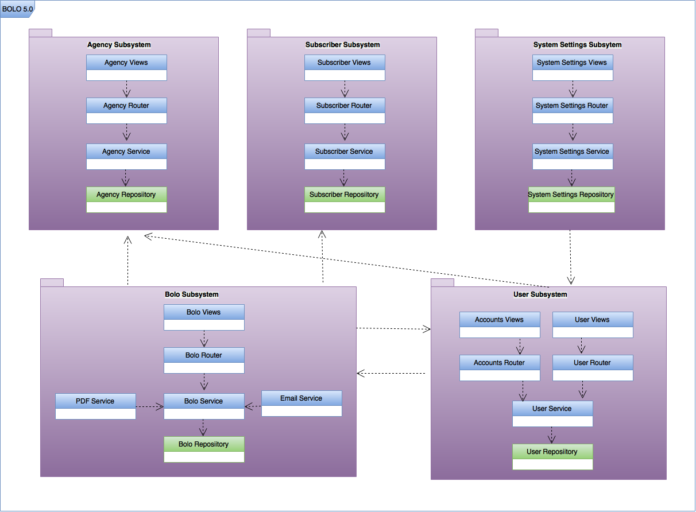Figure 1 - Package diagram

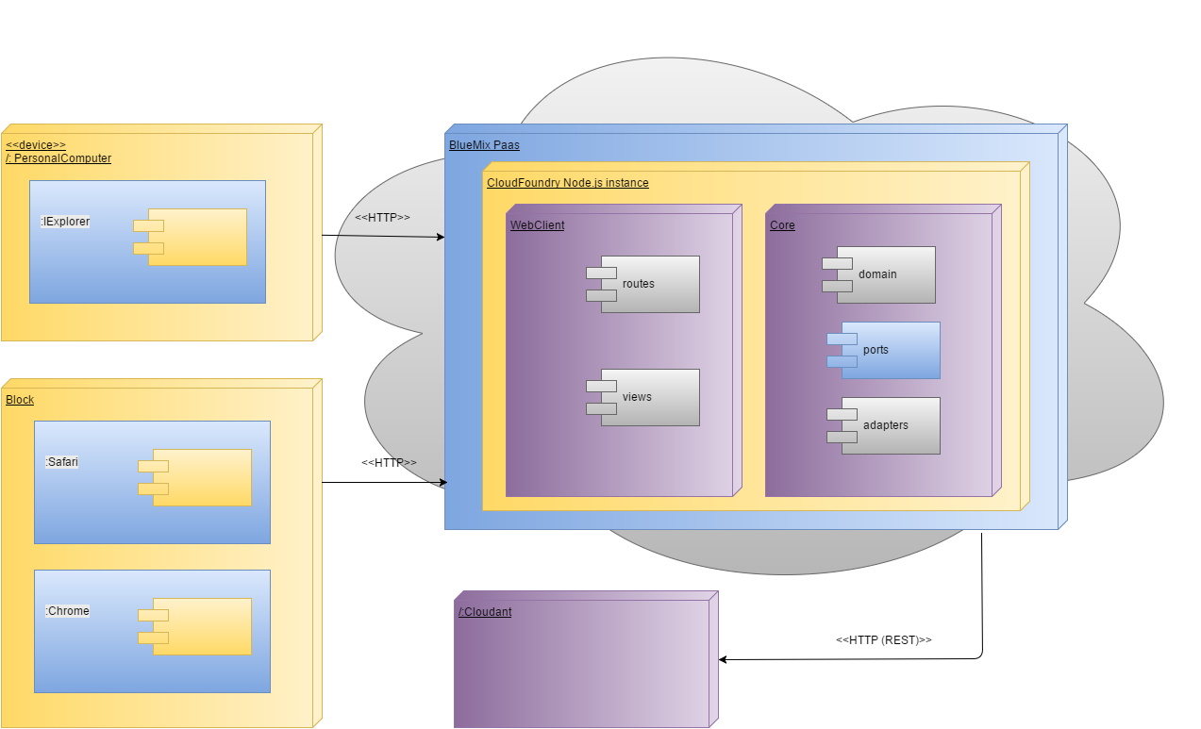

Figure 2 - General Deployment Diagram

[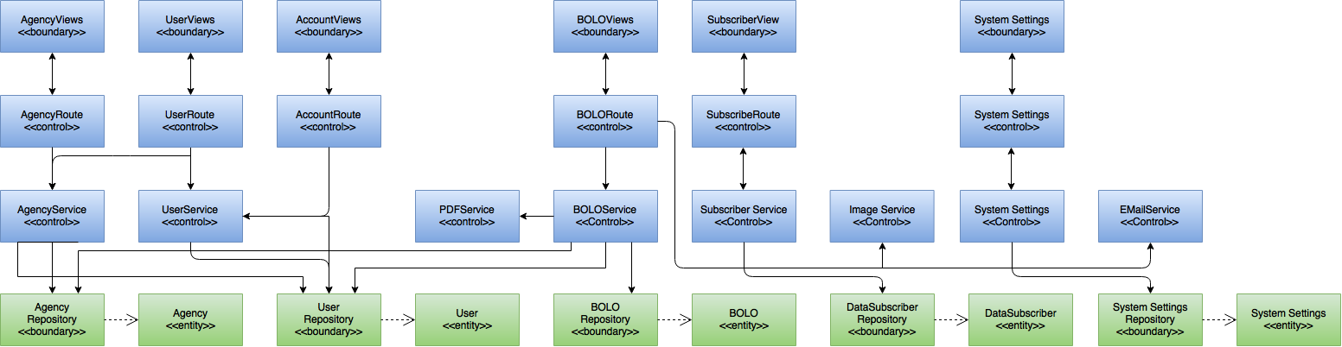](https://drive.draw.io/#G0Bw0gfTN_oxKscUVrTjFYcDNSa0U)

Figure 3 - Minimal Class Diagram

## Design Patterns

The following design patterns were chosen during the last iteration of the system and they have been maintained for the current one:

* Observer: This is essential to maintain an organized execution of asynchronous calls in order to prevent the system from malfunctioning.
* Adapter: It is necessary to “adapt” the system to the services being utilized such as Sendgrid.
* Repository: This abstraction is used to mediate between the domain and the persistent data storage so that if the database service was to be changed, it can be done without altering the entire code.

# System Validation

Unit test is essential to test all the layers within the application. All test cases used to validate User Stories developed are shown in this section.

**User Story #887 - Remove unnecessary data from email alert**

Unit Tests

|  |
| --- |
| **Test ID**: USD-887-001 |
| **Purpose:** Verify whether sendgrid.send() bolo-notification email to subscribed users with unnecessary information removed. |
| **Preconditions:** User_email has been requested and received. |
| **Input:** (payload, function(err, json) ) |
| **Expected Output**: email notification has been delivered with additional text removed |

|  |
| --- |
| **Test ID**: USD-887-002 |
| **Purpose:** Verify whether sendgrid.send() bolo-notification email to subscribed users with unnecessary information removed. |
| **Preconditions:** User_email has been requested and received by helper functions |
| **Input:** (payload, function(err, json) ) |
| **Expected Output**: Console.log(err) |

**User Story #892 - Expire passwords after 90 days old.**

Unit Tests

|  |
| --- |
| **Test ID**: U-892-1-Sunny Day |
| **Purpose:** Test that the user is logged in if password is not expired |
| **Preconditions:** User.passwordLifetime >= Date.now() + 5 days |
| **Input:** Username: jason, password: Jasoncohen1 |
| **Expected Output**: Passport return User object with session key |

|  |
| --- |
| **Test ID**: USD-892-2 Rainy Day |
| **Purpose:** Test that the user is not allowed logon if password is expired |
| **Preconditions:** User.passwordLifetime <= Date.now() |
| **Input:** Username: jason, password: Jasoncohen1 |
| **Expected Output**: Passport return null |

Integration Tests

|  |
| --- |
| **Test ID**: I-892-1 |
| **Purpose:** Test that a call to the userService returns a user |
| **Preconditions:** System is running |
| **Input:** userService.geByUsername( ‘jason1’) |
| **Expected Output**: userService returns jason1 user object |

**User Story #882 - Implement WildCard Search field.**

Unit Tests

|  |
| --- |
| **Test ID**: U-882-1 |
| **Purpose:** Tests that if all values are searched when wildcard field is filled out. |
| **Preconditions:** System must be functional, BOLO testBOLO must exist in database |
| **Input:** WildCard field=”information” |
| **Expected Output**: testBOLO |

Integration Tests

|  |
| --- |
| **Test ID**: I-882-1 |
| **Purpose:** Tests that wildcards are used along with regular search fields when MatchField checkbox is unchecked. (Search must follow same behavior as logical OR) |
| **Preconditions:** System must be functional, BOLO testBOLO must exist in database |
| **Input:**  WildCard field=”information”, First Name= "someUser" |
| **Expected Output**: testBOLO |

|  |
| --- |
| **Test ID**: I-882-2 |
| **Purpose:** Tests that wildcards are used along with regular search fields when MatchField checkbox is checked. (Search must follow same behavior as logical AND) |
| **Preconditions:** System must be functional, BOLO testBOLO must exist in database |
| **Input:**  WildCard field=”information”, First Name= "someUser" |
| **Expected Output**: Null |

**User Story #888 - Open PDF documents in new tab.**

Unit Tests

|  |
| --- |
| **Test ID**: U-888-1 |
| **Purpose:** Test that PDFs open in new tab |
| **Preconditions:** System must be functional, BOLO testBOLO must exist in database |
| **Input:** Select View PDF for testBOLO |
| **Expected Output**: testBOLO PDF in new tab |

**User Story #894 - Update all Pages to Bolo v5.0.**

Unit Tests

|  |
| --- |
| **Test ID**: U-894-1 |
| **Purpose:** Validate that all pages show Bolo 5.0 |
| **Preconditions:** System must be functional |
| **Input:** Access all navigations |
| **Expected Output**: All pages show Bolo 5.0 version |

**User Story #895 - Create template for Theft-Boat BOLO.**

Unit Tests

|  |
| --- |
| **Test ID**: UT-895-001-Sunny Day |
| **Purpose:** Test Boat-Theft template view when the Boat - Theft option is selected |
| **Preconditions:** The create-bolo webpage is shown |
| **Input:** Boat-Theft option is selected |
| **Expected Output**: Render the data for the Boat-Theft template |

|  |
| --- |
| **Test ID**: UT-895-002-Rainy Day |
| **Purpose:** Test Boat-Theft template view when the Boat - Theft option is not selected |
| **Preconditions:** The create-bolo webpage is shown |
| **Input:** General bolo option is selected |
| **Expected Output**: Render the data for the general bolo template |

Integration Tests

|  |
| --- |
| **Test ID**: IT-895-001-Sunny Day |
| **Purpose:** Test show Boat-Theft template when that selection is chosen |
| **Preconditions:** The server is active, The user is logged in, The user is in the homepage |
| **Input:** The user clicks on create bolo button, The user chooses the THEFT - BOAT option from categories |
| **Expected Output**: The create BOLO webpage is populated with the related fields |

|  |
| --- |
| **Test ID**: IT-895-002-Rainy Day |
| **Purpose:** Test show Boat-Theft template when another section is chosen |
| **Preconditions:** The server is active, The user is logged in, The user is in the homepage |
| **Input:** The user clicks on create bolo button, The user chooses an option different to THEFT - BOAT from categories |
| **Expected Output**: The create BOLO webpage is populated with values not related with the THEFT - BOAT template |

**User Story #881 - Create template for Theft-Auto BOLO.**

Unit Tests

|  |
| --- |
| **Test ID** UT-881-001-Sunny Day |
| **Purpose:** Test Auto-Theft template view when the Auto - Theft option is selected |
| **Preconditions:** The create-bolo webpage is shown |
| **Input:** Auto-Theft option is selected |
| **Expected Output**: Render the data for the Auto-Theft template |

|  |
| --- |
| **Test ID**: UT-881-002-Rainy Day |
| **Purpose:** Test Boat-Theft template view when the Auto - Theft option is not selected |
| **Preconditions:** The create-bolo webpage is shown |
| **Input:** General bolo option is selected |
| **Expected Output**: Render the data for the general bolo template |

Integration Tests

|  |
| --- |
| **Test ID**: IT-881-001-Sunny Day |
| **Purpose:** Test show Auto-Theft template when that selection is chosen |
| **Preconditions:** The server is active, The user is logged in, The user is in the homepage |
| **Input:** The user clicks on create bolo button, The user chooses the THEFT - Auto option from categories |
| **Expected Output**: The create BOLO webpage is populated with the related fields |

|  |
| --- |
| **Test ID**: IT-881-002-Rainy Day |
| **Purpose:** Test show Auto-Theft template when another section is chosen |
| **Preconditions:** The server is active, The user is logged in, The user is in the homepage |
| **Input:** The user clicks on create bolo button, The user chooses an option different to THEFT - Auto from categories |
| **Expected Output**: The create BOLO webpage is populated with values not related with the THEFT - Auto template |

**User Story #893 - Authenticate password reset confirmation**

Integration Tests

|  |
| --- |
| **Test ID** ISD-893.001 |
| **Purpose:** This test is the confirmation password is required when resetting the user password as an administrator. |
| **Preconditions:** Administrator must be logged into the system and on the password reset page. This page should display two empty text fields, one for the password and the other for the confirmation password. In addition it should also display a submit button |
| **Input:**  Password = JASONcohen4  Confirmation password = JASONcohen4  Click submit button |
| **Expected Output**: The administrator is taken to their information page with an information message displayed stating, “User update successful. |

|  |
| --- |
| **Test ID**: ISD-893.002 |
| **Purpose:** This test is to authenticate the confirmation password is required when resetting the another user’s password as an administrator. |
| **Preconditions:** Administrator must be logged into the system and on the password reset page for another employee. This page should display two empty text fields, one for the password and the other for the confirmation password. In addition it should also display a submit button |
| **Input:**   1. Password = JASONcohen2 2. Confirmation password = JASONcohen2 3. Click submit button |
| **Expected Output**: The administrator is taken to the user’s information page with their information displayed with a message stating, “User update successful. |

|  |
| --- |
| **Test ID:** ISD-893.003 |
| **Purpose:** This test is the confirmation password is required when resetting the user password as an officer. |
| **Preconditions:** An officer must be logged into the system and on the password reset page (via email request). This page should display two empty text fields, one for the password and the other for the confirmation password. In addition it should also display a submit button. |
| **Input:**   1. Password = JASONcohen1 2. Confirmation password = JASONcohen1 3. Click submit button |
| **Expected output:** The administrator is taken to the their information page with an information message displayed stating, “User update successful.” |
| **Actual output:** Pass |

|  |
| --- |
| **Test ID: IRD-893.004** |
| **Purpose:** This test is to authenticate the confirmation password is required when resetting the user password as an administrator. |
| **Preconditions:** Administrator must be logged into the system and on the password reset page. This page should display two empty text fields, one for the password and the other for the confirmation password. In addition it should also display a submit button. |
| **Input:**   1. Password = JASONcohen4 2. Confirmation password = Blank 3. Click submit button |
| **Expected output:** The administrator is redirected back to the password reset page with a message displayed stating, “Confirmation can’t be blank.” |
| **Actual output:** Pass |

|  |
| --- |
| **Test ID: IRD-893.005** |
| **Purpose:** Test is the confirmation password is required when resetting the another user’s password as an administrator. |
| **Preconditions:** Administrator must be logged into the system and on the password reset page for another employee. This page should display two empty text fields, one for the password and the other for the confirmation password. In addition it should also display a submit button. |
| **Input:**   1. Password = JASONcohen2 2. Confirmation password = Blank 3. Click submit button |
| **Expected output:** The administrator is redirected back to the password reset page with a message displayed stating, “Confirmation can’t be blank.” |
| **Actual output:** Pass |

|  |
| --- |
| **Test ID: IRD-893.006** |
| **Purpose:** This test is to authenticate the confirmation password is required when resetting the user password as an officer. |
| **Preconditions:** An officer must be logged into the system and on the password reset page (via email request). This page should display two empty text fields, one for the password and the other for the confirmation password. In addition it should also display a submit button. |
| **Input:**   1. Password = JASONcohen1 2. Confirmation password = Blank 3. Click submit button |
| **Expected output:** The officer is redirected back to the password reset page with a message displayed stating, “Confirmation can’t be blank.” |
| **Actual output:** Pass |

**User Story #919 - Adjust the timeout secession to ten minutes**

Integration Tests

|  |  |
| --- | --- |
| **Test ID** | ISD-919.001 |
| **Purpose** | To verify the system automatically logs the root user out. |
| **Pre Conditions** | * The server and application are up and running. * Root user is logged in with valid credentials * System has received no input for 10 minutes |
| **Inputs** | None |
| **Expected Outputs** | Upon refresh, the root user will be taken back to the login page. |

|  |  |
| --- | --- |
| **Test ID** | ISD-919.002 |
| **Purpose** | To verify the system automatically logs an administrator out. |
| **Pre Conditions** | * The server and application are up and running. * Administrator user is logged in with valid credentials * System has received no input for 10 minutes |
| **Inputs** | None |
| **Expected Outputs** | Upon refresh, the root user will be taken back to the login page. |

|  |  |
| --- | --- |
| **Test ID** | ISD-919.003 |
| **Purpose** | To verify the system automatically logs an officer out. |
| **Pre Conditions** | * The server and application are up and running. * Officer user is logged in with valid credentials * System has received no input for 10 minutes |
| **Inputs** | None |
| **Expected Outputs** | Upon refresh, the login page will be displayed |

**User Story #930 - Send email notification after my password has been reset**

Integration Tests

|  |
| --- |
| **Test ID: ISD-930-001** |
| **Purpose:** This test is the confirmation password is required when resetting the user password as an administrator. |
| **Preconditions:** Administrator must be logged into the system and on the password reset page. This page should display two empty text fields, one for the password and the other for the confirmation password. In addition it should also display a submit button. |
| **Input:**   1. Password = JASONcohen4 2. Confirmation password = JASONcohen4 3. Click submit button |
| **Expected output:** The administrator will receive an email their password has been changed. |
| **Actual output:** Pass |

|  |
| --- |
| **Test ID: ISD-930-002** |
| **Purpose:** This test is to authenticate the confirmation password is required when resetting the another user’s password as an administrator. |
| **Preconditions:** Administrator must be logged into the system and on the password reset page for another employee. This page should display two empty text fields, one for the password and the other for the confirmation password. In addition it should also display a submit button. |
| **Input:**   1. Password = JASONcohen2 2. Confirmation password = JASONcohen2 3. Click submit button |
| **Expected output:** The administrator will receive an email about an account update |
| **Actual output:** Pass |

|  |
| --- |
| **Test ID: ISD-930-003** |
| **Purpose:** This test is the confirmation password is required when resetting the user password as an officer. |
|  |
| **Preconditions:** An officer must be logged into the system and on the password reset page (via email request). This page should display two empty text fields, one for the password and the other for the confirmation password. In addition, it should also display a submit button. |
| **Input:**   1. Password = JASONcohen1 2. Confirmation password = JASONcohen1 3. Click submit button |
| **Expected output:** The officer will receive an email about their account update |
| **Actual output:** Pass |

|  |
| --- |
| **Test ID: IRD-930-004** |
| **Purpose:** This test is to authenticate the confirmation password is required when resetting the user password as an administrator. |
| **Preconditions:** Administrator must be logged into the system and on the password reset page. This page should display two empty text fields, one for the password and the other for the confirmation password. In addition it should also display a submit button. |
| **Input:**   1. Password = JASONcohen4 2. Confirmation password = Blank 3. Click submit button |
| **Expected output:** No email will be sent |
| **Actual output:** Pass |

|  |
| --- |
| **Test ID: IRD-930-005** |
| **Purpose:** Test is the confirmation password is required when resetting the another user’s password as an administrator. |
| **Preconditions:** Administrator must be logged into the system and on the password reset page for another employee. This page should display two empty text fields, one for the password and the other for the confirmation password. In addition it should also display a submit button. |
| **Input:**   1. Password = JASONcohen2 2. Confirmation password = Blank 3. Click submit button |
| **Expected output:** No email will be sent |
| **Actual output:** Pass |

|  |
| --- |
| **Test ID: IRD-830-006** |
| **Purpose:** This test is to authenticate the confirmation password is required when resetting the user password as an officer. |
| **Preconditions:** An officer must be logged into the system and on the password reset page (via email request). This page should display two empty text fields, one for the password and the other for the confirmation password. In addition it should also display a submit button. |
| **Input:**   1. Password = JASONcohen1 2. Confirmation password = Blank 3. Click submit button |
| **Expected output:** No email will be sent |
| **Actual output:** Pass |

**User Story #879 - Implement BOLO creation confirmations via email**

Unit Tests

|  |  |
| --- | --- |
| ID: | U-879-1 - Sunny Day |
| Purpose: | Create a BOLO and check that confirmation email is sent |
| Preconditions: | Application is running |
| Input: | { category: theft, FirstName: Test, LastName: Bolo, Sex: male, Height: 05-09, Weight: 200, FeaturedImage: Bolo1.png } |
| Expected Output: | Bolo is created and email is sent out to subscribers |

|  |  |
| --- | --- |
| ID: | U-879-2 |
| Purpose: | Try to confirm  BOLO with incorrect token |
| Preconditions: | Email has been sent to user with generated bolo token |
| Input: | GET request to: [http://bolo.mybluemix.net/bolo/confirmBolo/3d26d15eded51332d0919de93da07e762bbd470c](https://u3005259.ct.sendgrid.net/wf/click?upn=nFWYJjtKH5Rd3FC1KyaE2rttl1zxMMBrRPtlpiFIag7nli9aOCRLPxUHDG8pW2IqIN-2FCBuzpCjvXl953cZG9dpSug1XfhKo-2BR2uTV4HhA5W5QnIOy8yrF67vAkqygfLm_Hx3KpmsUTZK2NTiv6b86-2F4nkW35YkxeuP0D05UYaz0NehNENUManpK34gM5i6pQop9BMYSsRFUAZdfwMs34YDh1-2FEDn6Nw0qYPfdvehODP2h42-2FAk2xiHMM-2BnEiQLPlypRUWJBmGiMzGX7Qrg3wSnLLxWphTDQa6JkDzkHx42ZFQaTGbOCKhpgu9wvAYPYINuTg-2BYL2Irnu0D9QxqAv5-2Bg-3D-3D) |
| Expected Output: | System will respond that the bolo does not exist |

Integration Tests

|  |  |
| --- | --- |
| ID: | I-892-1 |
| Purpose: | Test that the application confirms the bolo succesfully |
| Preconditions: | System is running |
| Input: | [http://bolo.mybluemix.net/bolo/confirmBolo/3d26d15eded51332d0919de93da07e762bbd470c](https://u3005259.ct.sendgrid.net/wf/click?upn=nFWYJjtKH5Rd3FC1KyaE2rttl1zxMMBrRPtlpiFIag7nli9aOCRLPxUHDG8pW2IqIN-2FCBuzpCjvXl953cZG9dpSug1XfhKo-2BR2uTV4HhA5W5QnIOy8yrF67vAkqygfLm_Hx3KpmsUTZK2NTiv6b86-2F4nkW35YkxeuP0D05UYaz0NehNENUManpK34gM5i6pQop9BMYSsRFUAZdfwMs34YDh1-2FEDn6Nw0qYPfdvehODP2h42-2FAk2xiHMM-2BnEiQLPlypRUWJBmGiMzGX7Qrg3wSnLLxWphTDQa6JkDzkHx42ZFQaTGbOCKhpgu9wvAYPYINuTg-2BYL2Irnu0D9QxqAv5-2Bg-3D-3D) |
| Expected Output: | Bolo confirmed field is set to true |

**User Story #880 - Send feed of BOLOs as JSON documents**

Unit Tests

|  |  |
| --- | --- |
| ID: | U-880-1 |
| Purpose: | Validate if Sendgrid service sends BOLOs as JSON objects to required active subscribers |
| Preconditions: | testBOLO has been confirmed |
| Input: | testBolo |
| Expected Output: | Email received with testBOLO |

|  |  |
| --- | --- |
| ID: | U-880-2 |
| Purpose: | Validate if Sendgrid service sends BOLO’s attachments to required active subscribers along with JSON object |
| Preconditions: | testBOLO has been confirmed and featured image has been inserted |
| Input: | testBolo |
| Expected Output: | Email received with testBOLO and featured image attached |

Integration Tests

|  |  |
| --- | --- |
| ID: | I-880-1 |
| Purpose: | Validate if deactivation of Data Subscriber through Admin-router prevent the subscriber from receiving notifications |
| Preconditions: | testBOLO has been confirmed and testDataSubscriber has been inactivated |
| Input: | testBolo |
| Expected Output: | Email received with testBOLO and featured image attached by all active data subscribers, not by testDataSubscriber |

**User Story #920 - Compress images upon upload**

Unit Tests

|  |  |
| --- | --- |
| ID: | U-920-1 |
| Purpose: | Validate System compress images bigger than threshold on Agency Creation. |
| Preconditions: | System Administrator fills all Agency fields |
| Input: | Images for Agency shield and logo |
| Expected Output: | Images are compressed to meet the system requirements |

|  |  |
| --- | --- |
| ID: | U-920-2 |
| Purpose: | Validate System compress images bigger than threshold on Bolo Creation. |
| Preconditions: | System Administrator fills all Bolo fields |
| Input: | testBOLO |
| Expected Output: | All images loaded into the BOLO are compressed |

Integration Tests

|  |  |
| --- | --- |
| ID: | I-920-1 |
| Purpose: | Validate that the System handles image compression correctly when creating the PDFs. |
| Preconditions: | testBOLO has been confirmed |
| Input: | testBOLO |
| Expected Output: | Email attachment received on BOLO creation is less than 50KB big |

**User Story #896 - Create Specific Bolo for Theft-Auto**

Unit Tests

|  |  |
| --- | --- |
| **ID:** | UT-896-001-Sunny Day |
| **Purpose:** | Test create Theft-Auto bolo |
| **Preconditions:** | * The create Theft-Auto webpage is shown |
| **Input:** | * The user enter the data related * The user enters the image related * The user clicks on the preview button * The user clicks on the pdf button * The user clicks on the submit button |
| **Expected Output:** | * If the preview button is clicked on, render the preview view * If the pdf button is clicked on, render the preview pdf document * If the submit button is clicked on, store the bolo on cloudant and render the homepage |

|  |  |
| --- | --- |
| **ID:** | UT-896-002-Rainy Day |
| **Purpose:** | Test Theft-Auto template view when the Theft-Auto option is not selected |
| **Preconditions:** | * The create-general-bolo webpage is shown |
| **Input:** | * The user enter the data related * The user enters the image related * The user clicks on the preview button * The user clicks on the pdf button * The user clicks on the submit button |
| **Expected Output:** | * If the preview button is clicked on, render the preview view * If the pdf button is clicked on, render the preview pdf document * If the submit button is clicked on, store the bolo on cloudant and render the homepage |

Integration Tests

|  |  |
| --- | --- |
| **ID:** | IT-896-001-Sunny Day |
| **Purpose:** | Test create Theft-Auto bolo |
| **Preconditions:** | * The server is active * The user is logged in * The user is in the homepage |
| **Input:** | * The user clicks on create bolo button * The user clicks on the Theft-Auto button * The create Theft-Auto BOLO webpage is populated and the user enters this info: Category (static): THEFT - AUTO; Vehicle Make: Toyota; Vehicle Model: Camry; Vehicle Color: Blue; Vehicle Year: 2015; Vehicle Type: xe; Vehicle Tag Number: 123xyz; Vehicle Identification Number (VIN): 1HGCM82633A004352; Featured ImageChoose File: sketch.png; Video Link: http:www.testauto.com; Additional Info: Testing info; Summary: Summary test. * The user clicks on the preview button * The user clicks on the pdf button * The user clicks on the submit button |
| **Expected Output:** | * If the preview button is clicked on, the preview webpage is shown * If the preview pdf is clicked on, the previed pdf is shown * If the submit button is clicked on, the homepage is shown and the following message: BOLO successfully created |

|  |  |
| --- | --- |
| **ID:** | IT-896-002-Rainy Day |
| **Purpose:** | Test create Theft-Auto bolo |
| **Preconditions:** | * The server is active * The user is logged in * The user is in the homepage |
| **Input:** | * The user clicks on create bolo button * The user clicks on the Theft-boat button * The create Theft-Boat BOLO webpage is populated and the user enters this info: Category(static): THEFT - BOAT; Boat Make: Axopart; Boat Model: Axopart; Boat Color: White; Boat Year: 2015; Boat Type: Cruiser Boats; Boat Hull Identification Number: XXX12345M73EX; Boat Registration Number: LA3717ZW; Featured ImageChoose File: boat.png; Video Link: http:www.testboat.com; Additional Info; Testing info; Summary: Summary test. * The user clicks on the preview button * The user clicks on the pdf button * The user clicks on the homepage button |
| **Expected Output:** | * If the preview button is clicked on, the preview webpage is shown * If the preview pdf is clicked on, the previed pdf is shown * If the submit button is clicked on, the homepage is shown and the following message: BOLO successfully created |

**User Story #932 - View Bolo Details for Theft-Auto**

Unit Tests

|  |  |
| --- | --- |
| **ID:** | UT-932-001-Sunny Day |
| **Purpose:** | Test details for Theft-Auto |
| **Preconditions:** | * The homepage is shown |
| **Input:** | * The user clicks on the details button * The user clicks on the pdf button |
| **Expected Output:** | * If the details button is clicked on, store the bolo on cloudant and render the homepage * If the pdf button is clicked on, the pdf document will be generated |

|  |  |
| --- | --- |
| **ID:** | UT-932-002-Rainy Day |
| **Purpose:** | Test details for Theft-Auto when details for Theft-Boat option is selected |
| **Preconditions:** | * The homepage is shown |
| **Input:** | * The user clicks on the details button for Theft-Boat * The user clicks on the pdf button |
| **Expected Output:** | * If the details button is clicked on, render the details view * If the pdf button is clicked on, the pdf document will be generated |

Integration Tests

|  |  |
| --- | --- |
| **ID:** | IT-932-001-Sunny Day |
| **Purpose:** | Test details for Theft-Auto |
| **Preconditions:** | * The server is active * The user is logged in * The user is in the homepage |
| **Input:** | * The user clicks on details button for Theft-Auto * The user clicks on the generate pdf button |
| **Expected Output:** | * If the details button is clicked on, the details view for Theft-Auto will be shown * If the generate pdf button is clicked on, the pdf document will be shown |

|  |  |
| --- | --- |
| **ID:** | IT-932-002-Rainy Day |
|  |  |
| **Purpose:** | Test details for Theft-Auto |
| **Preconditions:** | * The server is active * The user is logged in * The user is in the homepage |
| **Input:** | * The user clicks on the details button for Theft-Boat * The user clicks on the pdf button |
| **Expected Output:** | * If the details button is clicked on, the details view for Theft-Boat will be shown * If the generate pdf button is clicked on, the pdf document will be shown |

**User Story #933 - Edit Bolo for Theft-Auto**

Unit Tests

|  |  |
| --- | --- |
| **ID:** | UT-933-001-Sunny Day |
| **Purpose:** | Test edit Theft-Auto bolo |
| **Preconditions:** | * The homepage is shown |
| **Input:** | * The user clicks on the edit button for Theft-Auto * The user enters the data to be changed * The user clicks on the publish button |
| **Expected Output:** | * The updated data will be stored in on cloudant and render the homepage |

|  |  |
| --- | --- |
| **ID:** | UT-933-002-Rainy Day |
| **Purpose:** | Test edit Theft-Auto bolo when another option is  selected |
| **Preconditions:** | * The homepage is shown |
| **Input:** | * The user clicks on the details button for Theft-Boat * The user clicks on the submit button |
| **Expected Output:** | * The system will retrieve the data details for Theft-Boat |

Integration Tests

|  |  |
| --- | --- |
| **ID:** | IT-933-001-Sunny Day |
| **Purpose:** | Test edit Theft-Auto bolo |
| **Preconditions:** | * The server is active * The user is logged in * The user is in the homepage |
| **Input:** | * The user clicks on the edit button for Theft-Auto * The user enters the date to be modified * The user clicks on the publish button |
| **Expected Output:** | * The homepage is shown and the following message: BOLO successfully updated |

|  |  |
| --- | --- |
| **ID:** | IT-933-002-Rainy Day |
| **Purpose:** | Test edit Theft-Auto bolo |
| **Preconditions:** | * The server is active * The user is logged in * The user is in the homepage |
| **Input:** | * The user clicks on the details button for Theft-Auto |
| **Expected Output:** | * The details for Theft-Auto will be shown |

**User Story #936 - Create Specific Bolo for Theft-Boat**

Unit Tests

|  |  |
| --- | --- |
| **ID:** | UT-936-001-Sunny Day |
| **Purpose:** | Test create Theft-Boat bolo |
| **Preconditions:** | * The create Theft-Boat webpage is shown |
| **Input:** | * The user enter the data related * The user enters the image related * The user clicks on the preview button * The user clicks on the pdf button * The user clicks on the submit button |
| **Expected Output:** | * If the preview button is clicked on, render the preview view * If the pdf button is clicked on, render the preview pdf document * If the submit button is clicked on, store the bolo on cloudant and render the homepage |

|  |  |
| --- | --- |
| **ID:** | UT-936-002-Rainy Day |
| **Purpose:** | Test Theft-Boat template view when the Theft-Boat option is not selected |
| **Preconditions:** | * The create-general-bolo webpage is shown |
| **Input:** | * The user enter the data related * The user enters the image related * The user clicks on the preview button * The user clicks on the pdf button * The user clicks on the submit button |
| **Expected Output:** | * If the preview button is clicked on, render the preview view * If the pdf button is clicked on, render the preview pdf document * If the submit button is clicked on, store the bolo on cloudant and render the homepage |

Integration Tests

|  |  |  |
| --- | --- | --- |
| **ID:** |  | IT-936-001-Sunny Day |
| **Purpose:** |  | Test create Theft-Boat bolo |
| **Preconditions:** |  | * The server is active * The user is logged in * The user is in the homepage |
| **Input:** |  | * The user clicks on create bolo button * The user clicks on the Theft-Boat button * The create Theft-boat BOLO webpage is populated and the user enters this info: Category (static): THEFT - AUTO; Vehicle Make: Toyota; Vehicle Model: Camry; Vehicle Color: Blue; Vehicle Year: 2015; Vehicle Type: xe; Vehicle Tag Number: 123xyz; Vehicle Identification Number (VIN): 1HGCM82633A004352; Featured ImageChoose File: sketch.png; Video Link: http:www.testauto.com; Additional Info: Testing info; Summary: Summary test. * The user clicks on the preview button * The user clicks on the pdf button * The user clicks on the submit button |
| **Expected Output:** |  | * If the preview button is clicked on, the preview webpage is shown * If the preview pdf is clicked on, the previed pdf is shown * If the submit button is clicked on, the homepage is shown and the following message: BOLO successfully created |

|  |  |
| --- | --- |
| **ID:** | IT-936-002-Rainy Day |
| **Purpose:** | Test create Theft-Boat bolo |
| **Preconditions:** | * The server is active * The user is logged in * The user is in the homepage |
| **Input:** | * The user clicks on create bolo button * The user clicks on the Theft-auto button * The create Theft-auto BOLO webpage is populated and the user enters this info: Category(static): THEFT - AUTO; Year: 2016; Make: Toyota; Model: Camry; Trim: Sport; Color: Black; License Plate: HGT854; Vehicle Identification Number (VIN): VHG123456789; Featured ImageChoose File: Car.png; Video Link: http://www.testauto.com; Additional Info: Testing Info; Summary: Summary Test * The user clicks on the preview button * The user clicks on the pdf button * The user clicks on the homepage button |
| **Expected Output:** | * If the preview button is clicked on, the preview webpage is shown * If the preview pdf is clicked on, the previed pdf is shown * If the submit button is clicked on, the homepage is shown and the following message: BOLO successfully created |

**User Story #937 - View Bolo Details for Theft-Boat**

Unit Tests

|  |  |
| --- | --- |
| **ID:** | UT-937-001-Sunny Day |
| **Purpose:** | Test details for Theft-Boat |
| **Preconditions:** | * The homepage is shown |
| **Input:** | * The user clicks on the details button * The user clicks on the pdf button |
| **Expected Output:** | * If the details button is clicked on, store the bolo on cloudant and render the homepage * If the pdf button is clicked on, the pdf document will be generated |

|  |  |
| --- | --- |
| **ID:** | UT-937-002-Rainy Day |
| **Purpose:** | Test details for Theft-Boat when details for Theft-Auto option is selected |
| **Preconditions:** | * The homepage is shown |
| **Input:** | * The user clicks on the details button for Theft-Auto * The user clicks on the pdf button |
| **Expected Output:** | * If the details button is clicked on, render the details view * If the pdf button is clicked on, the pdf document will be generated |

Integration Tests

|  |  |
| --- | --- |
| **ID:** | IT-937-001-Sunny Day |
| **Purpose:** | Test details for Theft-Boat |
| **Preconditions:** | * The server is active * The user is logged in * The user is in the homepage |
| **Input:** | * The user clicks on details button for Theft-Boat * The user clicks on the generate pdf button |
| **Expected Output:** | * If the details button is clicked on, the details view for Theft-Boat will be shown * If the generate pdf button is clicked on, the pdf document will be shown |

|  |  |
| --- | --- |
| **ID:** | IT-932-002-Rainy Day |
| **Purpose:** | Test details for Theft-Boat |
| **Preconditions:** | * The server is active * The user is logged in * The user is in the homepage |
| **Input:** | * The user clicks on the details button for Theft-Auto * The user clicks on the pdf button |
| **Expected Output:** | * If the details button is clicked on, the details view fro Theft-Auto will be shown * If the generate pdf button is clicked on, the pdf document will be shown |

**User Story #938 - Edit Bolo for Theft-Boat**

**Unit Tests**

|  |  |
| --- | --- |
| **ID:** | UT-938-001-Sunny Day |
| **Purpose:** | Test edit Theft-Boat bolo |
| **Preconditions:** | * The homepage is shown |
| **Input:** | * The user clicks on the edit button for Theft-Boat * The user enters the data to be changed * The user clicks on the publish button |
| **Expected Output:** | * The updated data will be stored in on cloudant and render the homepage |

|  |  |
| --- | --- |
| **ID:** | UT-938-002-Rainy Day |
| **Purpose:** | Test edit Theft-Boat bolo when another option is  selected |
| **Preconditions:** | * The homepage is shown |
| **Input:** | * The user clicks on the details button for Theft-Auto * The user clicks on the submit button |
| **Expected Output:** | * The system will retrieve the data details for Theft-Auto |

**Integration Test**

|  |  |
| --- | --- |
| **ID:** | IT-938-001-Sunny Day |
| **Purpose:** | Test edit Theft-Boat bolo |
| **Preconditions:** | * The server is active * The user is logged in * The user is in the homepage |
| **Input:** | * The user clicks on the edit button for Theft-Boat * The user enters the date to be modified * The user clicks on the publish button |
| **Expected Output:** | * The homepage is shown and the following message: BOLO successfully updated |

|  |  |
| --- | --- |
| **ID:** | IT-938-002-Rainy Day |
| **Purpose:** | Test edit Theft-Boat bolo |
| **Preconditions:** | * The server is active * The user is logged in * The user is in the homepage |
| **Input:** | * The user clicks on the details button for Theft-Auto |
| **Expected Output:** | * The details for Theft-Auto will be shown |

**User Story #934 - Remove unnecessary fields from PDF BOLO display**

Integration Tests

|  |  |
| --- | --- |
| **Test ID** | ISD-934.001 |
| **Purpose** | To verify the PDF version BOLO send in an email does not display empty fields titles |
| **Preconditions** | Create a BOLO |
| **Input** | Confirm the BOLO |
| **Expected output** | Receive an email with the PDF BOLO and all N/A fields to not be displayed nor their titles. I.e. Name N/A will not be displayed |
| **Actual output:** | Pass |

|  |  |
| --- | --- |
| **Test ID** | ISD-934.002 |
| **Purpose** | To verify a PDF view from the system does not display empty fields nor their titles |
| **Preconditions** | A BOLO has been created no value in any field and is being viewed through the details link at the bottom of the BOLO |
| **Input** | Click, “Generate PDF” |
| **Expected output** | A display of the PDF without the display of empty fields and their titles |
| **Actual output:** | Pass |

|  |  |
| --- | --- |
| **Test ID** | ISD-934.003 |
| **Purpose** | To verify a PDF BOLO view from the system does not display empty fields nor their titles that were previously holding some value after it has been updated |
| **Preconditions** | A BOLO has been created and has been updated |
| **Input** | 1. Delete all existing test fields of the  BOLO 2. Click “Submit” 3. Click “Details” 4. Click “Generate PDF” |
| **Expected output** | A display of the PDF without the display of empty fields and their titles |
| **Actual output:** | Pass |

|  |  |
| --- | --- |
| **Test ID** | IRD-934.004 |
| **Purpose** | To verify a PDF without empty fields and their titles will not be displayed. |
| **Preconditions** | A terminated officer gains access to the system and creates a BOLO but cannot confirm it. |
| **Input** | 1. A second officer logged into the system after the previous event 2. The officer views existing BOLO in PDF format |
| **Expected output** | The second officer will not be able to view the unconfirmed BOLO and therefore no PDF will be generated without empty fields displayed |
| **Actual output:** | Pass |

|  |  |
| --- | --- |
| **Test ID** | IRD-934.005 |
| **Purpose** | To verify a PDF format of a BOLO with value in all fields does not display as a BOLO with empty fields |
| **Preconditions** | A BOLO has been created with value in all fields and is being viewed through the details link at the bottom of the BOLO |
| **Input** | Click, “Generate PDF” |
| **Expected output** | A display of the PDF without the display of empty fields and their titles |
| **Actual output:** | Pass |

|  |  |
| --- | --- |
| **Test ID** | IRD-934.006 |
| **Purpose** | To verify a PDF format of a updated BOLO with value in all fields does not display as a BOLO with empty fields |
| **Preconditions** | A BOLO has been updated with value in all fields and is being viewed through the details link at the bottom of the BOLO |
| **Input** | Click, “Generate PDF” |
| **Expected output** | A display of the PDF without the display of empty fields and their titles |
| **Actual output:** | Pass |

**User Story #935 - Add drop down for links such as settings, user guide, logout and others to be added at a later time**

Integration Tests

|  |  |
| --- | --- |
| **Test ID** | ISD-935.001 |
| **Purpose** | To verify a tier four user will have access to the new menu via the drop down link |
| **Preconditions** | Logged into the system |
| **Input** | Click on the user name which is a drop down |
| **Expected output** | A new drop down menu will appear |
| **Actual output:** | Pass |

|  |  |
| --- | --- |
| **Test ID** | ISD-935.002 |
| **Purpose** | To verify a tier three user will have access to the new menu via the drop down link |
| **Preconditions** | Logged into the system |
| **Input** | Click on the user name which is a drop down |
| **Expected output** | A new drop down menu will appear |
| **Actual output:** | Pass |

|  |  |
| --- | --- |
| **Test ID** | ISD-935.003 |
| **Purpose** | To verify a tier two user will have access to the new menu via the drop down link |
| **Preconditions** | Logged into the system |
| **Input** | Click on the user name which is a drop down |
| **Expected output** | A new drop down menu will appear |
| **Actual output:** | Pass |

|  |  |
| --- | --- |
| **Test ID** | ISD-935.004 |
| **Purpose** | To verify a tier one user will have access to the new menu via the drop down link |
| **Preconditions** | Logged into the system |
| **Input** | Click on the user name which is a drop down |
| **Expected output** | A new drop down menu will appear |
| **Actual output:** | Pass |

|  |  |
| --- | --- |
| **Test ID** | IRD-935.005 |
| **Purpose** | To verify a tier four user will not access to the new menu via another dropdown |
| **Preconditions** | Logged into the system |
| **Input** | Click on the Create BOLO which is a drop down link |
| **Expected output** | A new drop down menu will not appear |
| **Actual output:** | Pass |

|  |  |
| --- | --- |
| **Test ID** | IRD-935.006 |
| **Purpose** | To verify a tier threeuser will not access to the new menu via another dropdown |
| **Preconditions** | Logged into the system |
| **Input** | Click on the Create BOLO which is a drop down link |
| **Expected output** | A new drop down menu will not appear |
| **Actual output:** | Pass |

|  |  |
| --- | --- |
| **Test ID** | IRD-935.007 |
| **Purpose** | To verify a tier three user will not access to the new menu via another dropdown |
| **Preconditions** | Logged into the system |
| **Input** | Click on the Creat BOLO which is a drop down link |
| **Expected output** | A new drop down menu will not appear |
| **Actual output:** | Pass |

|  |  |
| --- | --- |
| **Test ID** | IRD-935.008 |
| **Purpose** | To verify a tier oneuser will not access to the new menu via another dropdown |
| **Preconditions** | Logged into the system |
| **Input** | Click on the Creat BOLO which is a drop down link |
| **Expected output** | A new drop down menu will not appear |
| **Actual output:** | Pass |

|  |  |
| --- | --- |
| **Test ID** | ISD-935.009 |
| **Purpose** | To verify the user guide link works in the new menu for an officer user |
| **Preconditions** | Logged into the system |
| **Input** | 1. Click on the user name which is a drop down 2. Click on the user guide |
| **Expected output** | The officer will be taken to the user’s guide for officers |
| **Actual output:** | Pass |

|  |  |
| --- | --- |
| **Test ID** | ISD-935.010 |
| **Purpose** | To verify the user guide link works in the new menu for a root user |
| **Preconditions** | Logged into the system |
| **Input** | 1. Click on the user name which is a drop down 2. Click on the user guide |
| **Expected output** | The officer will be taken to the user’s guide for a root users |
| **Actual output:** | Pass |

|  |  |
| --- | --- |
| **Test ID** | ISD-935.011 |
| **Purpose** | To verify the user guide link works in the new menu for an admin user |
| **Preconditions** | Logged into the system |
| **Input** | 1. Click on the user name which is a drop down 2. Click on the user guide |
| **Expected output** | The officer will be taken to the user’s guide for admin users |
| **Actual output:** | Pass |

|  |  |
| --- | --- |
| **Test ID** | IRD-935.012 |
| **Purpose** | To verify the user guide link does not work if a neighbor link is clicked instead |
| **Preconditions** | Logged into the system |
| **Input** | 1. Click on the user name which is a drop down 2. Click on the logout button |
| **Expected output** | The officer will not be taken to the user’s guide page |
| **Actual output:** | Pass |

|  |  |
| --- | --- |
| **Test ID** | IRD-935.013 |
| **Purpose** | To verify the user guide link does not work if a neighbor link is clicked instead |
| **Preconditions** | Logged into the system |
| **Input** | 1. Click on the user name which is a drop down 2. Click on the User Settings button |
| **Expected output** | The officer will not be taken to the user’s guide page |
| **Actual output:** | Pass |

|  |  |
| --- | --- |
| **Test ID** | IRD-935.014 |
| **Purpose** | To verify the user guide link does not work if a neighbor link is clicked instead |
| **Preconditions** | Logged into the system |
| **Input** | 1. Click on the user name which is a drop down 2. Click on the About Us button |
| **Expected output** | The officer will not be taken to the user’s guide page |
| **Actual output:** | Pass |

|  |  |
| --- | --- |
| **Test ID** | ISD-935.015 |
| **Purpose** | To verify the About Us link works in the new menu for an officer user |
| **Preconditions** | Logged into the system |
| **Input** | 1. Click on the user name which is a drop down 2. Click on the About Us |
| **Expected output** | The officer will be taken to the  About Us page |
| **Actual output:** | Pass |

|  |  |
| --- | --- |
| **Test ID** | ISD-935.016 |
| **Purpose** | To verify the About Us link works in the new menu for a root user |
| **Preconditions** | Logged into the system |
| **Input** | 1. Click on the user name which is a drop down 2. Click on the About Us |
| **Expected output** | The officer will be taken to the  About Us page |
| **Actual output:** | Pass |

|  |  |
| --- | --- |
| **Test ID** | ISD-935.017 |
| **Purpose** | To verify the About Us link works in the new menu for an admin user |
| **Preconditions** | Logged into the system |
| **Input** | 1. Click on the user name which is a drop down 2. Click on the About Us |
| **Expected output** | The officer will be taken to the  About Us page |
| **Actual output:** | Pass |

|  |  |
| --- | --- |
| **Test ID** | IRD-935.018 |
| **Purpose** | To verify the user About Us does not work if a neighbor link is clicked instead |
| **Preconditions** | Logged into the system |
| **Input** | 1. Click on the user name which is a drop down 2. Click on the logout button |
| **Expected output** | The officer will not be taken to the About Us page |
| **Actual output:** | Pass |

|  |  |
| --- | --- |
| **Test ID** | IRD-935.019 |
| **Purpose** | To verify the About Us link does not work if a neighbor link is clicked instead |
| **Preconditions** | Logged into the system |
| **Input** | 1. Click on the user name which is a drop down 2. Click on the User Settings button |
| **Expected output** | The officer will not be taken to the About Us page |
| **Actual output:** | Pass |

|  |  |
| --- | --- |
| **Test ID** | IRD-935.020 |
| **Purpose** | To verify the About Us link does not work if a neighbor link is clicked instead |
| **Preconditions** | Logged into the system |
| **Input** | 1. Click on the user name which is a drop down 2. Click on the About Us button |
| **Expected output** | The officer will not be taken to the About Us page |
| **Actual output:** | Pass |

**User Story#1006 - Add a user guide page for each tier**

Integration Tests

|  |  |
| --- | --- |
| **Test ID** | ISD-1006.001 |
| **Purpose** | To verify a root user will have access to the root’s user’s guide page |
| **Preconditions** | Logged into the system |
| **Input** | Click on the user name which is a drop down |
| **Expected output** | A new drop down menu will appear |
| **Actual output:** | Pass |

|  |  |
| --- | --- |
| **Test ID** | ISD-1006.002 |
| **Purpose** | To verify an admin user will have access to the admin’s user’s guide page |
| **Preconditions** | Logged into the system |
| **Input** | Click on the user name which is a drop down |
| **Expected output** | A new drop down menu will appear |
| **Actual output:** | Pass |

|  |  |
| --- | --- |
| **Test ID** | ISD-1006.003 |
| **Purpose** | To verify a supervisor user will have access to the supervisor’s user’s guide page |
| **Preconditions** | Logged into the system |
| **Input** | Click on the user name which is a drop down |
| **Expected output** | A new drop down menu will appear |
| **Actual output:** | Pass |

|  |  |
| --- | --- |
| **Test ID** | ISD-1006.004 |
| **Purpose** | To verify an officer user will have access to the officer’s user’s guide page |
| **Preconditions** | Logged into the system |
| **Input** | Click on the user name which is a drop down |
| **Expected output** | A new drop down menu will appear |
| **Actual output:** | Pass |

|  |  |
| --- | --- |
| **Test ID** | IRD-1006.005 |
| **Purpose** | To verify a root user will not access to the user’s guide via another dropdown |
| **Preconditions** | Logged into the system |
| **Input** | Click on the Create BOLO which is a drop down link |
| **Expected output** | A new drop down menu will not appear |
| **Actual output:** | Pass |

|  |  |
| --- | --- |
| **Test ID** | IRD-1006.006 |
| **Purpose** | To verify an admin user will not access to the user’s guide via another dropdown |
| **Preconditions** | Logged into the system |
| **Input** | Click on the Create BOLO which is a drop down link |
| **Expected output** | A new drop down menu will not appear |
| **Actual output:** | Pass |

|  |  |
| --- | --- |
| **Test ID** | IRD-1006.007 |
| **Purpose** | To verify a supervisor user will not access to the user’s guide via another dropdown |
| **Preconditions** | Logged into the system |
| **Input** | Click on the Creat BOLO which is a drop down link |
| **Expected output** | A new drop down menu will not appear |
| **Actual output:** | Pass |

|  |  |
| --- | --- |
| **Test ID** | IRD-1006.008 |
| **Purpose** | To verify an officer user will not access to the user’s guide via another dropdown |
| **Preconditions** | Logged into the system |
| **Input** | Click on the Creat BOLO which is a drop down link |
| **Expected output** | A new drop down menu will not appear |
| **Actual output:** | Pass |

**User Story #1046 - Add an About Us page**

Integration Tests

|  |  |
| --- | --- |
| **Test ID** | ISD-1046.001 |
| **Purpose** | To verify a root user will have access to the About Us page |
| **Preconditions** | Logged into the system |
| **Input** | Click on the user name which is a drop down |
| **Expected output** | A new drop down menu will appear |
| **Actual output:** | Pass |

|  |  |
| --- | --- |
| **Test ID** | ISD-1046.002 |
| **Purpose** | To verify an admin user will have access to the About Us page |
| **Preconditions** | Logged into the system |
| **Input** | Click on the user name which is a drop down |
| **Expected output** | A new drop down menu will appear |
| **Actual output:** | Pass |

|  |  |
| --- | --- |
| **Test ID** | ISD-1046.003 |
| **Purpose** | To verify a supervisor user will have access to the About Us page |
| **Preconditions** | Logged into the system |
| **Input** | Click on the user name which is a drop down |
| **Expected output** | A new drop down menu will appear |
| **Actual output:** | Pass |

|  |  |
| --- | --- |
| **Test ID** | ISD-1046.004 |
| **Purpose** | To verify an officer user will have access to the About Us page |
| **Preconditions** | Logged into the system |
| **Input** | Click on the user name which is a drop down |
| **Expected output** | A new drop down menu will appear |
| **Actual output:** | Pass |

|  |  |
| --- | --- |
| **Test ID** | IRD-1046.005 |
| **Purpose** | To verify a root user will not access to About Us page via another dropdown |
| **Preconditions** | Logged into the system |
| **Input** | Click on the Create BOLO which is a drop down link |
| **Expected output** | A new drop down menu will not appear |
| **Actual output:** | Pass |

|  |  |
| --- | --- |
| **Test ID** | IRD-1046.006 |
| **Purpose** | To verify an admin user will not access to About Us page via another dropdown |
| **Preconditions** | Logged into the system |
| **Input** | Click on the Create BOLO which is a drop down link |
| **Expected output** | A new drop down menu will not appear |
| **Actual output:** | Pass |

|  |  |
| --- | --- |
| **Test ID** | IRD-1046.007 |
| **Purpose** | To verify a supervisor user will not access to About Us page via another dropdown |
| **Preconditions** | Logged into the system |
| **Input** | Click on the Creat BOLO which is a drop down link |
| **Expected output** | A new drop down menu will not appear |
| **Actual output:** | Pass |

|  |  |
| --- | --- |
| **Test ID** | IRD-1046.008 |
| **Purpose** | To verify an officer user will not access to About Us page via another dropdown |
| **Preconditions** | Logged into the system |
| **Input** | Click on the Creat BOLO which is a drop down link |
| **Expected output** | A new drop down menu will not appear |
| **Actual output:** | Pass |

**User Story #1011 - Filter BOLOS by author and reformat the dropdown**

Unit Tests

|  |  |
| --- | --- |
| **ID:** | U-1008-1-Sunny Day |
| **Purpose:** | Test that the correct bolos are returned when a call is made |
| **Preconditions:** | User is logged in |
| **Input:** | userService.getBolosByAuthor(‘egonz077’) |
| **Expected Output:** | Bolos that were authored by egonz077 will be returned. |

Integration Tests

|  |  |
| --- | --- |
| **ID:** | I-1011-1 |
| **Purpose:** | Test that a call to the database returns BOLOs by author |
| **Preconditions:** | Database is live |
| **Input:** | https://4473c6b8-33bc-426e-9147-3019756e24a0-bluemix.cloudant.com/bolo/_design/bolo/_view/by_author?limit=100&{"keys":"egonz077"}&reduce=false |
| **Expected Output:** | Database will return bolos by author |

**User Story #1008 - Prevent user email domain from being something other than their agency's domain**

Unit Tests

|  |  |
| --- | --- |
| **ID:** | U-1008-1-Sunny Day |
| **Purpose:** | Test that the user is created using the parameters of the form |
| **Preconditions:** | User logged in is admin |
| **Input:** | { Username: testuser,   Email:  testuser,   Password: testuser,   Confirm: testuser,   First Name: test,   Last Name: user,   Role:   Admin,   Badge: 1,  Section: 1,  Rank: Admin } |
| **Expected Output:** | User will be successfully created. |

|  |  |
| --- | --- |
| **ID:** | U-1008-2-Rainy Day |
| **Purpose:** | Test that the user is not created if email domain is provided. |
| **Preconditions:** | User logged in is admin |
| **Input:** | { Username: testuser,   Email:  testuser@fiu.edu,   Password: testuser,   Confirm: testuser,   First Name: test,   Last Name: user,   Role:   Admin,   Badge: 1,  Section: 1,  Rank: Admin } |
| **Expected Output:** | User will not be created. |

Integration Tests

|  |  |
| --- | --- |
| **ID:** | I-1008-1 |
| **Purpose:** | Test that a call to the database creates the user |
| **Preconditions:** | Database is live |
| **Input:** | { Username: testuser,   Email:  testuser@fiu.edu,   Password: testuser,   Confirm: testuser,   First Name: test,   Last Name: user,   Role:   Admin,   Badge: 1,  Section: 1,  Rank: Admin } |
| **Expected Output:** | User will be created. |

**User Story #931 - Create script to reset DB Schema**

Unit Tests

|  |  |
| --- | --- |
| **ID:** | U-931-1 |
| **Purpose:** | Validate if design documents are updated when script is executed |
| **Preconditions:** | Cloudant instance has been initialized and some data has been already loaded |
| **Input:** | Insert new view into Agency Design document:  "views": {  "by_agency": {  "map": "function ( doc ) { if ( 'agency' === doc.Type ) emit( doc.name, null ); }"  },  "all_active": {  "map": "function ( doc ) { if ( 'agency' === doc.Type && true === doc.isActive) emit( doc.name, null ); }"  },  "revs": {  "map": "function ( doc ) { if ( 'agency' === doc.Type ) emit( null, doc._rev ); }"  },  "NewView": {  "map": "function ( doc ) { if ( 'agency' === doc.Type ) emit( null, doc._rev ); }"  }  }, |
| **Expected Output:** | Cloudant creates a new view as soon the new document design is inserted, no Agency us deleted by applying this change |

|  |  |
| --- | --- |
| **ID:** | U-931-2 |
| **Purpose:** | Validate if new design documents are inserted into the database |
| **Preconditions:** | Cloudant instance has been initialized and some data has been already loaded |
| **Input:** | New Design document is added to the script to update Cloudant instance:  var NEW_DESIGN_DOC = {  "views": {  "by_agency": {  "map": "function ( doc ) { if ( 'agency' === doc.Type ) emit( doc.name, null ); }"  },  "all_active": {  "map": "function ( doc ) { if ( 'agency' === doc.Type && true === doc.isActive) emit( doc.name, null ); }"  },  "revs": {  "map": "function ( doc ) { if ( 'agency' === doc.Type ) emit( null, doc._rev ); }"  },  "revs2": {  "map": "function ( doc ) { if ( 'agency' === doc.Type ) emit( null, doc._rev ); }"  }  },  indexes: {  agencies: {  analyzer: {  name: 'standard'  },  index: agency_indexer  }  }  }; |
| **Expected Output:** | New Design document is created in Database |

Integration Tests

|  |  |
| --- | --- |
| **ID:** | I-931-1 |
| **Purpose:** | Validate if Search service is able to search BOLOs using a new view inserted with the Schema-Updater script |
| **Preconditions:** | testBOLO has been confirmed and new view has been inserted into BOLO design document using the script, search is changed to use the new view |
| **Input:** | Search for testBOLO |
| **Expected Output:** | testBOLO is showed on the search results |

**User Story #985 - Enhance Image Service**

Unit Tests

|  |  |
| --- | --- |
| **ID:** | U-985-1 |
| **Purpose:** | Validate that final size of images is less than 1 MB |
| **Preconditions:** | Officer is logged in the system |
| **Input:** | Officer tries to create a new BOLO using an image which is 4MB big |
| **Expected Output:** | Final size of BOLO flyer is less than 1MB, keeping good quality |

Integration Tests

|  |  |
| --- | --- |
| **ID:** | I-985-1 |
| **Purpose:** | Validate that the layout of BOLO flyers is not affected by the original size of the images used on the BOLO |
| **Preconditions:** | Officer is logged in the system |
| **Input:** | Officer tries to create a new BOLO using an image which is 400x400.px |
| **Expected Output:** | BOLO flyer is created and the image uploaded is resized to the default dimensions of the flyers |

**User Story # 986 - Unsubscribe from BOLO emails**

Unit Tests

|  |  |
| --- | --- |
| **ID:** | U-986-1 |
| **Purpose:** | Validate if correct agency is displayed on new bolo notification link to unsubscribe |
| **Preconditions:** | testBOLO has been confirmed for testAgency agency |
| **Input:** | Officer receives email with new BOLO notification |
| **Expected Output:** | The verbiage on the link to unsubscribe refers to the Agency for which the BOLO was submitted. |

|  |  |
| --- | --- |
| **ID:** | U-986-2 |
| **Purpose:** | Validate if officer is unsubscribed from Agency when he clicks on the link on the email. |
| **Preconditions:** | testBOLO has been confirmed for testAgency agency |
| **Input:** | Officer receives bolo notification for testBOLO and clicks on the link to unsubscribe from testAgency. |
| **Expected Output:** | User is unsubscribed from Agency |

Integration Tests

|  |  |
| --- | --- |
| **ID:** | I-986-1 |
| **Purpose:** | Validate if user is required to authenticate before been unsubscribed from Agency. |
| **Preconditions:** | testBOLO has been confirmed for testAgency agency. Officer is not logged into the BOLO system |
| **Input:** | Officer receives bolo notification for testBOLO and clicks on the link to unsubscribe from testAgency. |
| **Expected Output:** | Officer is unsubscribed from testAgency after authentication. |

**User Story #1001** – **Implement routes with authentication**

|  |  |
| --- | --- |
| **ID:** | U-1001-1 |
| **Purpose:** | Validate that user is requested to login if he has not created a session before. |
| **Preconditions:** | User is not currently authenticated with the BOLO app |
| **Input:** | User access a previously saved link for a route inside the BOLO application. |
| **Expected Output:** | User is asked to login before accessing the route.. |

|  |  |
| --- | --- |
| **ID:** | U-1001-2 |
| **Purpose:** | Validate that the system can handle not valid routes. |
| **Preconditions:** | User is not currently authenticated with the BOLO app. |
| **Input:** | User tries to access a route that does not exist. |
| **Expected Output:** | After login, the user receives a 404 message describing that the requested URL is not valid. |

Integration Tests

|  |  |
| --- | --- |
| **ID:** | I-1001-1 |
| **Purpose:** | Validate that the officer cannot access admin exclusive routes |
| **Preconditions:** | User is not currently authenticated with the BOLO app |
| **Input:** | User tries to access a route that is only allowed to Root administrator. |
| **Expected Output:** | After login, the user receives a message saying that he is not authorized to access the page. |

**User Story #1007 – Redesign Filter by Agencies in Home page**

Unit Tests

|  |  |
| --- | --- |
| **ID:** | U-1007-1 |
| **Purpose:** | Validate that only BOLOs from the selected Agency are shown |
| **Preconditions:** | Officer is logged in the system, at least one BOLO has already been confirmed. |
| **Input:** | Officer selects a particular Agency on the filter by Agency in the Home Page |
| **Expected Output:** | Only BOLOs from the selected Agency are shown on the results. |

|  |  |
| --- | --- |
| **ID:** | U-1007-2 |
| **Purpose:** | Validate that the number of pages shown on the results relates only to the current search. |
| **Preconditions:** | Officer is logged in the system, at least n+1 BOLOs had already been confirmed. (where n is the limit of BOLOs to show by page) |
| **Input:** | Officer selects a particular Agency on the Filter, the Agency has more than n BOLOs already confirmed (n is the number of BOLOs to show by page) |
| **Expected Output:** | The system displays multiple pages for the results. |

Integration Tests

|  |  |
| --- | --- |
| **ID:** | I-1007-1 |
| **Purpose:** | Validate that the system will not display an error or a 404 message when user tries to send an Agency that does not exists to the Filter |
| **Preconditions:** | Officer is logged in the system. |
| **Input:** | Officer customize the URL for the route created by the filter to any value |
| **Expected Output:** | The system will display a message saying that no BOLO exists for the particular Agency. |

**User Story #1033 – Fix several Bugs**

Unit Tests

|  |  |
| --- | --- |
| **ID:** | U-1033-1 |
| **Purpose:** | Validate that no error is shown when accessing the systems from a shortcut saved as PNG file on Apple devices. |
| **Preconditions:** | User has saved a link to the system as PNG. |
| **Input:** | User tries to access the system from a saved link as PNG |
| **Expected Output:** | Users gets to the Home page after sign in |

|  |  |
| --- | --- |
| **ID:** | U-1033-2 |
| **Purpose:** | Validate that users are able to unsubscribe from Agencies with names longer than one word |
| **Preconditions:** | Officer is subscribed to Key Biscayne agency |
| **Input:** | Officer selects to unsubscribe from Key Biscayne agency. |
| **Expected Output:** | Officer is unsubscribed from Key Biscayne BOLOs |

**User Story #990 – Redesign and add validations for General Bolo Template**

Unit Tests

|  |  |
| --- | --- |
| **ID:** | UT-990-001-Sunny Day |
| **Purpose:** | Test create General Bolo |
| **Preconditions:** | * The create General Bolo webpage is shown |
| **Input:** | * The user enter the data related * The user enters the image related * The user clicks on the preview button * The user clicks on the pdf button * The user clicks on the submit button |
| **Expected Output:** | * If the preview button is clicked on, render the preview view * If the pdf button is clicked on, render the preview pdf document * If the submit button is clicked on, store the bolo on cloudant and render the homepage |

|  |  |
| --- | --- |
| **ID:** | UT-990-002-Rainy Day |
| **Purpose:** | Test General Bolo template view when the General Bolo option is not selected |
| **Preconditions:** | * The create Theft-Auto webpage is shown |
| **Input:** | * The user enter the data related * The user enters the image related * The user clicks on the preview button * The user clicks on the pdf button * The user clicks on the submit button |
| **Expected Output:** | * If the preview button is clicked on, render the preview view * If the pdf button is clicked on, render the preview pdf document * If the submit button is clicked on, store the bolo on cloudant and render the homepage |

Integration Tests

|  |  |
| --- | --- |
| **ID:** | IT-990-001-Sunny Day |
| **Purpose:** | Test create General Bolo |
| **Preconditions:** | * The server is active * The user is logged in * The user is in the homepage |
| **Input:** | * The user clicks on create bolo button * The user clicks on the General Bolo button * The create General Bolo webpage is populated and the user enters this info: Category: Arson; First Name: John; Last Name: Doe; Date of Birth: 01/01/1974; Driver License Number: M0123456789; Address: 111 NW 54TH AVE; Zip Code: 33311; Race: White; Sex: Male; Height - Feet-Inches: 06-02; Weight - Pounds: 188; Hair Color: Black; Tattoos: None; Featured ImageChoose File: Sketch.png; Video Link: http://www.testbolo.com; Additional Info: Testing Info; Summary: Summary Test * The user clicks on the preview button * The user clicks on the pdf button * The user clicks on the submit button |
| **Expected Output:** | * If the preview button is clicked on, the preview webpage is shown * If the preview pdf is clicked on, the previed pdf is shown * If the submit button is clicked on, the homepage is shown and the following message: BOLO successfully created |

|  |  |
| --- | --- |
| **ID:** | IT-990-002-Rainy Day |
| **Purpose:** | Test create General Bolo |
| **Preconditions:** | * The server is active * The user is logged in * The user is in the homepage |
| **Input:** | * The user clicks on create bolo button * The user clicks on the Theft-Boat button * The create Theft-Boat BOLO webpage is populated and the user enters this info: Category(static): THEFT - BOAT; VESSEL Year: 2016; Manufacturer: Mariner; Type: Boat; Length - Feet: 30; Color: White; Hull Identification Number: HH123456789; Registration Number: FL1234AB; PROPULSION Propulsion: Sail; Type: Single; Make: Honda; Model: Sea; Serial Number: ABC123456; TRAILER Trailer: Yes; Manufacturer: Aluma; Vehicle ID Number HG12345; Tag License Plate: FL123456 Featured ImageChoose File: boat.png; Video Link: http://www.testboat.com; Additional Info: Testing Info; Summary: Summary Test * The user clicks on the preview button * The user clicks on the pdf button * The user clicks on the homepage button |
| **Expected Output:** | * If the preview button is clicked on, the preview webpage is shown * If the preview pdf is clicked on, the previed pdf is shown * If the submit button is clicked on, the homepage is shown and the following message: BOLO successfully created |

**User Story #981 – Implement Search for New Bolo Templates**

Unit Tests

|  |  |
| --- | --- |
| **ID:** | UT-981-001-Sunny Day |
| **Purpose:** | Test search for General Bolo |
| **Preconditions:** | * The search General Bolo webpage is shown * Bolos for General Bolo exist |
| **Input:** | * The user enter the data to search * The user clicks on the submit button |
| **Expected Output:** | * The bolos which match the fields will be shown |

|  |  |
| --- | --- |
| **ID:** | UT-981-002-Rainy Day |
| **Purpose:** | Test search for General Bolo |
| **Preconditions:** | * The search General Bolo webpage is shown * No Bolos for General Bolo exist |
| **Input:** | * The user enter the data to search * The user clicks on the submit button |
| **Expected Output:** | * Any bolo will be shown |

Integration Tests

|  |  |
| --- | --- |
| **ID:** | IT-981-001-Sunny Day |
| **Purpose:** | Test search for General Bolo |
| **Preconditions:** | * The search General Bolo webpage is shown * Bolos for General Bolo exist |
| **Input:** | * The user enter the data to search e.g Category: Arson * The user clicks on the submit button |
| **Expected Output:** | * The bolos which match the fields will be shown |

|  |  |
| --- | --- |
| **ID:** | IT-981-002-Rainy Day |
| **Purpose:** | Test search for General Bolo |
| **Preconditions:** | * The search General Bolo webpage is shown * Bolos for General Bolo does not exist |
| **Input:** | * The user enters the data to search e.g Category: Arson * The user clicks on the submit button |
| **Expected Output:** | * No bolos will be shown |

**User Story #991 – Redesign and add validations for Theft Auto Template**

Unit Tests

|  |  |
| --- | --- |
| **ID:** | UT-991-001-Sunny Day |
| **Purpose:** | Test create Theft-Auto bolo |
| **Preconditions:** | * The create Theft-Auto webpage is shown |
| **Input:** | * The user enter the data related * The user enters the image related * The user clicks on the preview button * The user clicks on the pdf button * The user clicks on the submit button |
| **Expected Output:** | * If the preview button is clicked on, render the preview view * If the pdf button is clicked on, render the preview pdf document * If the submit button is clicked on, store the bolo on cloudant and render the homepage |

|  |  |
| --- | --- |
| **ID:** | UT-991-002-Rainy Day |
| **Purpose:** | Test Theft-Auto template view when the Theft-Auto option is not selected |
| **Preconditions:** | * The create-general-bolo webpage is shown |
| **Input:** | * The user enter the data related * The user enters the image related * The user clicks on the preview button * The user clicks on the pdf button * The user clicks on the submit button |
| **Expected Output:** | * If the preview button is clicked on, render the preview view * If the pdf button is clicked on, render the preview pdf document * If the submit button is clicked on, store the bolo on cloudant and render the homepage |

Integration Tests

|  |  |
| --- | --- |
| **ID:** | IT-991-001-Sunny Day |
| **Purpose:** | Test create Theft-Auto bolo |
| **Preconditions:** | * The server is active * The user is logged in * The user is in the homepage |
| **Input:** | * The user clicks on create bolo button * The user clicks on the Theft-Auto button * The create Theft-Auto BOLO webpage is populated and the user enters this info: Category(static): THEFT - AUTO; Year: 2016; Make: Toyota; Model: Camry; Trim: Sport; Color: Black; License Plate: HGT854; Vehicle Identification Number (VIN): VHG123456789; Featured ImageChoose File: Car.png; Video Link: http://www.testauto.com; Additional Info: Testing Info; Summary: Summary Test * The user clicks on the preview button * The user clicks on the pdf button * The user clicks on the submit button |
| **Expected Output:** | * If the preview button is clicked on, the preview webpage is shown * If the preview pdf is clicked on, the previed pdf is shown * If the submit button is clicked on, the homepage is shown and the following message: BOLO successfully created |

|  |  |
| --- | --- |
| **ID:** | IT-991-002-Rainy Day |
| **Purpose:** | Test create Theft-Auto bolo |
| **Preconditions:** | * The server is active * The user is logged in * The user is in the homepage |
| **Input:** | * The user clicks on create bolo button * The user clicks on the Theft-boat button * The create Theft-Boat BOLO webpage is populated and the user enters this info: Category(static): THEFT - BOAT; VESSEL Year: 2016; Manufacturer: Mariner; Type: Boat; Length - Feet: 30; Color: White; Hull Identification Number: HH123456789; Registration Number: FL1234AB; PROPULSION Propulsion: Sail; Type: Single; Make: Honda; Model: Sea; Serial Number: ABC123456; TRAILER Trailer: Yes; Manufacturer: Aluma; Vehicle ID Number HG12345; Tag License Plate: FL123456 Featured ImageChoose File: boat.png; Video Link: http://www.testboat.com; Additional Info: Testing Info; Summary: Summary Test * The user clicks on the preview button * The user clicks on the pdf button * The user clicks on the homepage button |
| **Expected Output:** | * If the preview button is clicked on, the preview webpage is shown * If the preview pdf is clicked on, the previed pdf is shown * If the submit button is clicked on, the homepage is shown and the following message: BOLO successfully created |

**User Story #992 – Redesign and add validations for Theft Boat Template**

Unit Tests

|  |  |
| --- | --- |
| **ID:** | UT-992-001-Sunny Day |
| **Purpose:** | Test create Theft-Boat bolo |
| **Preconditions:** | * The create Theft-Boat webpage is shown |
| **Input:** | * The user enter the data related * The user enters the image related * The user clicks on the preview button * The user clicks on the pdf button * The user clicks on the submit button |
| **Expected Output:** | * If the preview button is clicked on, render the preview view * If the pdf button is clicked on, render the preview pdf document * If the submit button is clicked on, store the bolo on cloudant and render the homepage |

|  |  |
| --- | --- |
| **ID:** | UT-992-002-Rainy Day |
| **Purpose:** | Test Theft-Boat template view when the Theft-Boat option is not selected |
| **Preconditions:** | * The create-general-bolo webpage is shown |
| **Input:** | * The user enter the data related * The user enters the image related * The user clicks on the preview button * The user clicks on the pdf button * The user clicks on the submit button |
| **Expected Output:** | * If the preview button is clicked on, render the preview view * If the pdf button is clicked on, render the preview pdf document * If the submit button is clicked on, store the bolo on cloudant and render the homepage |

Integration Tests

|  |  |
| --- | --- |
| **ID:** | IT-992-001-Sunny Day |
| **Purpose:** | Test create Theft-Boat bolo |
| **Preconditions:** | * The server is active * The user is logged in * The user is in the homepage |
| **Input:** | * The user clicks on create bolo button * The user clicks on the Theft-Boat button * The create Theft-boat BOLO webpage is populated and the user enters this info: Category (static): THEFT - AUTO; Vehicle Make: Toyota; Vehicle Model: Camry; Vehicle Color: Blue; Vehicle Year: 2015; Vehicle Type: xe; Vehicle Tag Number: 123xyz; Vehicle Identification Number (VIN): 1HGCM82633A004352; Featured ImageChoose File: sketch.png; Video Link: http:www.testauto.com; Additional Info: Testing info; Summary: Summary test. * The user clicks on the preview button * The user clicks on the pdf button * The user clicks on the submit button |
| **Expected Output:** | * If the preview button is clicked on, the preview webpage is shown * If the preview pdf is clicked on, the previed pdf is shown * If the submit button is clicked on, the homepage is shown and the following message: BOLO successfully created |

|  |  |
| --- | --- |
| **ID:** | IT-992-002-Rainy Day |
| **Purpose:** | Test create Theft-Boat bolo |
| **Preconditions:** | * The server is active * The user is logged in * The user is in the homepage |
| **Input:** | * The user clicks on create bolo button * The user clicks on the Theft-auto button * The create Theft-auto BOLO webpage is populated and the user enters this info: Category(static): THEFT - AUTO; Year: 2016; Make: Toyota; Model: Camry; Trim: Sport; Color: Black; License Plate: HGT854; Vehicle Identification Number (VIN): VHG123456789; Featured ImageChoose File: Car.png; Video Link: http://www.testauto.com; Additional Info: Testing Info; Summary: Summary Test * The user clicks on the preview button * The user clicks on the pdf button * The user clicks on the homepage button |
| **Expected Output:** | * If the preview button is clicked on, the preview webpage is shown * If the preview pdf is clicked on, the preview pdf is shown * If the submit button is clicked on, the homepage is shown and the following message: BOLO successfully created |

**User Story #1010 – Create a front end page for root to customize system settings**

Integration Tests

|  |  |
| --- | --- |
| **Test ID** | ISD-1010.001 |
| **Purpose** | To verify root user will have access to the system setting page |
| **Preconditions** | Root user must be on the login page and on the “Admin” page |
| **Input** | * Click on the “System Setting” link on the admin page |
| **Expected output** | Display the system settings page |
| **Actual output:** | Pass |

|  |  |
| --- | --- |
| **Test ID** | IRD-1010.002 |
| **Purpose** | To verify an admin user will not  have access to the system setting page |
| **Preconditions** | User must be logged into the system and one the admin page |
| **Input** | * Cannot view the “System settings” link |
| **Expected output** | None |
| **Actual output:** | Pass |

|  |  |
| --- | --- |
| **Test ID** | IRD-1010.003 |
| **Purpose** | To verify a supervisor user will not  have access to the system setting page |
| **Preconditions** | User must be logged into the system |
| **Input** | * Cannot view the “Admin” link |
| **Expected output** | None |
| **Actual output:** | Pass |

|  |  |
| --- | --- |
| **Test ID** | IRD-1010.004 |
| **Purpose** | To verify an officer user will not  have access to the system setting page |
| **Preconditions** | User must be logged into the system |
| **Input** | * Cannot view the “Admin” link |
| **Expected output** | None |
| **Actual output:** | Pass |

**User Story #1096 – Implement a link to download a PDF of the user’s guide based on user’s tier**

Integration Tests

|  |  |
| --- | --- |
| **Test ID** | ISD-1096.001 |
| **Purpose** | To verify a root user will have access to the root PDF user’s guide page |
| **Preconditions** | Logged into the system and on the user’s guide page |
| **Input** | Click on the generate PDF |
| **Expected output** | A PDF will open in a new webpage specifically tailored for root |
| **Actual output:** | Pass |

|  |  |
| --- | --- |
| **Test ID** | ISD-1096.002 |
| **Purpose** | To verify an admin user will have access to the root PDF user’s guide page |
| **Preconditions** | Logged into the system and on the user’s guide page |
| **Input** | Click on the generate PDF |
| **Expected output** | A PDF will open in a new webpage specifically tailored for an admin |
| **Actual output:** | Pass |

|  |  |
| --- | --- |
| **Test ID** | ISD-1096.003 |
| **Purpose** | To verify a supervisor user will have access to the root PDF user’s guide page |
| **Preconditions** | Logged into the system and on the user’s guide page |
| **Input** | Click on the generate PDF |
| **Expected output** | A PDF will open in a new webpage specifically tailored a supervisor |
| **Actual output:** | Pass |

|  |  |
| --- | --- |
| **Test ID** | IRD-1096.004 |
| **Purpose** | To verify a root user will not access to the PDF user’s guide via another link |
| **Preconditions** | Logged into the system and on the user’s guide page |
| **Input** | Click on the Create BOLO which is a drop down link |
| **Expected output** | A new PDF user’s guide will not appear |
| **Actual output:** | Pass |

|  |  |
| --- | --- |
| **Test ID** | IRD-1096.005 |
| **Purpose** | To verify an admin user will not access to the user’s guide via another link |
| **Preconditions** | Logged into the system and on the user’s guide page |
| **Input** | Click on archive |
| **Expected output** | A new PDF user’s guide will not appear |
| **Actual output:** | Pass |

|  |  |
| --- | --- |
| **Test ID** | IRD-1096.006 |
| **Purpose** | To verify a supervisor user will not access to the user’s guide via another link |
| **Preconditions** | Logged into the system and on the user’s guide page |
| **Input** | Click on Home |
| **Expected output** | A new PDF user’s guide will not appear |
| **Actual output:** | Pass |

**User Story #1097 – Implement an About Miami Dade County Association of Chief of Police page**

Integration Test

|  |  |
| --- | --- |
| **Test ID** | ISD-1097.001 |
| **Purpose** | To verify a non-system user will have access to the About MDCACP page |
| **Preconditions** | User must be on the login page |
| **Input** | * Click on the “About Us” link which is a drop down * Click on the the menu item labeled “MDCACP” |
| **Expected output** | Display a new webpage with content about the MDCACP |
| **Actual output:** | Pass |

|  |  |
| --- | --- |
| **Test ID** | ISD-1097.002 |
| **Purpose** | To verify a root user will have access to the About MDCACP page |
| **Preconditions** | User must be on the login page |
| **Input** | * Click on the “About Us” link which is a drop down * Click on the the menu item labeled “MDCACP” |
| **Expected output** | Display a new webpage with content about the MDCACP |
| **Actual output:** | Pass |

|  |  |
| --- | --- |
| **Test ID** | ISD-1097.003 |
| **Purpose** | To verify an officer user will have access to the About MDCACP page |
| **Preconditions** | User must be on the login page |
| **Input** | * Click on the “About Us” link which is a drop down * Click on the the menu item labeled “MDCACP” |
| **Expected output** | Display a new webpage with content about the MDCACP |
| **Actual output:** | Pass |

|  |  |
| --- | --- |
| **Test ID** | IRD-1097.004 |
| **Purpose** | To verify a non-system user will not have access to the About MDCACP page if the user clicks the wrong link |
| **Preconditions** | User must be on the login page |
| **Input** | * Click on the “About Us” link which is a drop down * Click on the the menu item labeled “FIU’s Contribution” |
| **Expected output** | Display a new webpage with content about the FIU’s Contribution |
| **Actual output:** | Pass |

|  |  |
| --- | --- |
| **Test ID** | IRD-1097.005 |
| **Purpose** | To verify a root user will not have access to the About MDCACP page if the user clicks the wrong link |
| **Preconditions** | User must be on the login page |
| **Input** | * Click on the “About Us” link which is a drop down * Click on the the menu item labeled “FIU’s Contribution” |
| **Expected output** | Display a new webpage with content about the FIU’s Contribution |
| **Actual output:** | Pass |

|  |  |
| --- | --- |
| **Test ID** | IRD-1097.006 |
| **Purpose** | To verify an officer user will not have access to the About MDCACP page if the officer is logged into the system |
| **Preconditions** | User must be on the login page (can only see this page if logged out of the system) |
| **Input** | * Cannot view the “About Us” link |
| **Expected output** | None |
| **Actual output:** | Pass |

**User Story #1098 – Create an about us page for Florida International University’s contribution**

Integration Test

|  |  |
| --- | --- |
| **Test ID** | ISD-1098.001 |
| **Purpose** | To verify a non-system user will have access to “FIU’s Contribution” page |
| **Preconditions** | User must be on the login page |
| **Input** | * Click on the “About Us” link which is a drop down * Click on the the menu item labeled “FIU’s Contribution” |
| **Expected output** | Display a new webpage with content about the FIU’s Contribution |
| **Actual output:** | Pass |

|  |  |
| --- | --- |
| **Test ID** | ISD-1098.002 |
| **Purpose** | To verify a root user will have access to “FIU’s Contribution” page |
| **Preconditions** | User must be on the login page |
| **Input** | * Click on the “About Us” link which is a drop down * Click on the the menu item labeled “FIU’s Contribution” |
| **Expected output** | Display a new webpage with content about the FIU’s Contribution |
| **Actual output:** | Pass |

|  |  |
| --- | --- |
| **Test ID** | ISD-1098.003 |
| **Purpose** | To verify an officer user will have access to “FIU’s Contribution” page |
| **Preconditions** | User must be on the login page |
| **Input** | * Click on the “About Us” link which is a drop down * Click on the the menu item labeled “FIU’s Contribution” |
| **Expected output** | Display a new webpage with content about the FIU’s Contribution |
| **Actual output:** | Pass |

|  |  |
| --- | --- |
| **Test ID** | IRD-1098.004 |
| **Purpose** | To verify a non-system user will not have access to “FIU’s Contribution” page if the user clicks the wrong link |
| **Preconditions** | User must be on the login page |
| **Input** | * Click on the “About Us” link which is a drop down * Click on the the menu item labeled “FIU’s Contribution” |
| **Expected output** | Display a new webpage with content about the FIU’s Contribution |
| **Actual output:** | Pass |

|  |  |
| --- | --- |
| **Test ID** | IRD-1098.005 |
| **Purpose** | To verify a root user will not have access to “FIU’s Contribution” page if the user clicks the wrong link |
| **Preconditions** | User must be on the login page |
| **Input** | * Click on the “About Us” link which is a drop down * Click on the the menu item labeled “FIU’s Contribution” |
| **Expected output** | Display a new webpage with content about the FIU’s Contribution |
| **Actual output:** | Pass |

|  |  |
| --- | --- |
| **Test ID** | IRD-1098.006 |
| **Purpose** | To verify an officer user will not have access to “FIU’s Contribution” page if the officer is logged into the system |
| **Preconditions** | User must be on the login page (can only see this page if logged out of the system) |
| **Input** | * Cannot view the “About Us” link |
| **Expected output** | None |
| **Actual output:** | Pass |

**User Story #109 – Create an about us page for IBM’s contribution**

Integration Tests

|  |  |
| --- | --- |
| **Test ID** | ISD-1099.001 |
| **Purpose** | To verify a non-system user will have access to the “Ibm’s contribution” page |
| **Preconditions** | User must be on the login page |
| **Input** | * Click on the “About Us” link which is a drop down * Click on the the menu item labeled “Ibm’s contribution” |
| **Expected output** | Display a new webpage with content about the Ibm’s contribution |
| **Actual output:** | Pass |

|  |  |
| --- | --- |
| **Test ID** | ISD-1099.002 |
| **Purpose** | To verify a root user will have access to the about “Ibm’s contribution” page |
| **Preconditions** | User must be on the login page |
| **Input** | * Click on the “About Us” link which is a drop down * Click on the the menu item labeled “Ibm’s contribution” |
| **Expected output** | Display a new webpage with content about the Ibm’s contribution |
| **Actual output:** | Pass |

|  |  |
| --- | --- |
| **Test ID** | ISD-1099.003 |
| **Purpose** | To verify an officer user will have access to the “Ibm’s contribution” page |
| **Preconditions** | User must be on the login page |
| **Input** | * Click on the “About Us” link which is a drop down * Click on the the menu item labeled “Ibm’s contribution” |
| **Expected output** | Display a new webpage with content about the Ibm’s contribution |
| **Actual output:** | Pass |

|  |  |
| --- | --- |
| **Test ID** | IRD-1099.004 |
| **Purpose** | To verify a non-system user will not have access to the “Ibm’s contribution” page if the user clicks the wrong link |
| **Preconditions** | User must be on the login page |
| **Input** | * Click on the “About Us” link which is a drop down * Click on the the menu item labeled “Ibm’s contribution” |
| **Expected output** | Display a new webpage with content about the Ibm’s contribution |
| **Actual output:** | Pass |

|  |  |
| --- | --- |
| **Test ID** | IRD-1099.005 |
| **Purpose** | To verify a root user will not have access to the “Ibm’s contribution” page if the user clicks the wrong link |
| **Preconditions** | User must be on the login page |
| **Input** | * Click on the “About Us” link which is a drop down * Click on the the menu item labeled “Ibm’s contribution” |
| **Expected output** | Display a new webpage with content about the Ibm’s contribution |
| **Actual output:** | Pass |

|  |  |
| --- | --- |
| **Test ID** | IRD-1099.006 |
| **Purpose** | To verify an officer user will not have access to the “Ibm’s contribution” page if the officer is logged into the system |
| **Preconditions** | User must be on the login page (can only see this page if logged out of the system) |
| **Input** | * Cannot view the “About Us” link |
| **Expected output** | None |
| **Actual output:** | Pass |

**User Story #1100 – Create a page where root can retrieve data for analysis**

Integration Tests

|  |  |
| --- | --- |
| **Test ID** | ISD-1100.001 |
| **Purpose** | To verify root user will have access to the “Data Analysis” page |
| **Preconditions** | Root user must be on the login page and on the “Admin” page |
| **Input** | * Click on the “System Setting” link on the admin page |
| **Expected output** | Display the Data analysis page |
| **Actual output:** | Pass |

|  |  |
| --- | --- |
| **Test ID** | IRD-1100.002 |
| **Purpose** | To verify an admin user will not  have access to the system setting page via another link |
| **Preconditions** | User must be logged into the system and one the admin page |
| **Input** | * Click  “System settings” link |
| **Expected output** | Display the system settings page |
| **Actual output:** | Pass |

|  |  |
| --- | --- |
| **Test ID** | IRD-1010.003 |
| **Purpose** | To verify a supervisor user will not  have access to the data analysis page |
| **Preconditions** | User must be logged into the system |
| **Input** | * Cannot view the “Admin” link |
| **Expected output** | None |
| **Actual output:** | Pass |

|  |  |
| --- | --- |
| **Test ID** | IRD-1010.004 |
| **Purpose** | To verify an officer user will not  have access to the system setting page |
| **Preconditions** | User must be logged into the system |
| **Input** | * Cannot view the “Admin” link |
| **Expected output** | None |
| **Actual output:** | Pass |

**User Story #1014 – Lock user account after 10 login attempts**

Unit Tests

|  |  |
| --- | --- |
| ID: | U-1014-1 - Sunny Day |
| Purpose: | User has 5 incorrect login attempts |
| Preconditions: | Application is running |
| Input: | { username, passowrd } |
| Expected Output: | User is logged in and incorrect login counter is reset |

|  |  |
| --- | --- |
| ID: | U-1014-2 - Rainy Day |
| Purpose: | User account is locked |
| Preconditions: | Application is running |
| Input: | { username, passowrd } |
| Expected Output: | User is not allowed to login and is sent an email to reset his password |

Integration Tests

|  |  |
| --- | --- |
| ID: | I-1014-1 |
| Purpose: | Make sure user status acount status can be changed to false |
| Preconditions: | Application is running |
| Input: | Curl: <https://4473c6b8-33bc-426e-9147-3019756e24a0-bluemix.cloudant.com/bolo/a5eb2af7d434af3308ec0e1e0e78b620>  Body:  {"_id":"a5eb2af7d434af3308ec0e1e0e78b620","_rev":"1017-77491db23d046947235ee2311263a77d","username":"egonz077","email":"egonz077@fiu.edu","fname":"Emmanuel","lname":"Gonzalez","password":"d9894fbc3ab51825ff2040b49e4b637c6fd0263139c67a8d307e359d0b8478cd","passwordLifetime":1475779702087,"tier":4,"agency":"505cb009aa464867a38798f6f2f308e5","agencyName":"Pinecrest","badge":"2103","sectunit":"2","ranktitle":"Admin","notifications":["Pinecrest","f4dfb5d8a47a4f1db0c01efe7bf8d125","Coral Gables","FIU","Key Biscayne","South Miami","West Miami","2c3709d471744115ae4078a6507fa101","6ac32b9f859e4fc580eb6bd94c1be45d","36adc2accb17463db858dd052c2d2353","505cb009aa464867a38798f6f2f308e5"],"resetPasswordToken":"0ca6ef772221db84ba65e111427697599a45955f","resetPasswordExpires":1468690084945,"boloConfirmationToken":null,"boloTokenExpiration":null,"accountStatus":false,"incorrectLogins":0,"Type":"user"} |
| Expected Output: | User account status will be changed to false |

**User Story #1038 Filter by multiple agencies in bolo list page**

Unit Tests

|  |  |
| --- | --- |
| ID: | U-1038-1 - Sunny Day |
| Purpose: | User can filter through agencies |
| Preconditions: | Application is running |
| Input: | User selects Coral Gables, Pinecrest |
| Expected Output: | The bolos from coral gables and pinecrest are displayed |

|  |  |
| --- | --- |
| ID: | U-1038-2 - Rainy Day |
| Purpose: | User does not select any agency |
| Preconditions: | Application is running |
| Input: | No selection |
| Expected Output: | No agency is displayed |

Integration Tests

|  |  |
| --- | --- |
| ID: | I-1038-1 |
| Purpose: | Request to the backend returns the requested bolos from the agencies |
| Preconditions: | Application is running |
| Input: | Curl: https://4473c6b8-33bc-426e-9147-3019756e24a0-bluemix.cloudant.com/database/bolo/_design/bolo/_view/by_agency?keys=["Coral+Gables"%2C"Pinecrest"] |
| Expected Output: | Bolos will be returned |

**User Story #890 – Implement Watermark for agencies**

Unit tests

|  |  |
| --- | --- |
| ID: | U-890-1 |
| Purpose: | Validate that the watermarks are included in BOLOs |
| Preconditions: | Officer from agency testAgency is logged in the system, system administrator has inserted watermark for testAgency |
| Input: | Officer confirms and creates new bolo |
| Expected Output: | Email notification is sent to users, the PDF sent includes watermark. |

|  |  |
| --- | --- |
| ID: | U-890-2 |
| Purpose: | Validate that if no watermark is present for agency the PDF is sent without issues |
| Preconditions: | Officer from agency testAgency is logged in the system, system administrator has not inserted watermark for testAgency |
| Input: | Officer confirms and creates new bolo |
| Expected Output: | Email notification is sent to users |

Integration tests

|  |  |
| --- | --- |
| ID: | I-890-1 |
| Purpose: | Validate that watermarks are inserted in BOLO PDF previews |
| Preconditions: | Officer is logged in the system. |
| Input: | Officer access BOLO and clicks in generate PDF |
| Expected Output: | The system will display the BOLO PDF with the watermark (if present) |

**User Story #1037 – Allow Tier 3 users to control Agency settings**

Unit tests

|  |  |
| --- | --- |
| ID: | U-1037-1 |
| Purpose: | Validate that Agency Admins have only access to control settings for their own agency |
| Preconditions: | User is set as Agency Administrator |
| Input: | Tier 3 users access Management Dashboard |
| Expected Output: | Only own agency is shown to user. |

|  |  |
| --- | --- |
| ID: | U-1037-2 |
| Purpose: | Validate that users are not able to unsubscribe from their own agency when Administrators has prevented it on the settings |
| Preconditions: | Agency Administrator has prevented users from unsubscribing on the Agency settings |
| Input: | Officer selects to unsubscribe from agency |
| Expected Output: | System displays a message preventing the user from unsubscribing. |

Integration tests

|  |  |
| --- | --- |
| ID: | I-1037-1 |
| Purpose: | Validate that agency subscription settings are validated when unsubscribing from email. |
| Preconditions: | Officer is received BOLO notification; Agency Admin has set Agency to prevent un-subscription from own users. |
| Input: | Officer clicks on the link to unsubscribe. |
| Expected Output: | System displays a message preventing the user from unsubscribing. |

**User Story #1081 – Prevent Tier 3 users from granting Root access**

Unit tests

|  |  |
| --- | --- |
| ID: | U-1081-1 |
| Purpose: | Validate that the Root roles are not available on user settings from Agency Administrators |
| Preconditions: | Administrator from agency testAgency is logged in the system and edits an user |
| Input: | Administrators clicks available roles |
| Expected Output: | System displays Officer, Supervisor and Agency Administrator roles. |

Integration tests

|  |  |
| --- | --- |
| ID: | I-1081-1 |
| Purpose: | Validate that user roles changed by Tier 3 user is reflected in active user session instantly. |
| Preconditions: | Officer is logged in the system. |
| Input: | Tier 3 changes user’s role. |
| Expected Output: | The system will change available navigations for user based on role selected by Tier 3 |

**User Story #1083 – Prevent officers from previewing PDFs before confirmation**

Unit tests

|  |  |
| --- | --- |
| ID: | U-1083-1 |
| Purpose: | Validate that the PDF preview option is not available on BOLO creation |
| Preconditions: | Officer access the system. |
| Input: | Officer creates a BOLO. |
| Expected Output: | System only allows user to preview BOLO without PDF version |

Integration tests

|  |  |
| --- | --- |
| ID: | I-1083-1 |
| Purpose: | Validate that BOLO PDFs preview route is not available for new BOLOs |
| Preconditions: | Officer access the create BOLO route. |
| Input: | Officer types preview PDF route for new BOLO before confirmation. |
| Expected Output: | The system displays a message saying that the route is not valid. |

**User Story #1087 – Implement time retrieval points for data analysis for Create BOLO (General-Auto-Boat)**

Unit Tests

|  |  |
| --- | --- |
| **ID:** | UT-1087-001-Sunny Day |
| **Purpose:** | Test create General Bolo |
| **Preconditions:** | * The create General Bolo webpage is shown |
| **Input:** | * The user enters date and time reported * The user enters the data related * The user enters the image related * The user clicks on the preview button * The user clicks on the submit button |
| **Expected Output:** | * If the preview button is clicked on, render the preview view * If the submit button is clicked on, store the bolo on cloudant and render the homepage |

|  |  |
| --- | --- |
| **ID:** | UT-1087-002-Rainy Day |
| **Purpose:** | Test General Bolo template without enter date and time reported |
| **Preconditions:** | * The create General Bolo webpage is shown |
| **Input:** | * The user does not enter date and time required * The user enters the data related * The user enters the image related * The user clicks on the preview button * The user clicks on the submit button |
| **Expected Output:** | * If the preview button is clicked on, render the preview view * If the submit button is clicked on, the submit button is gray and disabled |

Integration Tests

|  |  |
| --- | --- |
| **ID:** | IT-1087-001-Sunny Day |
| **Purpose:** | Test create General Bolo |
| **Preconditions:** | * The server is active * The user is logged in * The user is in the homepage |
| **Input:** | * The user clicks on create bolo button * The user clicks on the General Bolo button * The create General Bolo webpage is populated and the user enters this info:  Date Reported: 07/18/2016; Time Reported: 14:00; Category: Missing Person; First Name: John; Last Name: Doe; Date of Birth: 01/01/1974; Driver License Number: M0123456789; Address: 111 NW 54TH AVE; Zip Code: 33311; Race: White; Sex: Male; Height - Feet-Inches: 06-02; Weight - Pounds: 188; Hair Color: Black; Tattoos: None; Featured ImageChoose File: Sketch.png; Video Link: http://www.testbolo.com; Additional Info: Testing Info; Summary: Summary Test * The user clicks on the preview button * The user clicks on the submit button |
| **Expected Output:** | * If the preview button is clicked on, the preview webpage is shown * If the submit button is clicked on, the homepage is shown and the following message: BOLO successfully created |

|  |  |
| --- | --- |
| **ID:** | IT-1087-002-Rainy Day |
| **Purpose:** | Test create General Bolo |
| **Preconditions:** | * The server is active * The user is logged in * The user is in the homepage |
| **Input:** | * The user clicks on create bolo button * The user clicks on the General Bolo button * The create General BOLO webpage is populated and the user enters this info: Date Reported: //; Time Reported: :;  Category: Missing Person; First Name: John; Last Name: Doe; Date of Birth: 01/01/1974; Driver License Number: M0123456789; Address: 111 NW 54TH AVE; Zip Code: 33311; Race: White; Sex: Male; Height - Feet-Inches: 06-02; Weight - Pounds: 188; Hair Color: Black; Tattoos: None; Featured ImageChoose File: Sketch.png; Video Link: http://www.testbolo.com; Additional Info: Testing Info; Summary: Summary Test * The user clicks on the preview button * The user clicks on the homepage button |
| **Expected Output:** | * If the preview button is clicked on, the preview webpage is shown * If the submit button is clicked on, the homepage is shown and the following message: BOLO successfully created |

**User Story #1119 – Implement time retrieval points for data analysis for Edit Bolo (General-Auto-Boat)**

Unit Tests

|  |  |
| --- | --- |
| **ID:** | UT-1119-001-Sunny Day |
| **Purpose:** | Test edit General bolo |
| **Preconditions:** | * The homepage is shown |
| **Input:** | * The user clicks on the edit button for General Bolo * The user changes the status to Located * The fields date recovered, time recovered, address, zip code recovered and agency recovered are displayed and completed by the user * The user enters the data to be changed * The user clicks on the publish button |
| **Expected Output:** | * The updated data will be stored in on Cloudant and render the homepage |

|  |  |
| --- | --- |
| **ID:** | UT-1119-002-Rainy Day |
| **Purpose:** | Test edit General Bolo without enter date, time, zip code and agency reported |
| **Preconditions:** | * The homepage is shown |
| **Input:** | * The user clicks on the edit button for General Bolo * The user changes the status to Located * The fields date recovered, time recovered, address, zip code recovered and agency recovered are displayed and not completed by the user * The user enters the data to be changed * The user clicks on the publish button |
| **Expected Output:** | * If the publish button is clicked on, the publish button is gray and disabled |

Integration Tests

|  |  |
| --- | --- |
| **ID:** | IT-1119-001-Sunny Day |
| **Purpose:** | Test edit General bolo |
| **Preconditions:** | * The server is active * The user is logged in * The user is in the homepage |
| **Input:** | * The user clicks on the edit button for General Bolo * The user changes the status to Located * The user enters this info:  Date Recovered: 07/18/2016; Time Recovered: 18:00; Address: 121 NW 54TH AVE, Zip Code Recovered: 33311; Agency Recovered: Pinecrest * The user enters the date to be modified * The user clicks on the publish button |
| **Expected Output:** | * The homepage is shown and the following message: BOLO successfully updated |

|  |  |
| --- | --- |
| **ID:** | IT-1119-002-Rainy Day |
| **Purpose:** | Test edit General bolo |
| **Preconditions:** | * The server is active * The user is logged in * The user is in the homepage |
| **Input:** | * The user clicks on the edit button for General Bolo * The user changes the status to Located * The user does not enter date recovered, time recovered, address, zip code recovered and agency recovered * The user enters the date to be modified * The user clicks on the publish button |
| **Expected Output:** | * If the publish button is clicked on, the publish button is gray and disabled |

**User Story #1088 – Deactivate and activate User Accounts from Root and Administrator**

Unit Tests

|  |  |
| --- | --- |
| **ID:** | UT-1088-001-Sunny Day |
| **Purpose:** | Test activate / deactivate user |
| **Preconditions:** | * The server is active * The root is logged in * The User Management webpage is shown |
| **Input:** | * The root clicks on settings * The root clicks on edit account details * The root clicks on activate / deactivate * The system shows a confirmation message * The root clicks on Ok |
| **Expected Output:** | * The system shows a message activation / deactivation successful |

|  |  |
| --- | --- |
| **ID:** | UT-1088-002-Rainy Day |
| **Purpose:** | Test activate / deactivate user without confirmation |
| **Preconditions:** | * The server is active * The root is logged in * The User Management webpage is shown |
| **Input:** | * The root clicks on settings * The root clicks on edit account details * The root clicks on activate / deactivate * The system shows a confirmation message * The root clicks on Cancel |
| **Expected Output:** | * The system will not activate / deactivate the user |

Integration Tests

|  |  |
| --- | --- |
| **ID:** | IT-1088-001-Sunny Day |
| **Purpose:** | Test activate / deactivate user |
| **Preconditions:** | * The server is active * The root is logged in * The User Management webpage is shown |
| **Input:** | * The root clicks on settings * The root clicks on activate / deactivate * The system shows a confirmation message * The root clicks on Ok |
| **Expected Output:** | * The system shows a message activation / deactivation successful |

|  |  |
| --- | --- |
| **ID:** | IT-1088-002-Rainy Day |
| **Purpose:** | Test activate / deactivate |
| **Preconditions:** | * The server is active * The user is logged in * The user is in the homepage |
| **Input:** | * The root clicks on settings * The root clicks on edit account details * The root clicks on activate / deactivate * The system shows a confirmation message * The root clicks on Cancel |
| **Expected Output:** | * The system will not activate / deactivate the user |

**User Story #1094 – Implement confirmation of BOLO updates**

Unit tests

|  |  |
| --- | --- |
| **ID:** | U-1094-1 |
| **Purpose:** | Validate that updates are applied when edits are confirmed |
| **Preconditions:** | testBolo exists in Database |
| **Input:** | Officer edits Bolo and email confirmation is sent by the System |
| **Expected Output:** | Bolo changes are shown when user cliks on confirmation link |

|  |  |
| --- | --- |
| **ID:** | U-1094-2 |
| **Purpose:** | Validate that Bolo is locked for editing when it is pending confirmation |
| **Preconditions:** | TestBolo has been edited by testUser but is still pending confirmation. |
| **Input:** | testUser2 tries to edit testBolo |
| **Expected Output:** | System displays message preventing testUser2 from updating testBolo. |

Integration tests

|  |  |
| --- | --- |
| **ID:** | I-1094-1 |
| **Purpose:** | Validate that confirmation route correctly redirects to Home page when token is not valid |
| **Preconditions:** | Officer has received confirmation link via email. |
| **Input:** | Officer clicks on confirmation link and add additional digits by mistake |
| **Expected Output:** | System redirects officer to Home page and displays a warning message. |

**User Story #1155 – Change PDF labels**

Unit tests

|  |  |
| --- | --- |
| **ID:** | U-1155-1 |
| **Purpose:** | Validate that PDF is sent with the correct labels |
| **Preconditions:** | Officer is authenticated with the BOLO app. |
| **Input:** | Officer confirms new BOLO |
| **Expected Output:** | Email notification is sent to users, the PDF sent has the correct headers in font 23. |

Integration tests

|  |  |
| --- | --- |
| **ID:** | I-1155-1 |
| **Purpose:** | Validate that PDF headers are not altered when information from time module is present |
| **Preconditions:** | Officer is authenticated with the BOLO app |
| **Input:** | Officer edits BOLO as Recovered, inserting the data required for time analysis |
| **Expected Output:** | Email notification is sent to users, the PDF sent has the correct headers in font 23. |

**User Story #1163 – Connect System Settings page to backend**

Integration Tests

|  |  |
| --- | --- |
| **Test ID** | ISD-1163.001 |
| **Purpose** | To verify root user can adjust timeout setting |
| **Preconditions** | Root user must be on the login page and on the “system settings” page |
| **Input** | * Use arrow to adjust new time for the system * Click submit |
| **Expected output** | The system will have new time to timeout and the new timeout value will be updated in the database |
| **Actual output:** | Pass |

|  |  |
| --- | --- |
| **Test ID** | ISD-1163.002 |
| **Purpose** | To verify root user can adjust Brute Force attempts setting |
| **Preconditions** | Root user must be on the login page and on the “system settings” page |
| **Input** | * Use arrow to adjust “Brute Force” attempts for the system * Click submit |
| **Expected output** | The system will have new Brute Force number for login attempts and the new Brute Force value will be updated in the database |
| **Actual output:** | Pass |

|  |  |
| --- | --- |
| **Test ID** | ISD-1163.003 |
| **Purpose** | To verify root user can adjust timeout and brute force settings |
| **Preconditions** | Root user must be on the login page and on the “system settings” page |
| **Input** | * Use arrow to adjust new time for the system * Use arrow to adjust “Brute Force” attempts for the system * Click submit |
| **Expected output** | The system will have new Brute Force number for login attempts and the new Brute Force value will be updated in the database and The system will have new time to timeout and the new timeout value will be updated in the database |
| **Actual output:** | Pass |

|  |  |
| --- | --- |
| **Test ID** | IRD-1010.004 |
| **Purpose** | To verify an admin user will not  have access to the system setting page |
| **Preconditions** | User must be logged into the system |
| **Input** | * Cannot view the “System settings” link |
| **Expected output** | None |
| **Actual output:** | Pass |

|  |  |
| --- | --- |
| **Test ID** | IRD-1010.004 |
| **Purpose** | To verify a supervisor user will not  have access to the system setting page |
| **Preconditions** | User must be logged into the system |
| **Input** | * Cannot view the “Admin” link |
| **Expected output** | None |
| **Actual output:** | Pass |

|  |  |
| --- | --- |
| **Test ID** | IRD-1163.006 |
| **Purpose** | To verify an admin user will not  have access to the system setting page |
| **Preconditions** | User must be logged into the system |
| **Input** | * Cannot view the “Admin” link |
| **Expected output** | None |
| **Actual output:** | Pass |

**User Story #1164 – Connect Data Analysis page to backend**

Integration Tests

|  |  |
| --- | --- |
| **Test ID** | ISD-1164.001 |
| **Purpose** | To verify root user can download the data for one agency |
| **Preconditions** | Root user must be on the login page and on the “Data Analysis” page |
| **Input** | * Select one agency for the select picker |
| **Expected output** | Download CSV file with the entire agency’s BOLO |
| **Actual output:** | Pass |

|  |  |
| --- | --- |
| **Test ID** | ISD-1164.002 |
| **Purpose** | To verify root user can download the data for two agencies |
| **Preconditions** | Root user must be on the login page and on the “Data Analysis” page |
| **Input** | * Select two agencies for the select picker |
| **Expected output** | Download CSV file with the both agency’s BOLO |
| **Actual output:** | Pass |

|  |  |
| --- | --- |
| **Test ID** | ISD-1164.003 |
| **Purpose** | To verify root user can download the data for all agencies |
| **Preconditions** | Root user must be on the login page and on the “Data Analysis” page |
| **Input** | * Select all agencies for the select picker |
| **Expected output** | Download CSV file with the all agency’s BOLO |
| **Actual output:** | Pass |

|  |  |
| --- | --- |
| **Test ID** | IRD-1164.004 |
| **Purpose** | To verify an officer user will not  have access to the data analysis page |
| **Preconditions** | User must be logged into the system |
| **Input** | * Cannot view the “Admin” link |
| **Expected output** | None |
| **Actual output:** | Pass |

|  |  |
| --- | --- |
| **Test ID** | IRD-1164.005 |
| **Purpose** | To verify an supervisor user will not  have access to the data analysis page |
| **Preconditions** | User must be logged into the system |
| **Input** | * Cannot view the “Admin” link |
| **Expected output** | None |
| **Actual output:** | Pass |

|  |  |
| --- | --- |
| **Test ID** | IRD-1164.006 |
| **Purpose** | To verify an admin user will not  have access to the data analysis  page |
| **Preconditions** | User must be logged into the system and on the “Admin page” |
| **Input** | * Cannot view the “Data Analysis” link |
| **Expected output** | None |
| **Actual output:** | Pass |

Glossary

**Administrator**: A police agent that operates from a desk coordinating and overviewing tasks.

**Agency**: A district-based police department.

**BOLO:** A Be-on-the-lookout flyer that contains information about a specific crime.

**Officer**: A police agent assigned to a crime scene.

**Supervisor:** A field operator in charge of multiple cases.

**Root Administrator**: An officer that has universal access to a system used in law enforcement.

# Appendix

## Appendix A – UML Diagrams

### Static UML Diagrams

### Sprint 1

(05/23/2016 - 06/05/2016)

**User Story #887** Remove unnecessary data from email alert

* Figure sp1-1

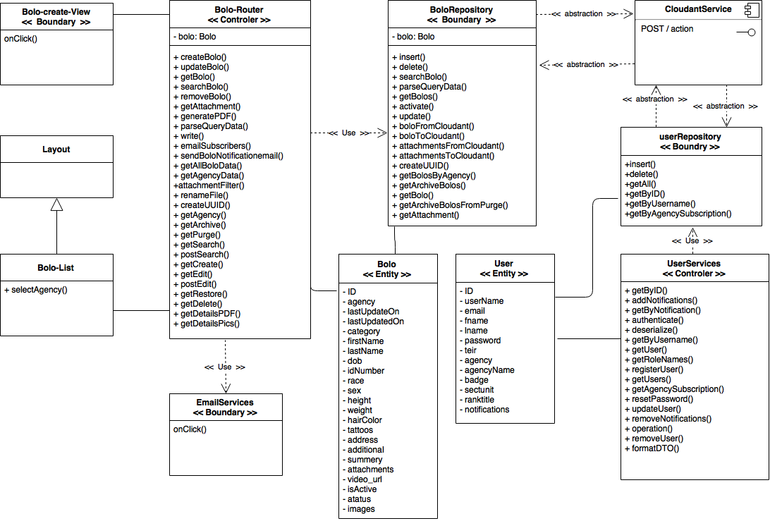

**User Story #892** Expire passwords in 90 days

* Figure sp1-2

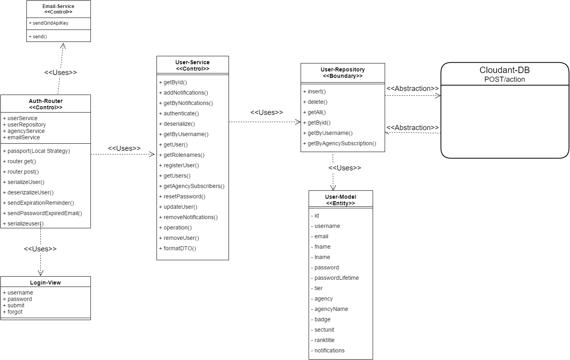

**User Story #882** Implement WildCard search field

* Figure sp1-3

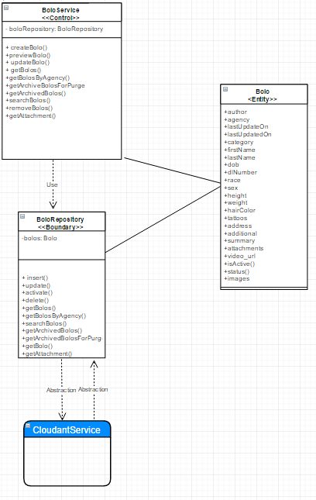

**User Story #888** Open PDF documents in new tab

* Figure sp1-4

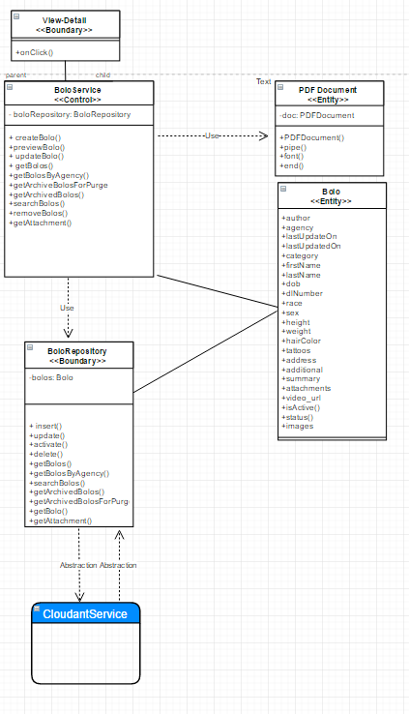

**User Story #894** Update all Pages to Bolo v5.0

* Figure sp1-5

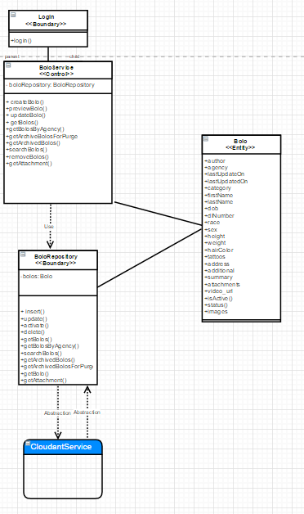

**User Story #895** Create template for Theft-Boat BOLO

* Figure sp1-6

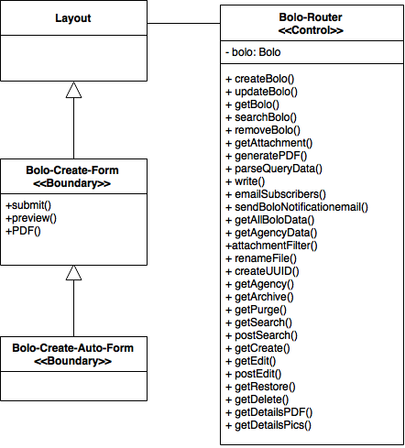

**User Story #881** Create template for Theft-Auto BOLO

* Figure sp1-7



### Sprint 2

(06/06/2016 - 06/19/2016)

**User Story #893** Authenticate password reset confirmation

* Figure sp2-1

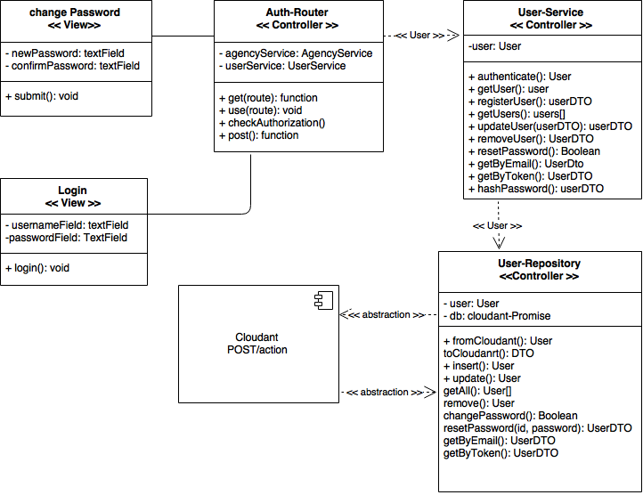

**User Story #919** Adjust timeout session

* Figure sp2-2

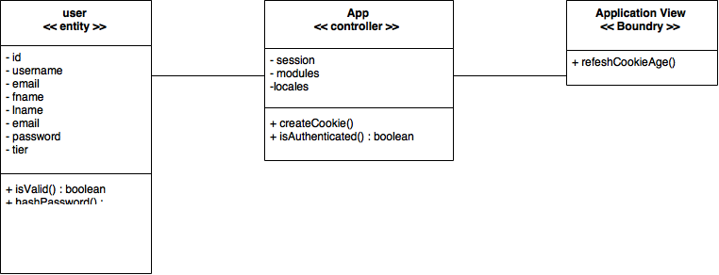

**User Story #930** Send email notification after password has been reset

* Figure sp2-3



**User Story #879** Confirm BOLO via email after creation

* Figure sp2-4



**User Story #891** Prevent password from displaying in url

* Figure sp2-5

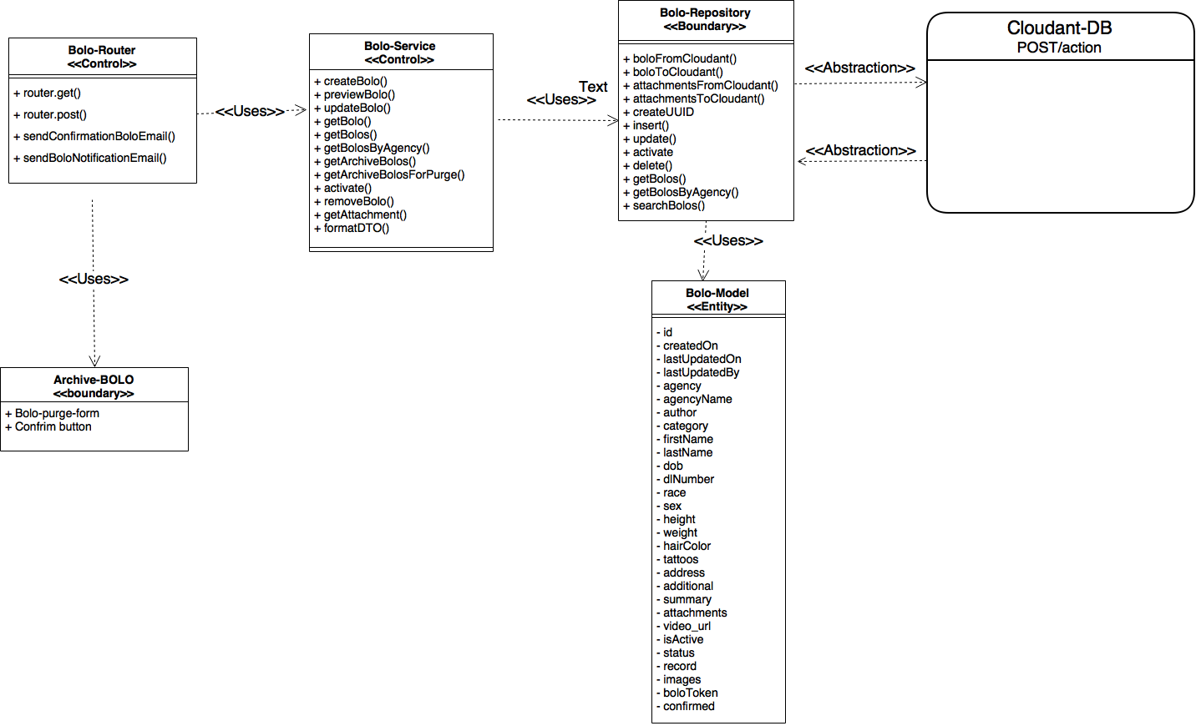

**User Story #880** Send feed of BOLOs as JSON documents

* Figure sp2-6

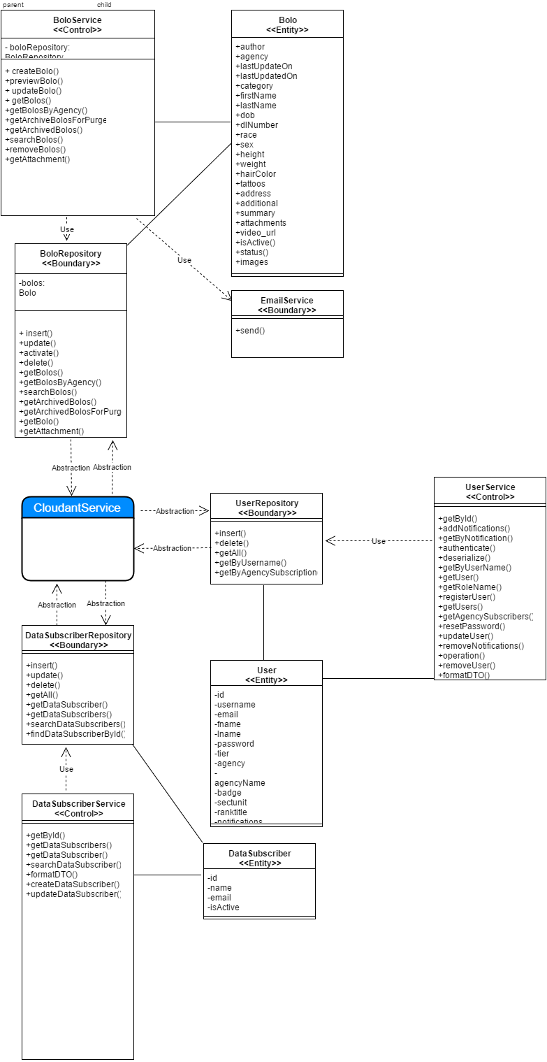

**User Story #920** Compress images upon upload

* Figure sp2-7

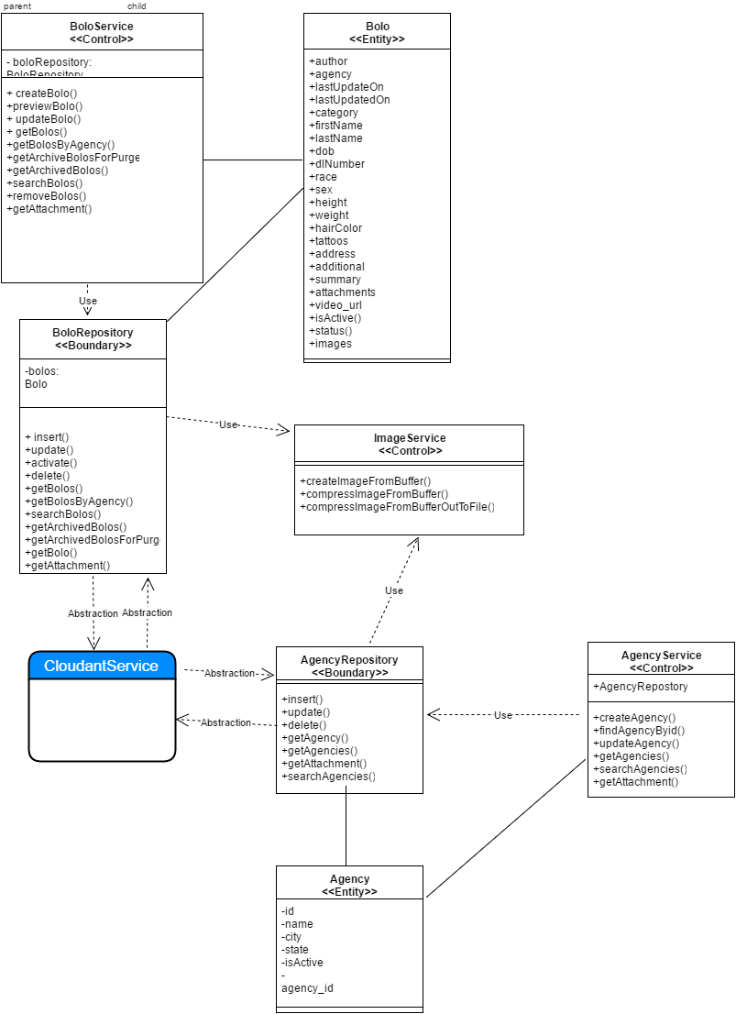

**User Story #896** Create specific Bolo for Theft-Auto

* Figure sp2-8

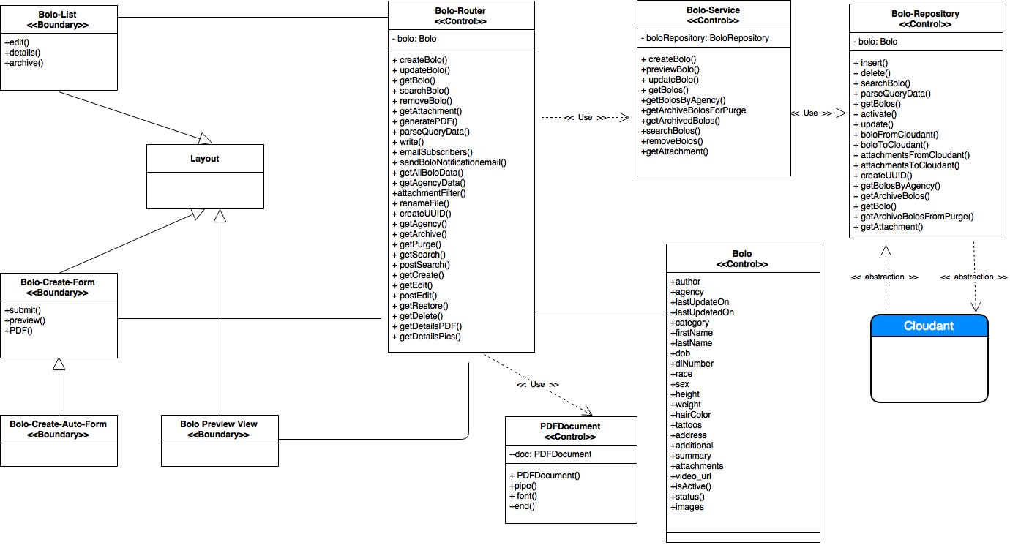

**User Story #932** View Bolo Details for Theft-Auto

* Figure sp2-9

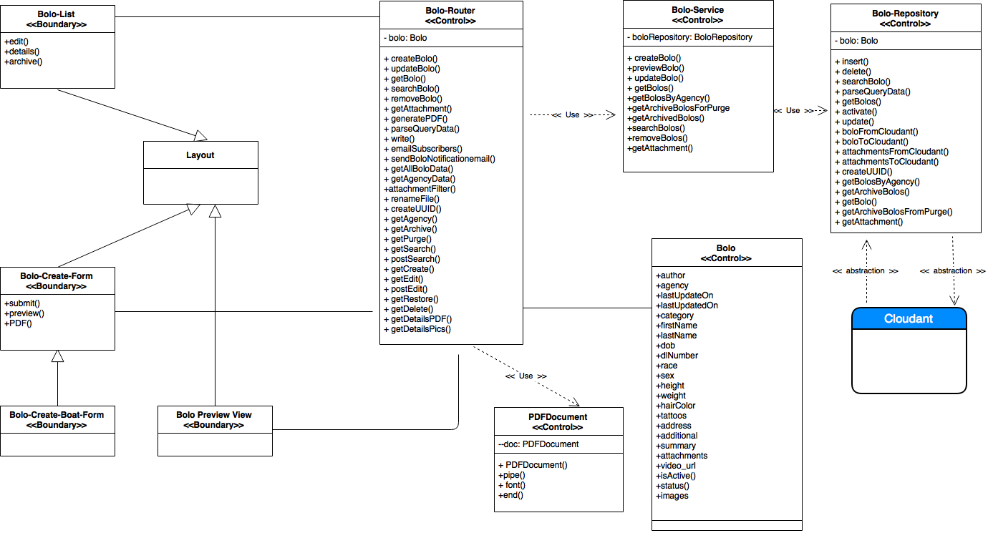

**User Story #933** Edit bolo for Theft-Auto

* Figure sp2-10

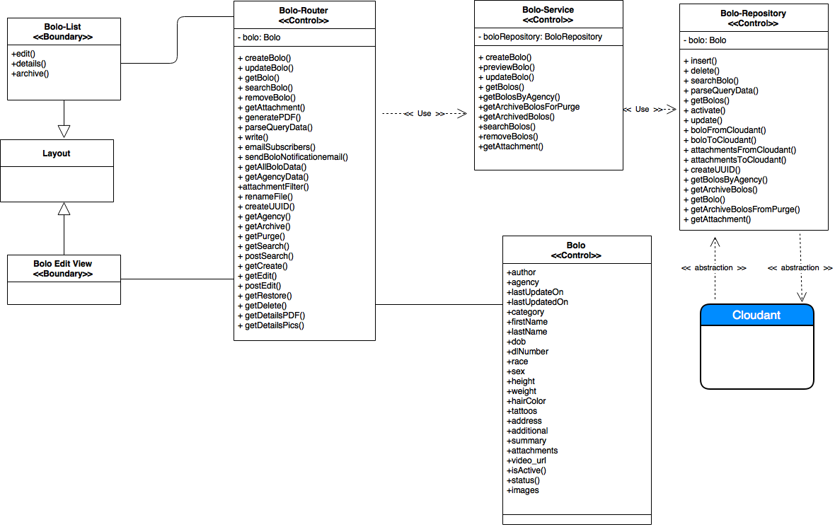

**User Story #936** Create specific Bolo for Theft-Boat

* Figure sp2-11



**User Story #937** View Bolo Details for Theft-Boat

* Figure sp2-12

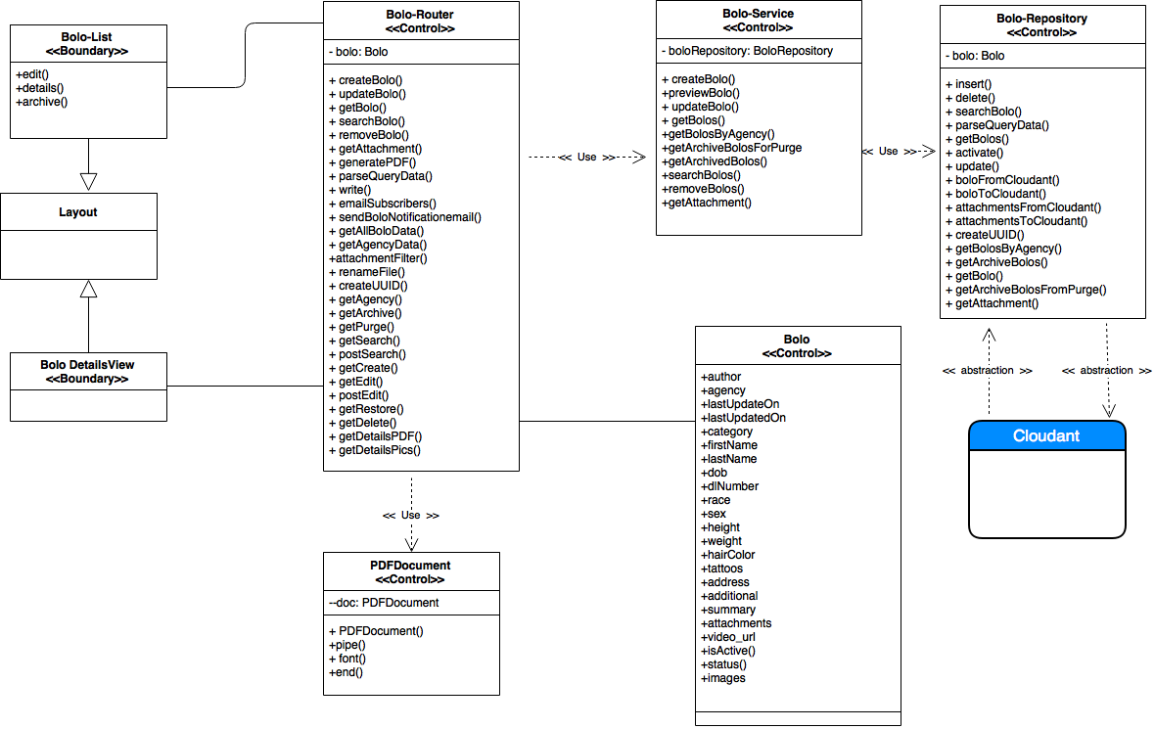

**User Story #938** Edit Bolo for Theft-Boat

* Figure sp2-13



### Sprint 3

(06/20/2016 – 07/03/2016)

**User Story #934** Remove empty fields from PDF bolo for display

* Figure sp3-1



**User Story #935** Add drop down menu for links such as settings, user guide, logout and others to be added at a later time

* No diagrams

**User Story #1006** Add a user guide page for each tier

* Figure sp3-2

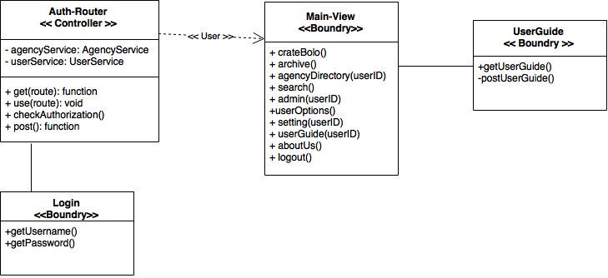

**User Story #1046** Add an about us page

* Figure sp3-3

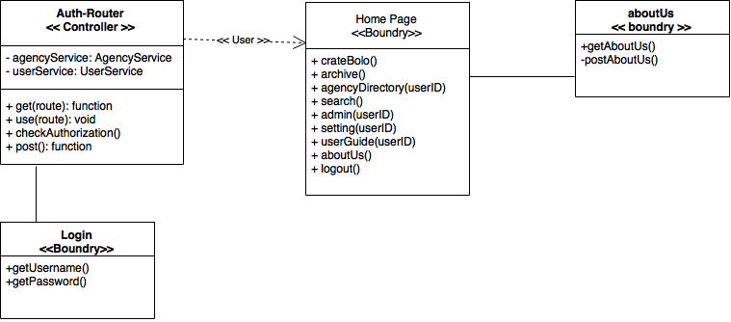

**User Story #1011** Filter BOLOS by author and reformat the dropdown

* Figure sp3-4

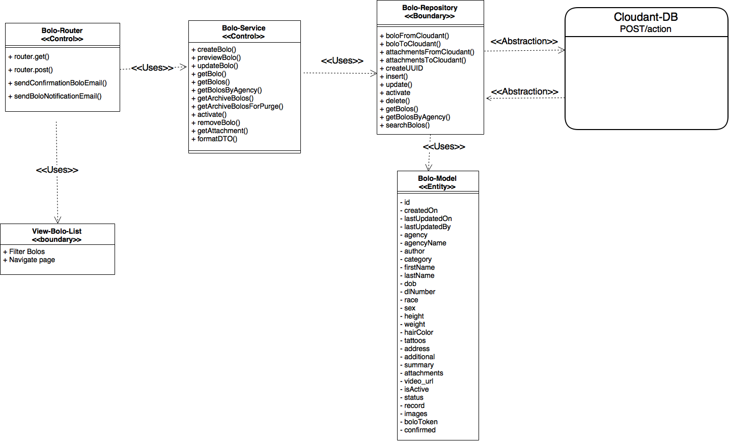

**User Story #1009** Automate database creation via scripts

* No diagrams

**User Story #1008** Prevent user email domain from being something other than their agency's domain

* Figure sp3-5

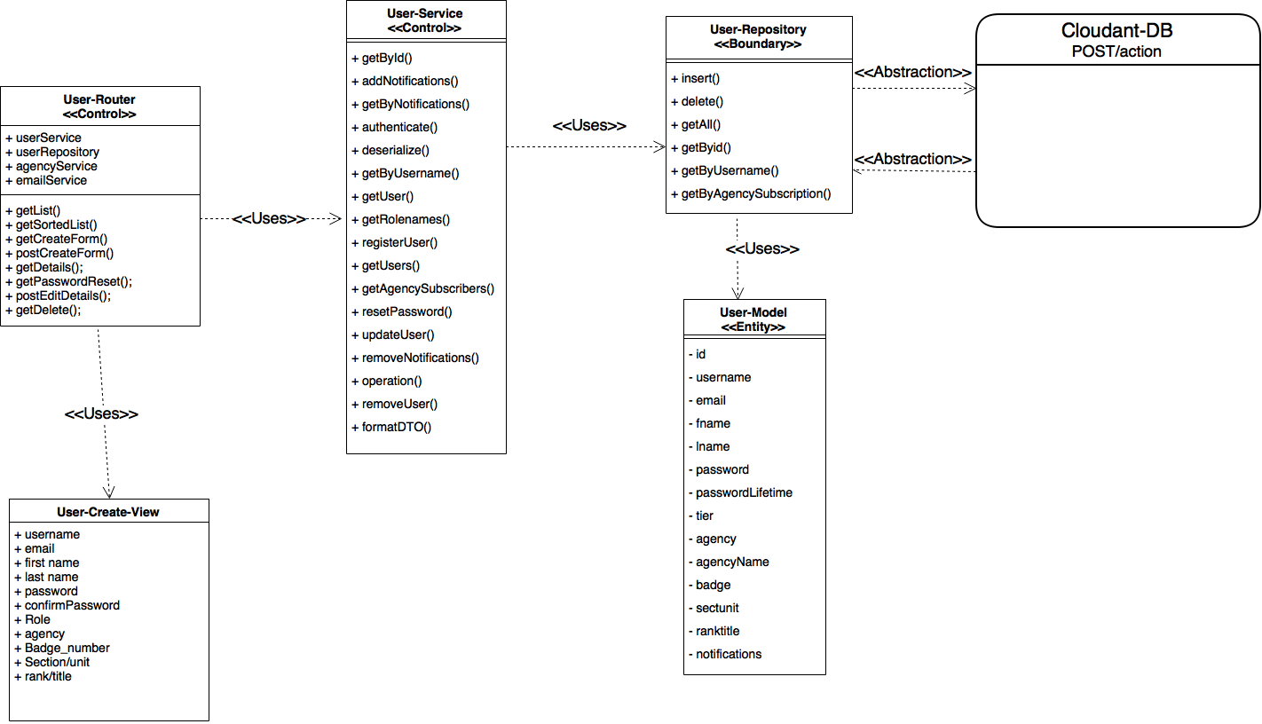

**User Story #889** Change bolo email to no-reply

* No diagrams

**User Story #931** Create script to reset DB Schema

* Figure sp3-6

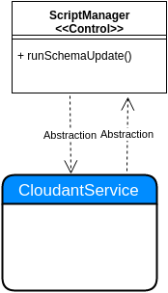

**User Story #985** Enhance ImageService

* No diagrams

**User Story #986** Unsubscribe from BOLO emails

* Figure sp3-7

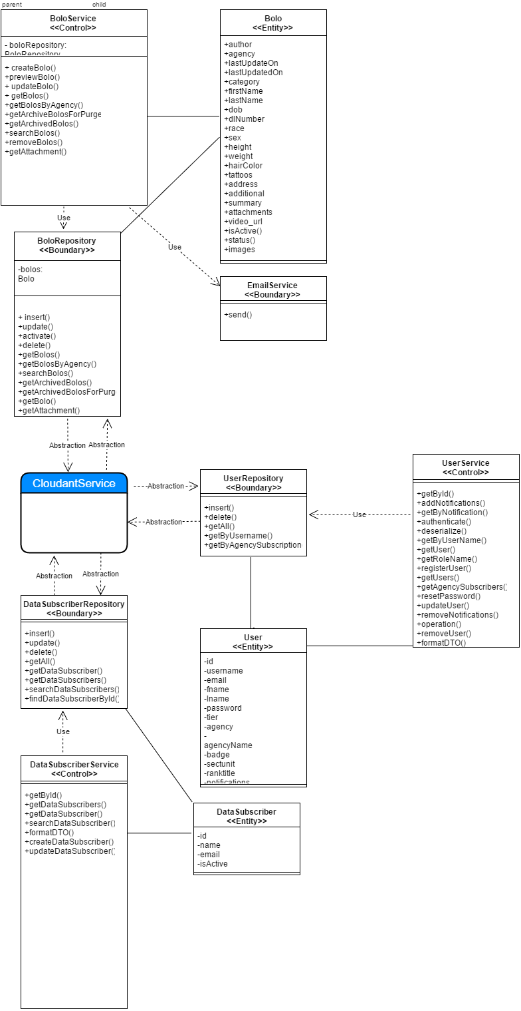

**User Story #1001** Implement routes with authentication

* Figure sp3-8

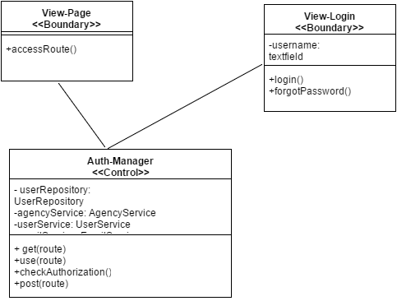

**User Story #1007** Redesign Filter by Agencies in Home page

* Figure sp3-9

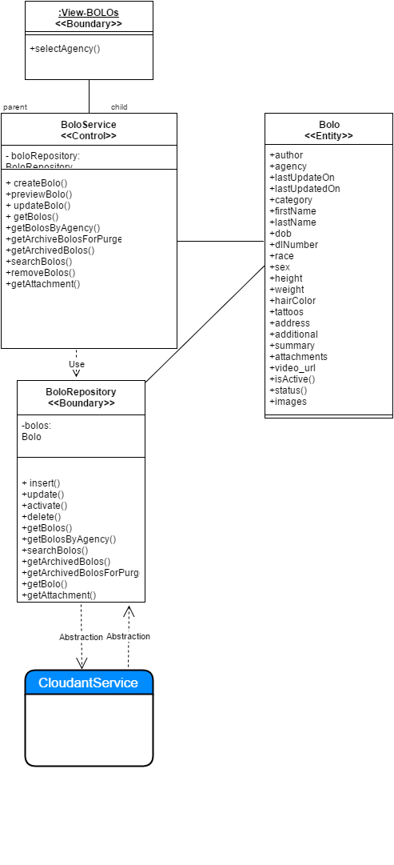

**User Story #1033** Fix several bugs

* No diagrams

**User Story #990** Redesign and add validations for General Bolo Template

* Figure sp3-10

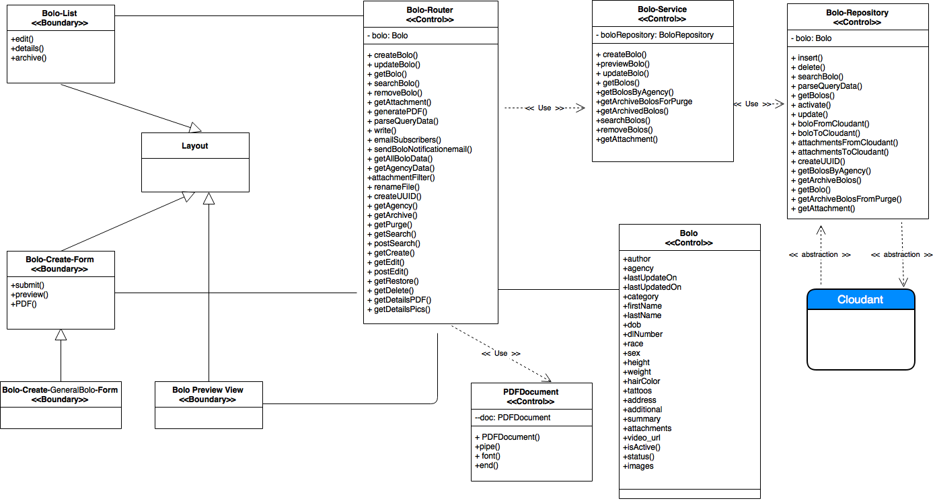

**User Story #981** Implement Search for New Bolo Templates

* Figure sp3-11

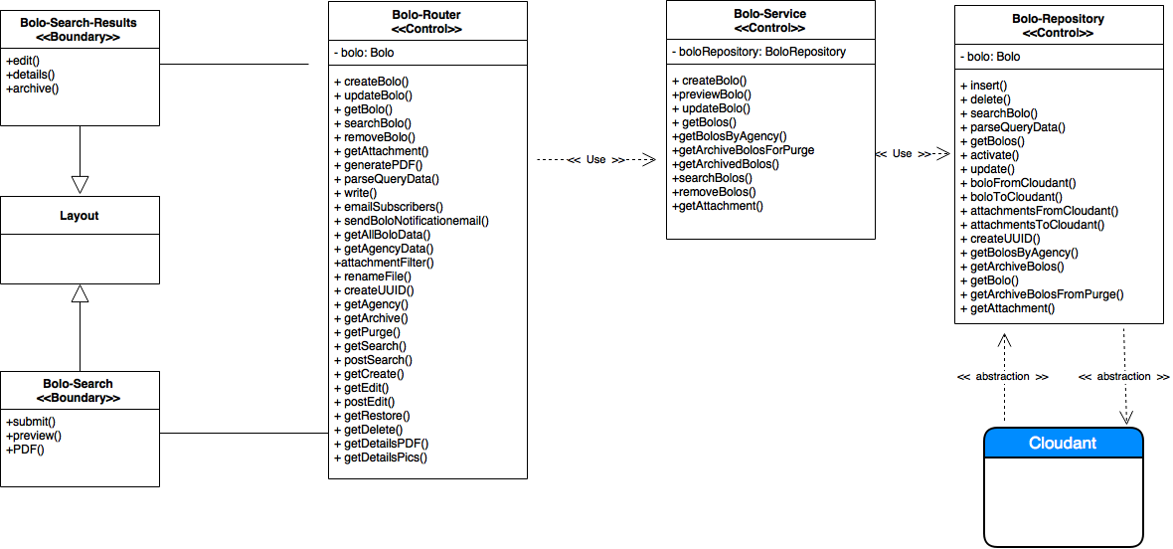

**User Story #991** Redesign and add validations for Theft Auto Template

* Figure sp3-12



**User Story #992** Redesign and add validations for Theft Boat Template

* Figure sp3-13



**User Story #1030** Delete the Ongoing Status from Bolo

* No diagrams

### Sprint 4

(07/04/2016 – 07/17/2016)

**User Story #1010** Create a front end page for root to customize system settings

* Figure sp4-1

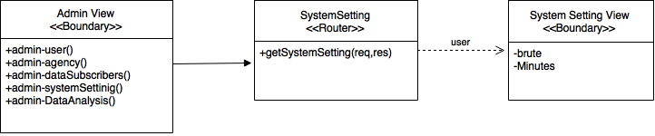

**User Story #1096** Implement a link to download a PDF of the user's guide based on user's tier

* Figure sp4-2

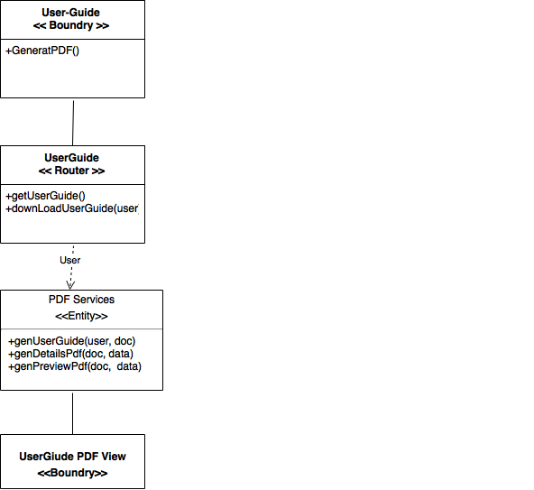

**User Story #1097** Implement an About Miami Dade County Association of Chief of Police (MDCACP) page

* Figure sp4-3

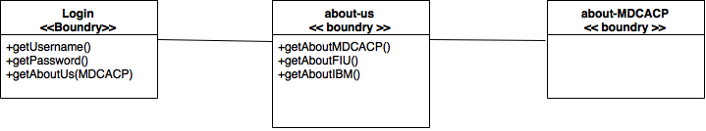

**User Story #1098** Create an about us page for Florida International University's (FIU) contribution

* Figure sp4-4

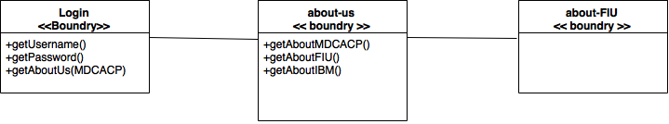

**User Story #1099** Create an about us page for IBM's contribution

* Figure sp4-5

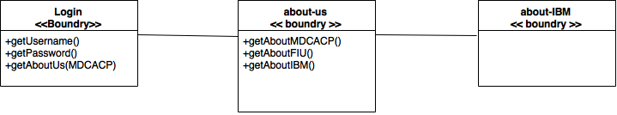

**User Story #1100** Create a page where root can retrieve data for analysis

* Figure sp4-6

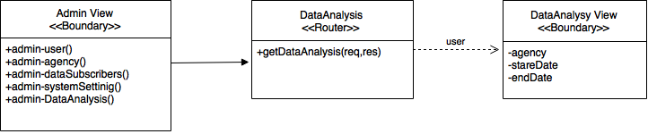

**User Story #1014** Lock user account after 10 incorrect login attempts

* Figure sp4-7

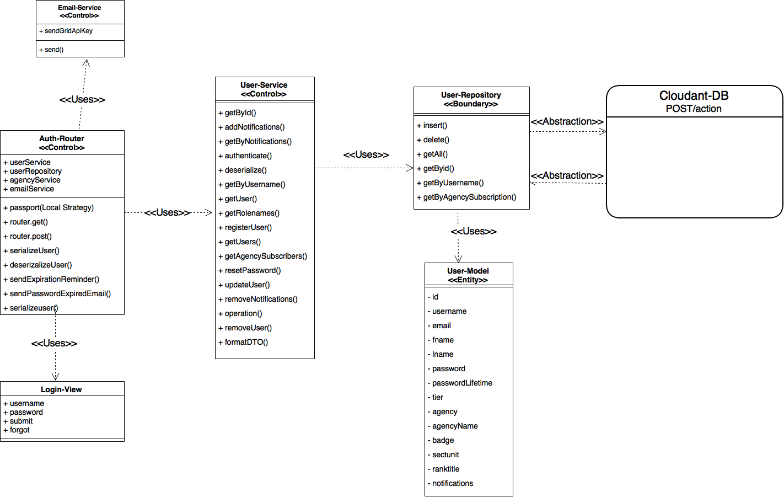

**User Story #1038** Filter by multiple agencies in bolo list page

* Figure sp4-8

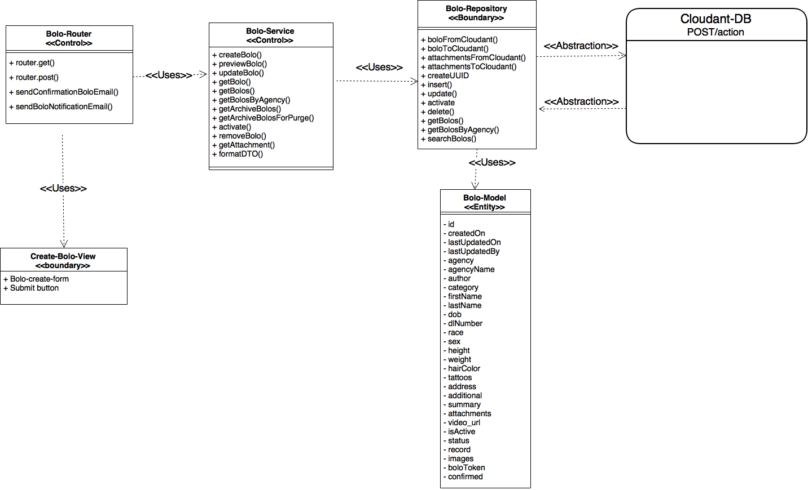

**User Story #890** Implement Watermarks for agencies

* Figure sp4-9

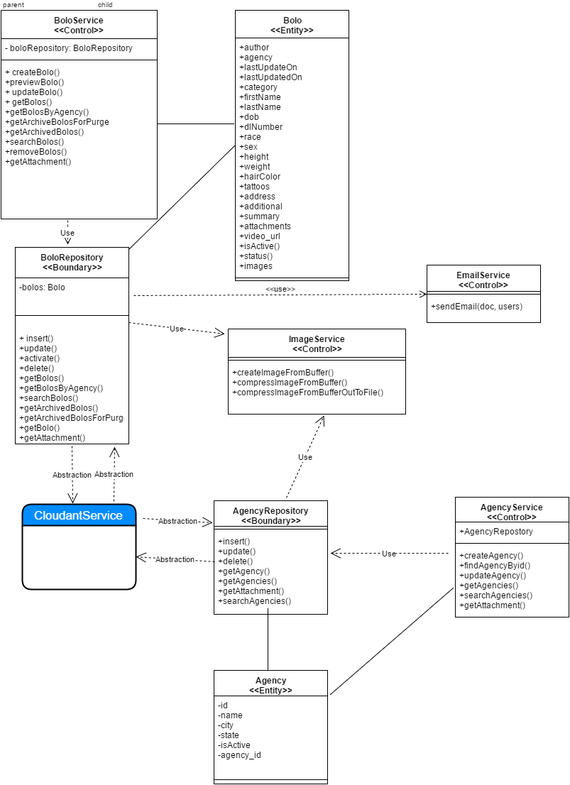

**User Story #1037** Allow Tier 3 users to control Agency settings

* Figure sp4-10

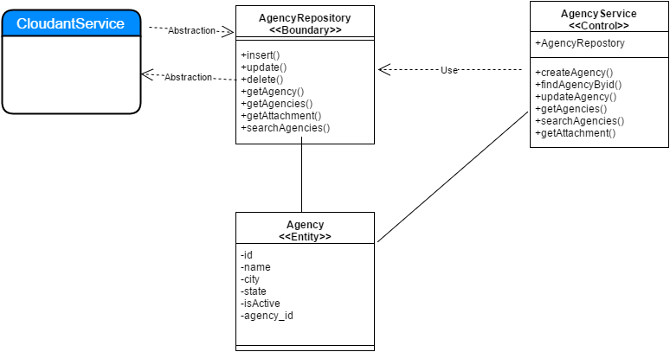

**User Story #1081** Prevent Tier 3 users from granting Root access

* Figure sp4-11

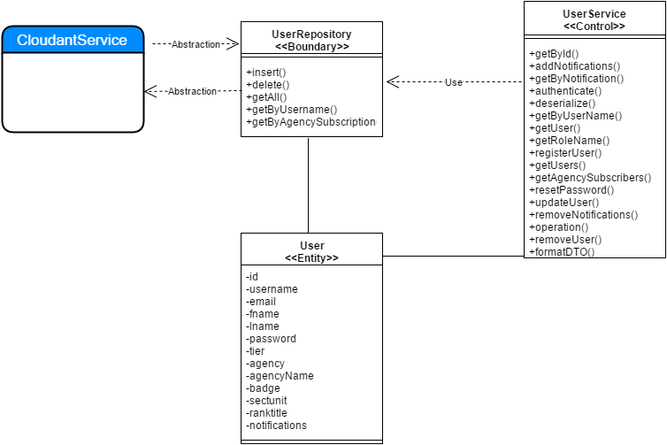

**User Story #1083** Prevent Officers from previewing PDFs before confirmation

* Figure sp4-12

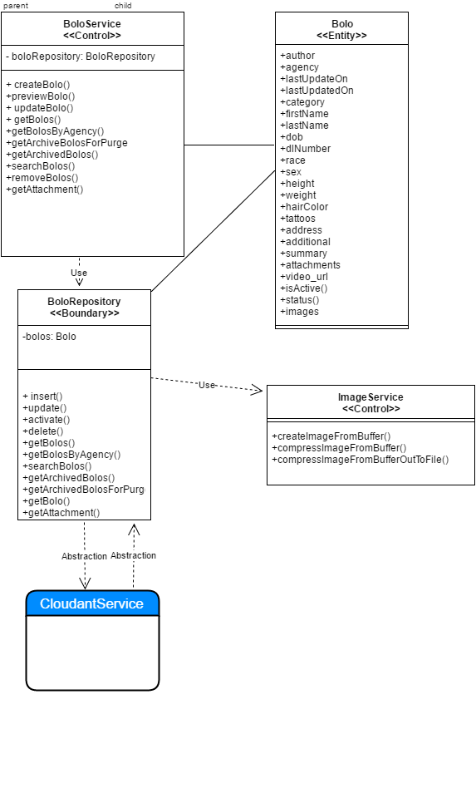

**User Story #1087** Implement time retrieval points for data analysis for Create Bolo (General - Auto - Boat)

* Figure sp4-13

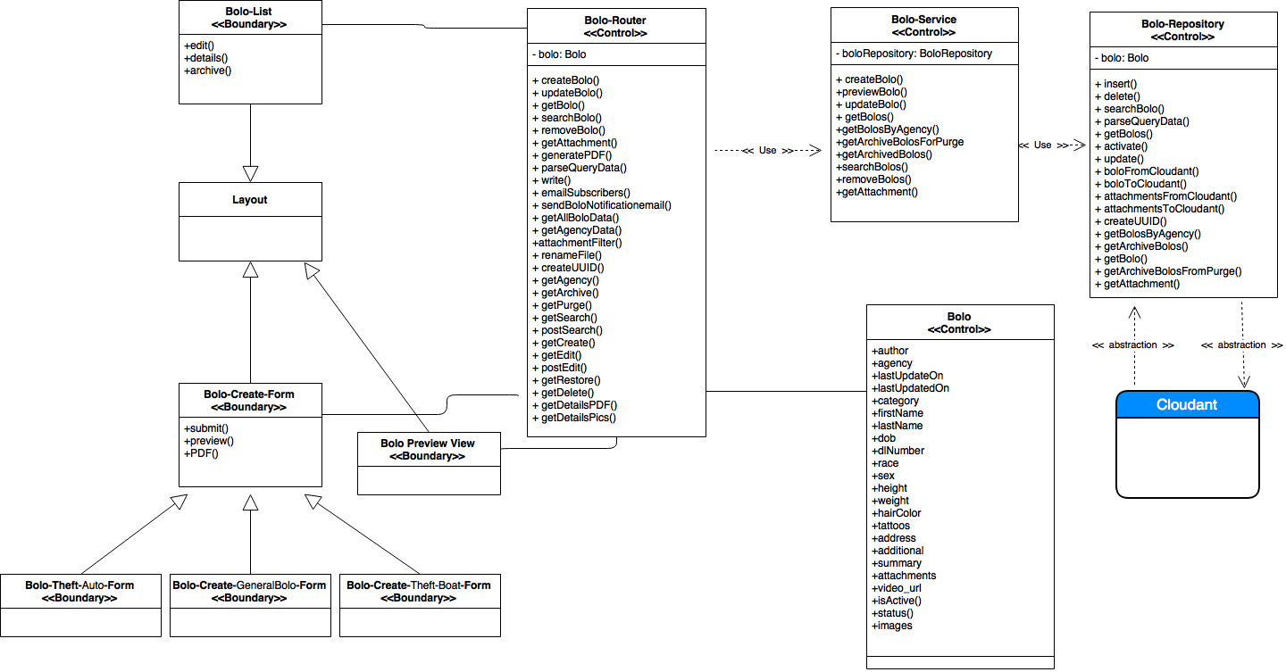

**User Story #1119** Implement time retrieval points for data analysis for Edit Bolo (General - Auto - Boat)

* Figure sp4-14

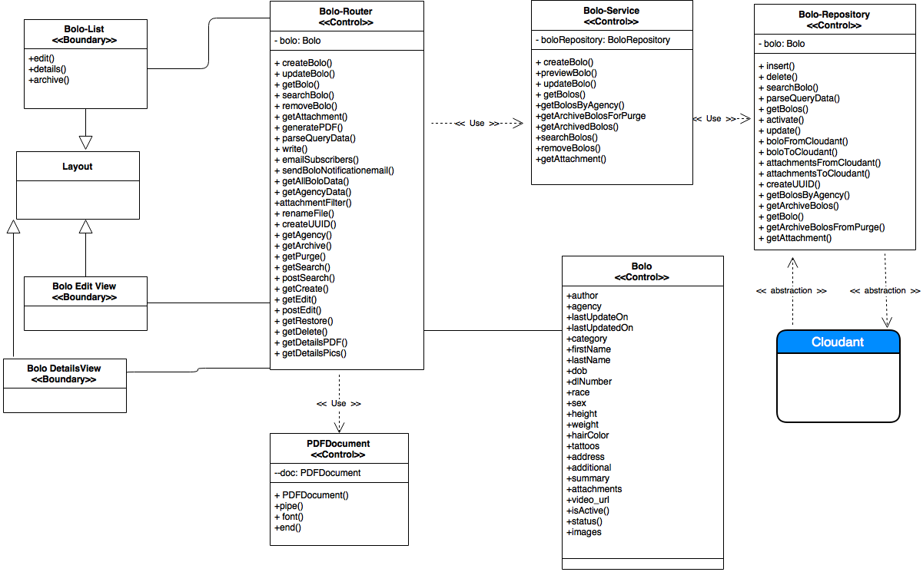

**User Story #1088** Deactivate and Activate User Accounts from Root and Administrator

* Figure sp4-15

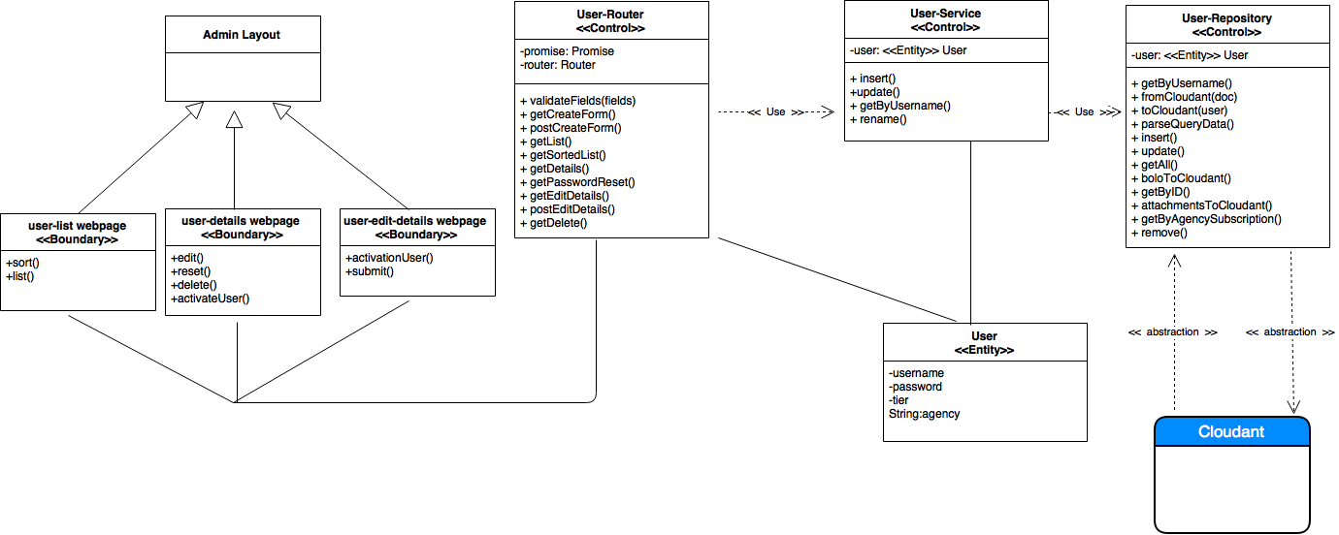

### Sprint 5

(07/18/2016 – 07/31/2016)

**User Story #1094** Implement confirmation of BOLO updates

* Figure sp5-1

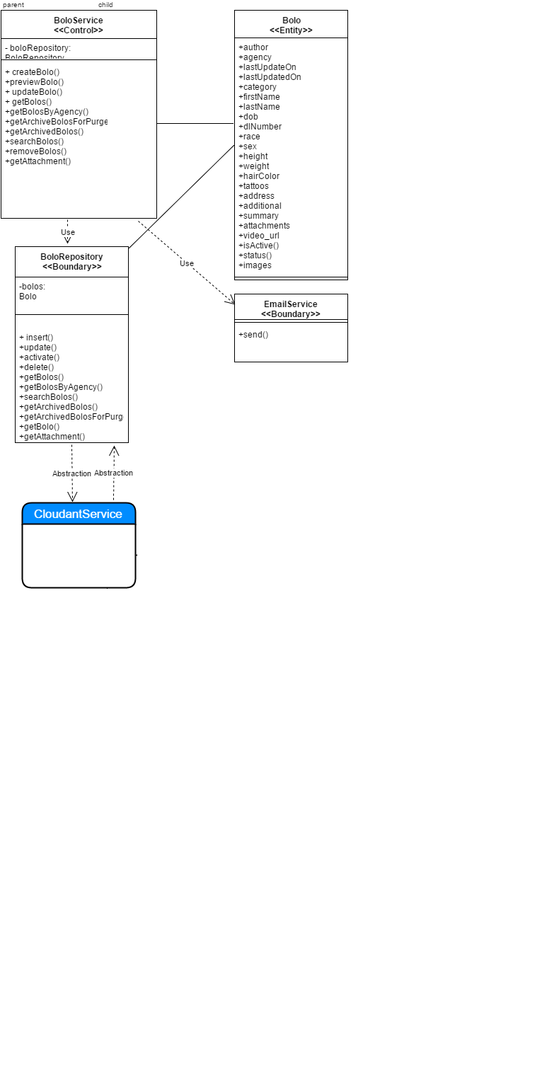

**User Story #1155** Change PDF labels

* Figure sp5-2



**User Story #1086** Change Interactive Edit Menu to Static Label for Status. Keep Data Field Contents After Validations When a New User and a New Agency is Created. Add New Aesthetic for Bolo Buttons

* No diagrams

**User Story #1089** Show Edit and Archive only for Root and Administrators and Only View for Users. Create the functionality to go back for Details for Bolos (General, Auto and Boat). Create the ability for view a Bolo when it is Archived, and show edit and restore for Root

* No diagrams

**User Story #1163** Connect system setting page to backend

* No diagrams

**User Story #1164** connect data analysis page to backend

* No diagrams

### Dynamic UML Diagrams

### Sprint 1

(05/23/2016 - 06/05/2016)

**User Story #887** Remove unnecessary data from email alert

* Figure sp1-1

[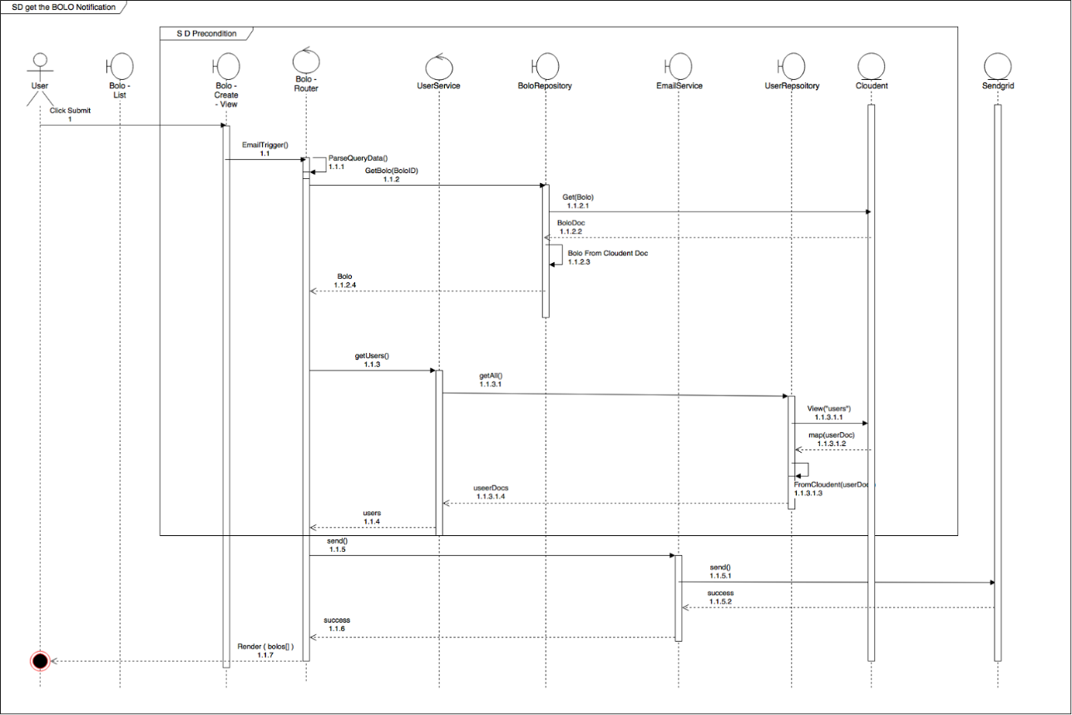](https://drive.draw.io/#G0Bw0gfTN_oxKsamZUbnBRODhkYmc)

**User Story #892** Expire passwords in 90 days

* Figure sp1-2

[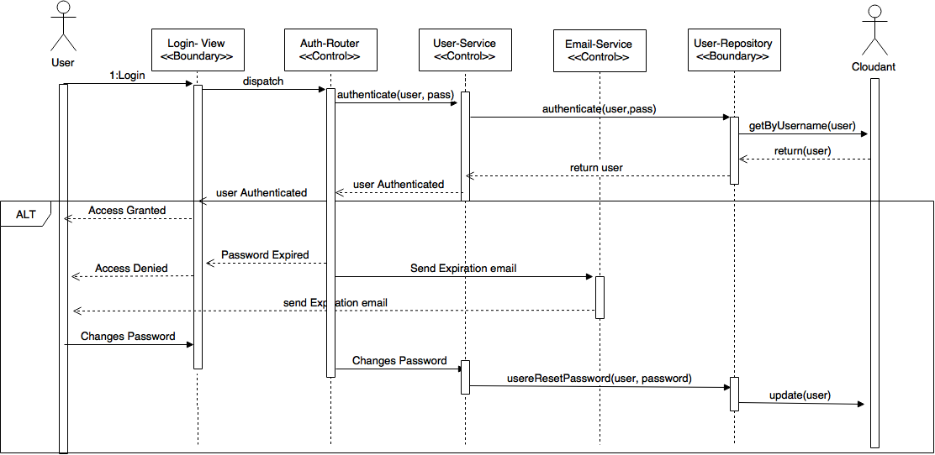](https://drive.draw.io/#G0Bz2XhRgCMcv3TGQ5bVlDenJoTnM)

**User Story #882** Implement WildCard search field

* Figure sp1-3

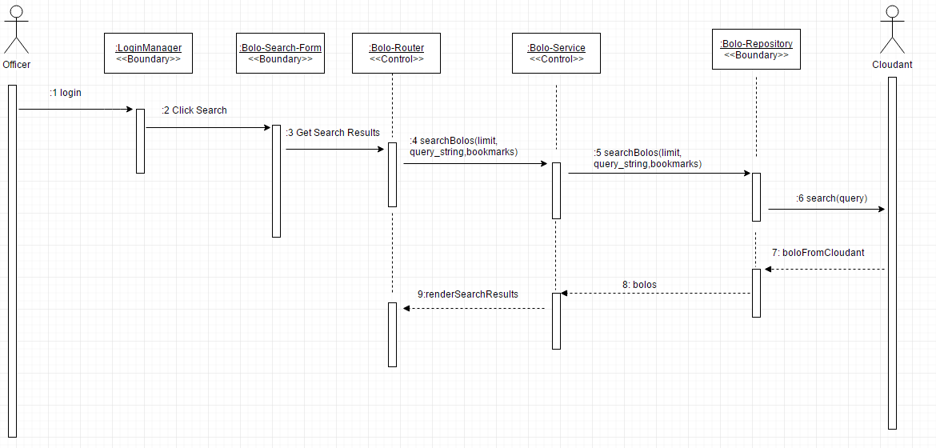

**User Story #888** Open PDF documents in new tab

* Figure sp1-4

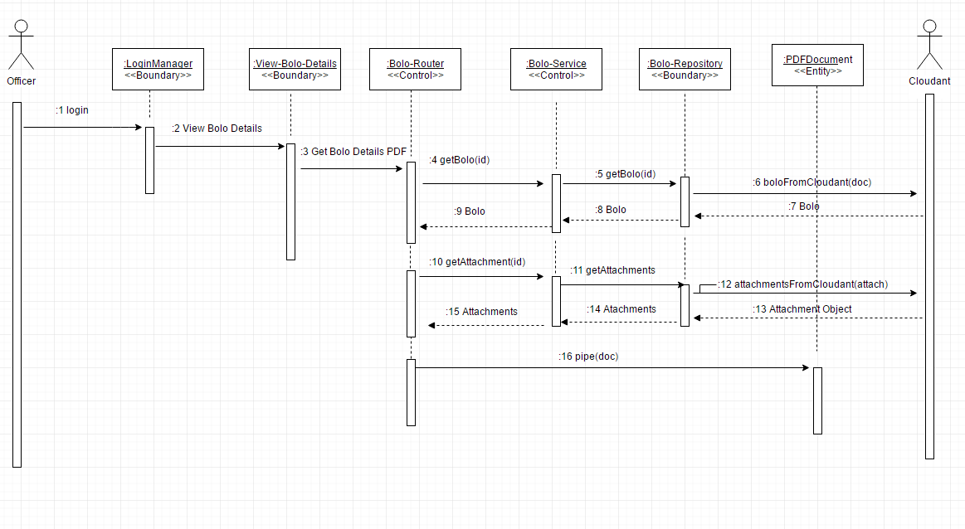

**User Story #894** Update all Pages to Bolo v5.0

* Figure sp1-5

[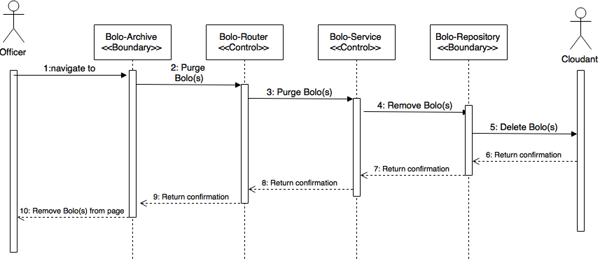](https://drive.draw.io/#G0Bz2XhRgCMcv3RWk3enpJWThtZ1k)

**User Story #895** Create template for Theft-Boat BOLO

* Figure sp1-6

[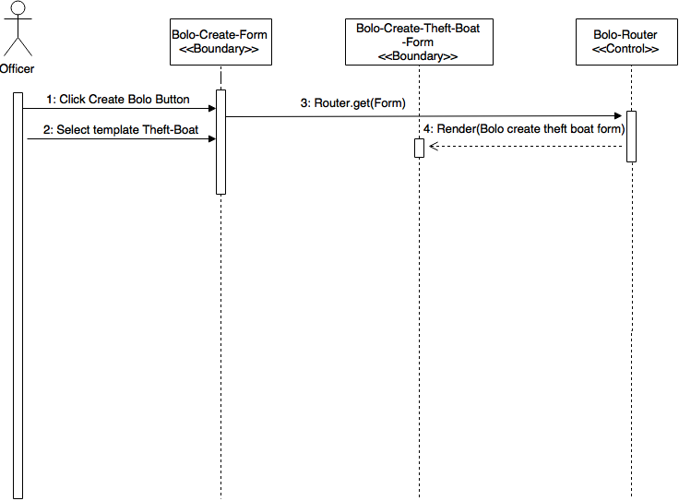](https://drive.draw.io/#G0B4S5V3PqnCmPX1BBR1VPdUFaNTg)

**User Story #881** Create template for Theft-Auto BOLO

* Figure sp1-7

[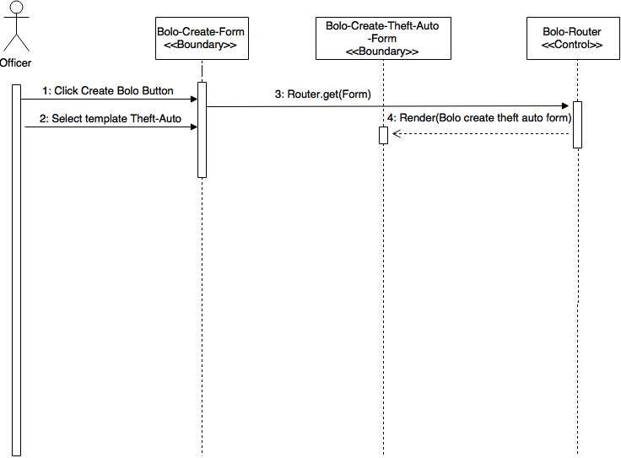](https://drive.draw.io/#G0B4S5V3PqnCmPS21UaWNDdnJmVmc)

### Sprint 2

(06/06/2016 - 06/19/2016)

**User Story #893** Authenticate password reset confirmation

* Figure sp2-1

[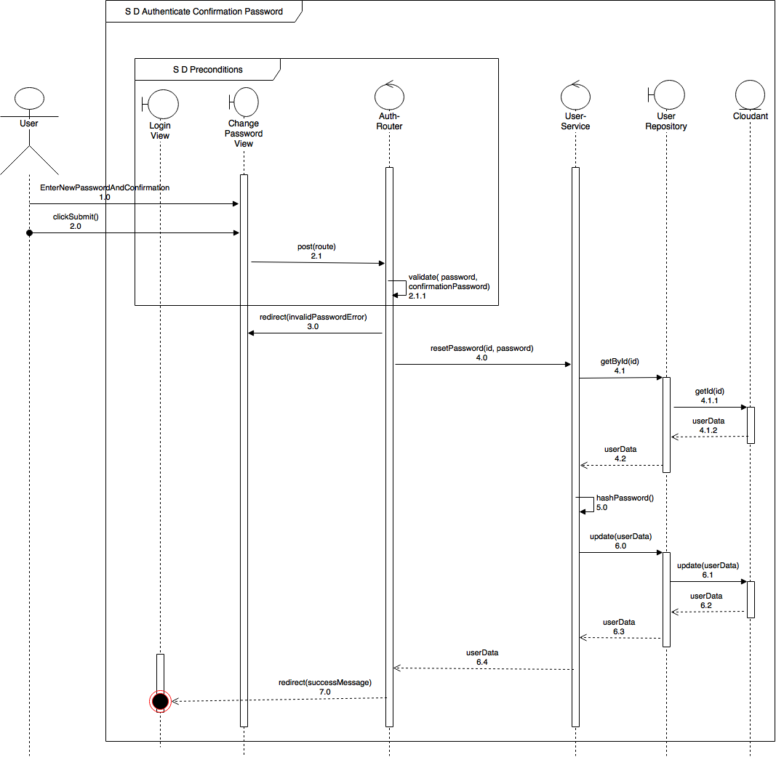](https://drive.draw.io/#G0Bw0gfTN_oxKsSjVfR1YwQUc2WTQ)

**User Story #919** Adjust timeout session

* Figure sp2-2

[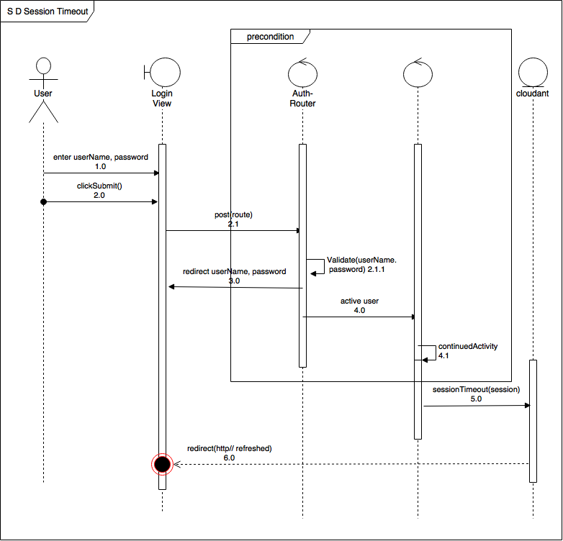](https://drive.draw.io/#G0Bw0gfTN_oxKsWEp6bGtsT3BFYkU)

**User Story #930** Send email notification after password has been reset

* Figure sp2-3

[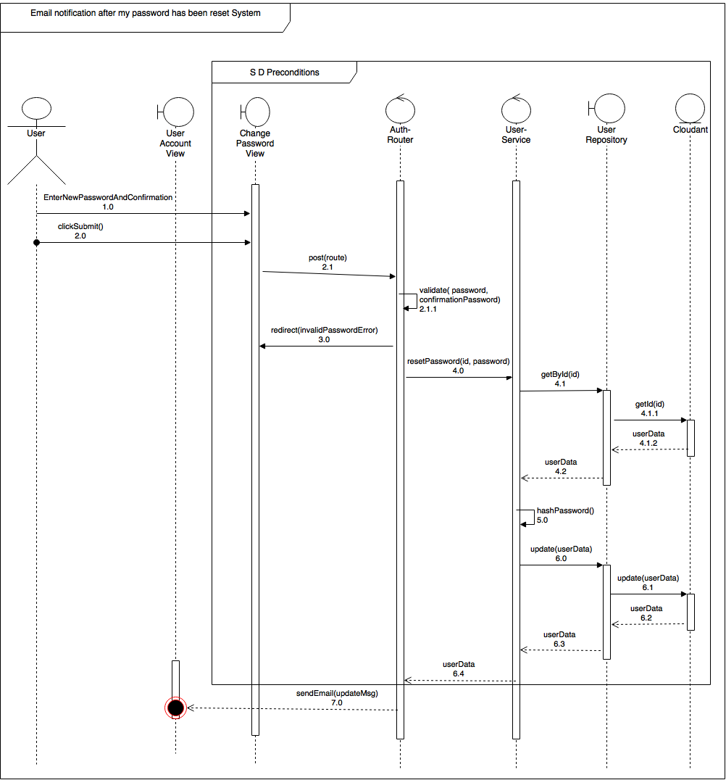](https://drive.draw.io/#G0Bw0gfTN_oxKsQ2p6VW8zSUthSEk)

**User Story #879** Confirm BOLO via email after creation

* Figure sp2-4

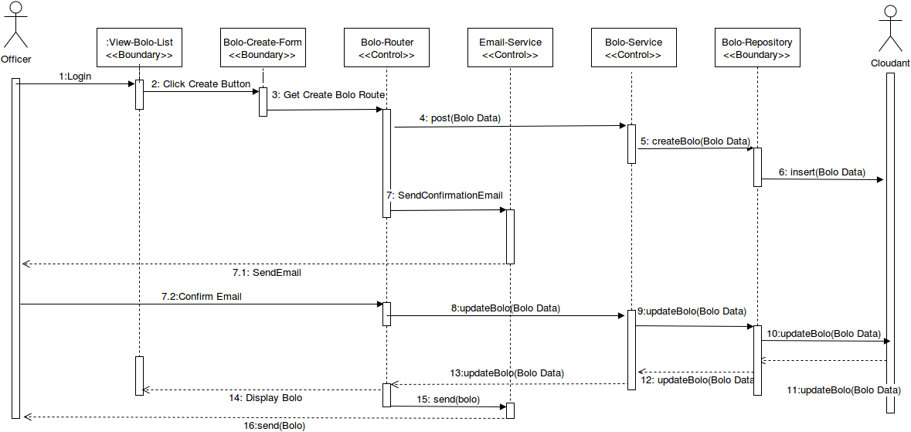

**User Story #891** Prevent password from displaying in url

* Figure sp2-5

[](https://drive.draw.io/#G0Bz2XhRgCMcv3RWk3enpJWThtZ1k)

**User Story #880** Send feed of BOLOs as JSON documents

* Figure sp2-6

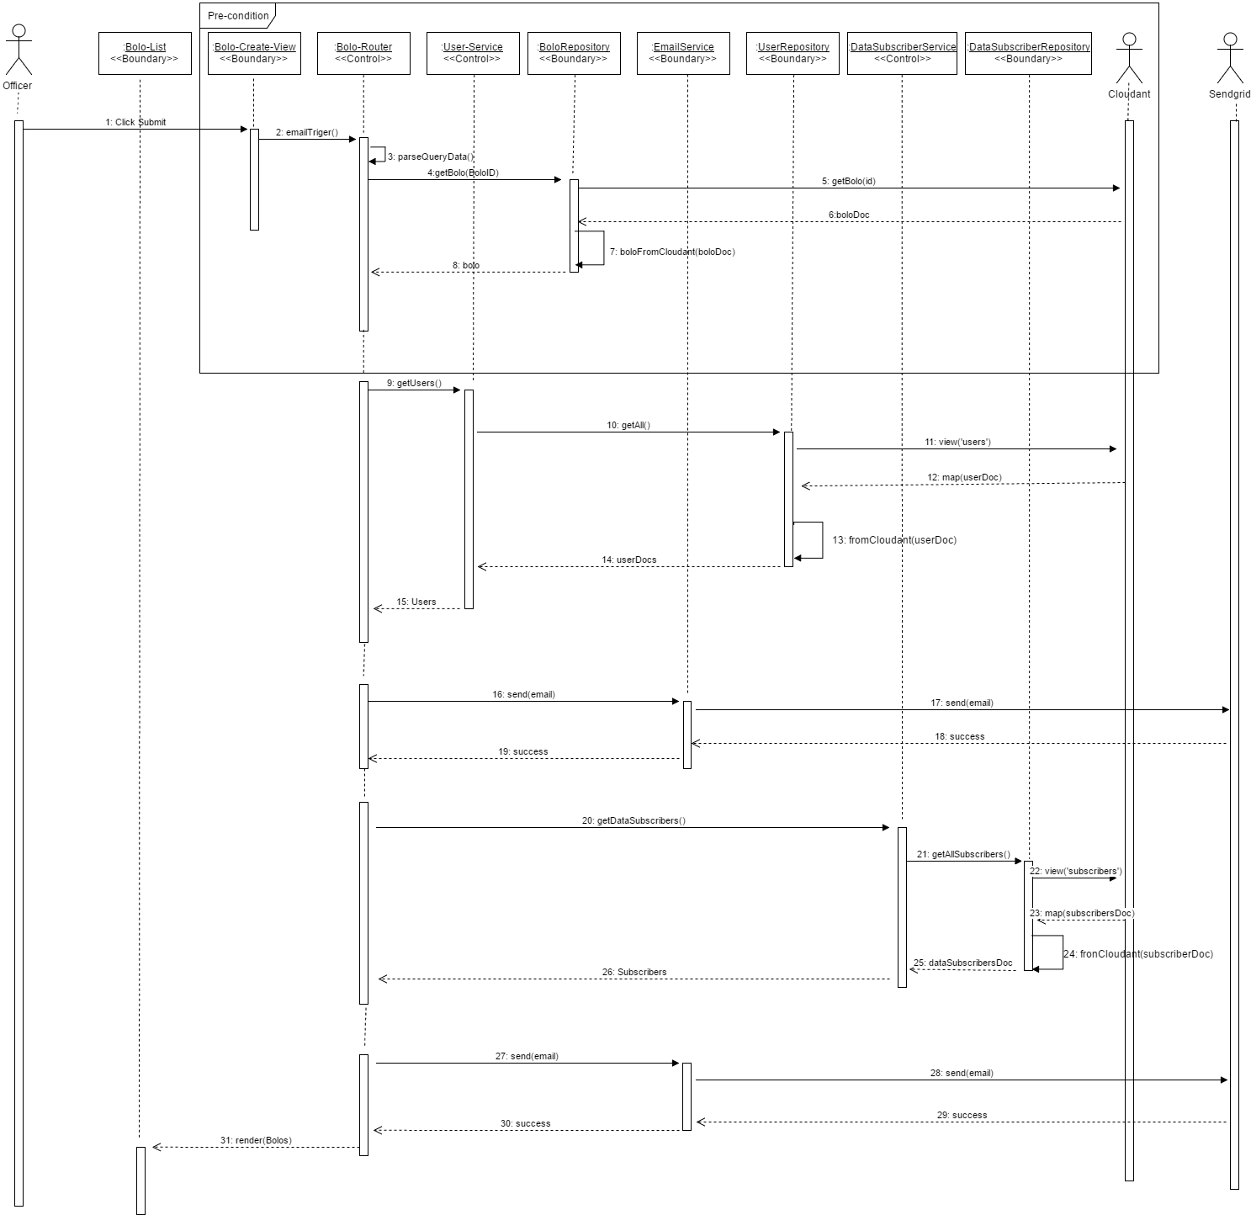

**User Story #920** Compress images upon upload

* Figure sp2-7

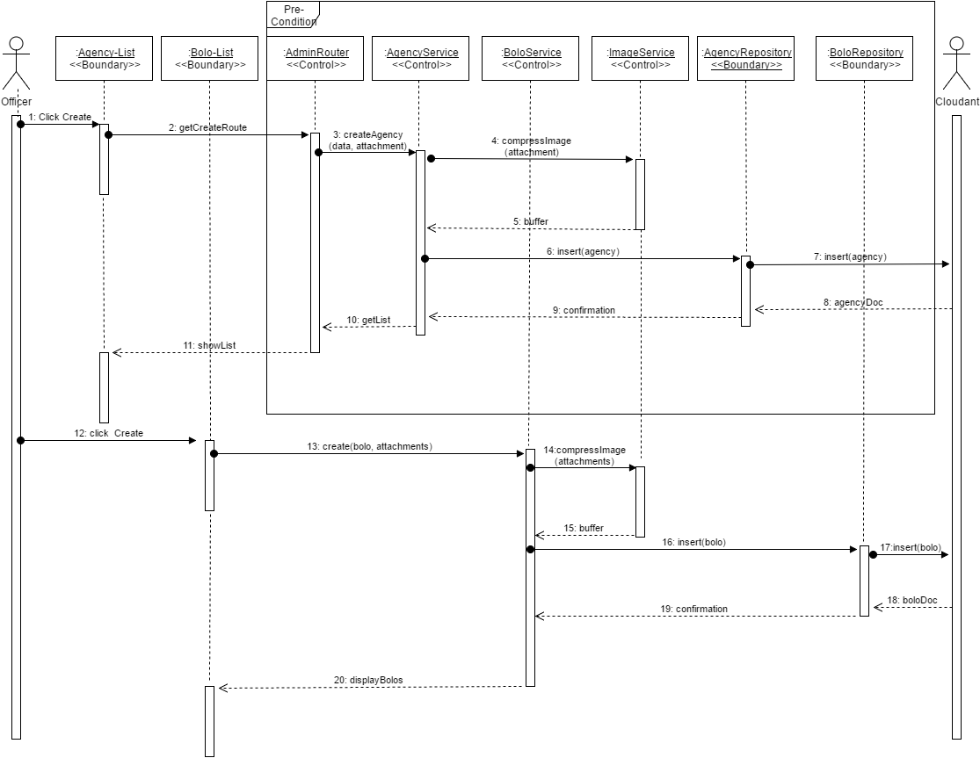

**User Story #896** Create specific Bolo for Theft-Auto

* Figure sp2-8

[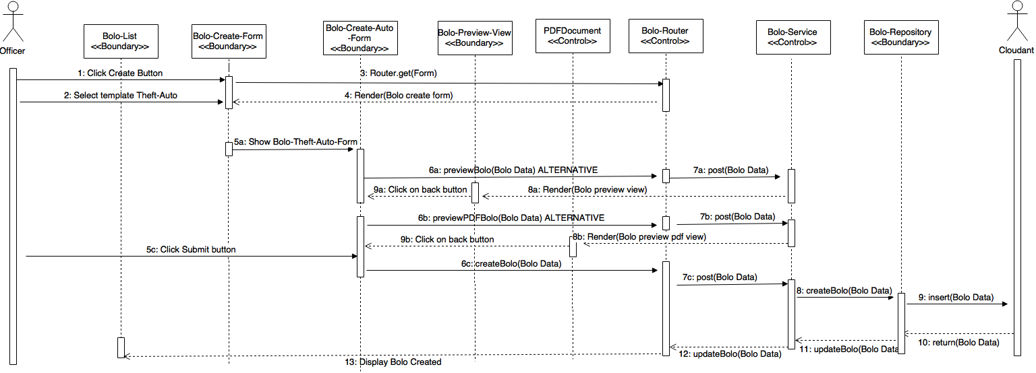](https://drive.draw.io/#G0B4S5V3PqnCmPUGlJZkd0enM1U2s)

**User Story #932** View Bolo Details for Theft-Auto

* Figure sp2-9

[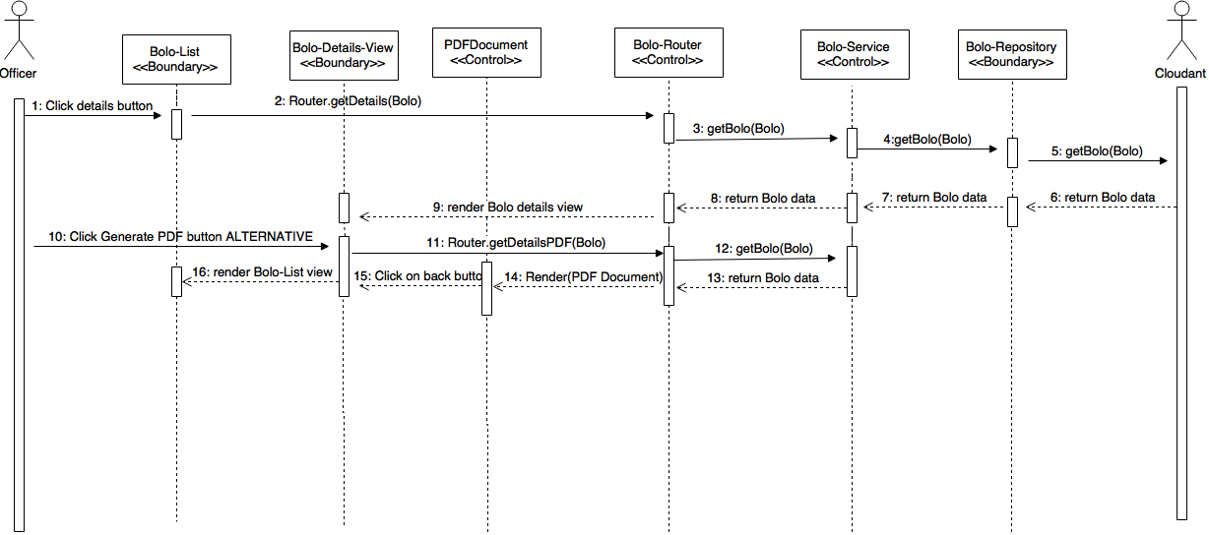](https://drive.draw.io/#G0B4S5V3PqnCmPV2gtd0NXcGFNX2M)

**User Story #933** Edit bolo for Theft-Auto

* Figure sp2-10

[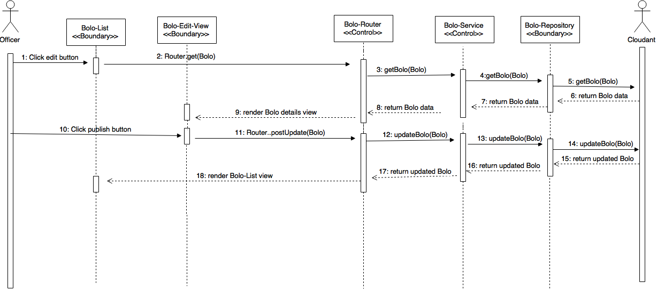](https://drive.draw.io/#G0B4S5V3PqnCmPZjNMc0xjczhfdEE)

**User Story #936** Create specific Bolo for Theft-Boat

* Figure sp2-11

[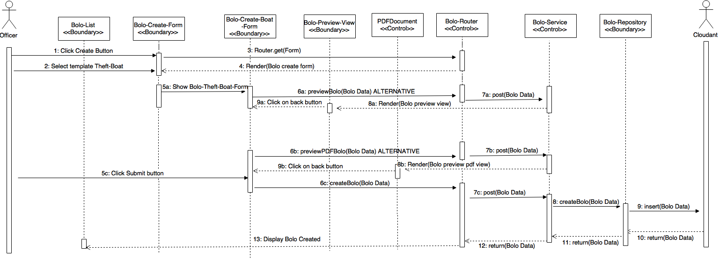](https://drive.draw.io/#G0B4S5V3PqnCmPU1gtYzcwRzR4Ulk)

**User Story #937** View Bolo Details for Theft-Boat

* Figure sp2-12

[](https://drive.draw.io/#G0B4S5V3PqnCmPanJZaXphVGtFc2c)

**User Story #938** Edit Bolo for Theft-Boat

* Figure sp2-13

[](https://drive.draw.io/#G0B4S5V3PqnCmPM1h6UXJsbjZlaE0)

### Sprint 3

(06/20/2016 – 07/03/2016)

**User Story #934** Remove empty fields from PDF bolo for display

* Figure sp3-1

[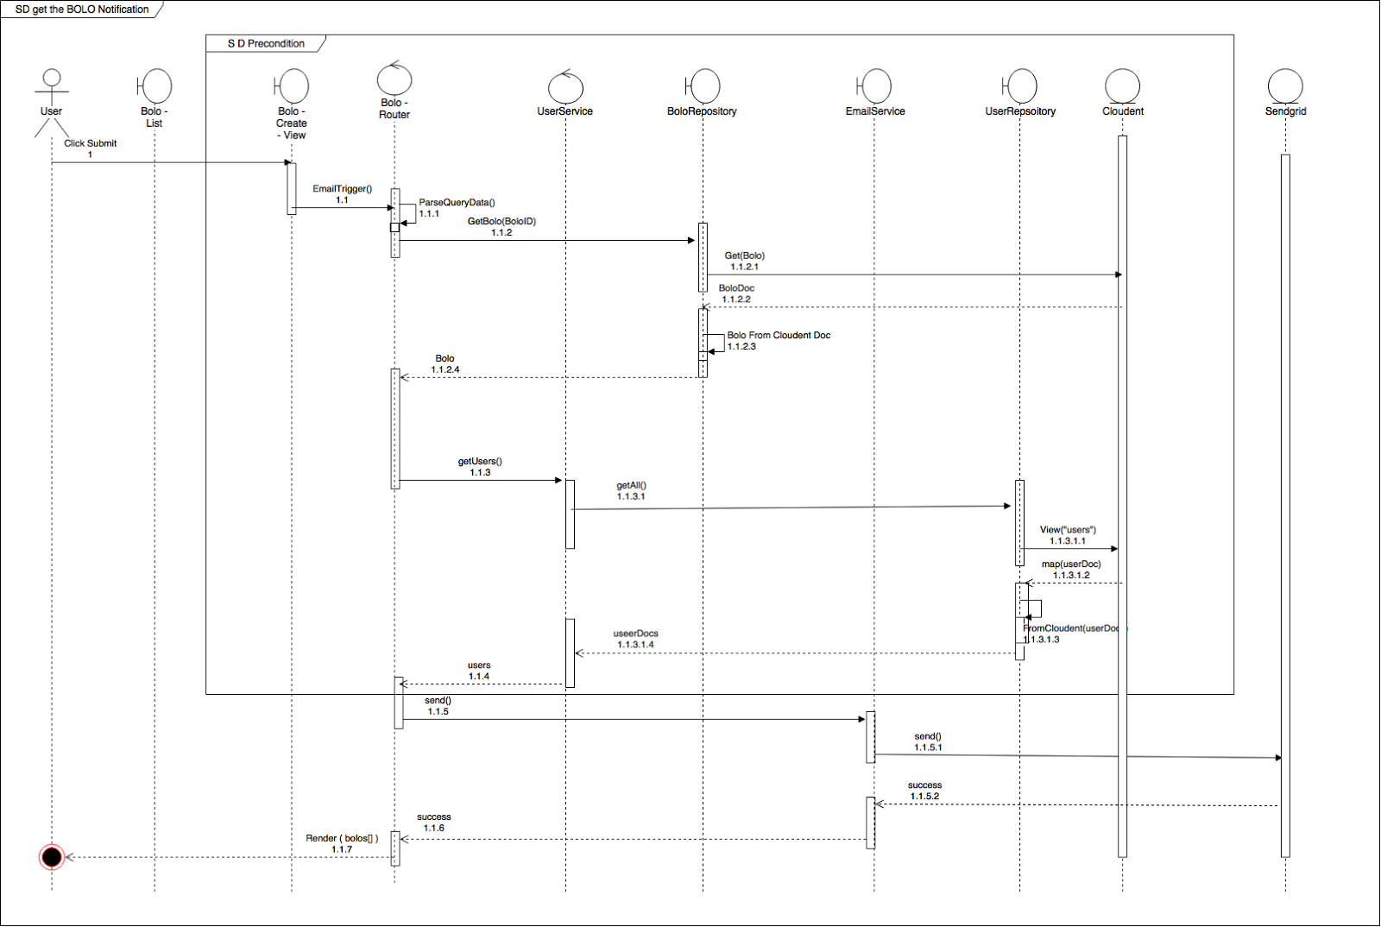](https://drive.draw.io/#G0Bw0gfTN_oxKsdzFhSHQxVF9pSWc)

**User Story #935** Add drop down menu for links such as settings, user guide, logout and others to be added at a later time

* No diagrams

**User Story #1006** Add a user guide page for each tier

* Figure sp3-2

[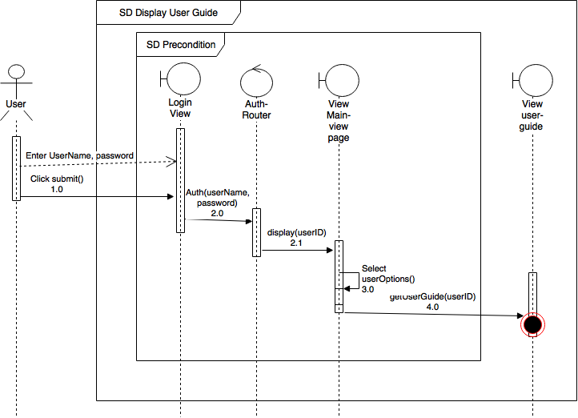](https://drive.draw.io/#G0Bw0gfTN_oxKsbllQbFh0SnoyMVU)

**User Story #1046** Add an about us page

* Figure sp3-3

[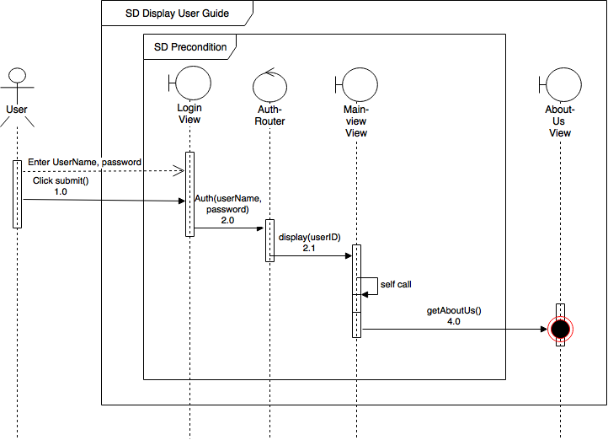](https://drive.draw.io/#G0Bw0gfTN_oxKsNkVWNXY5UWN1a0E)

**User Story #1011** Filter BOLOS by author and reformat the dropdown

* Figure sp3-4

[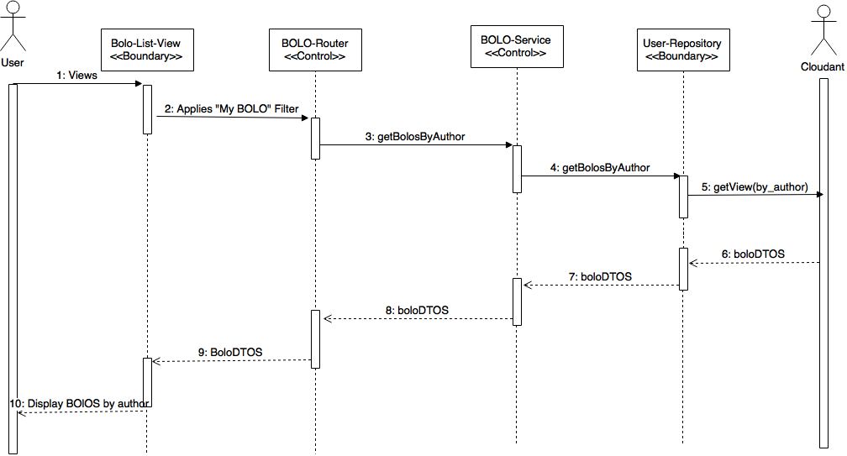](https://drive.draw.io/#G0Bz2XhRgCMcv3TUtIX0o1SWpXbE0)

**User Story #1009** Automate database creation via scripts

* No diagrams

**User Story #1008** Prevent user email domain from being something other than their agency's domain

* Figure sp3-5

[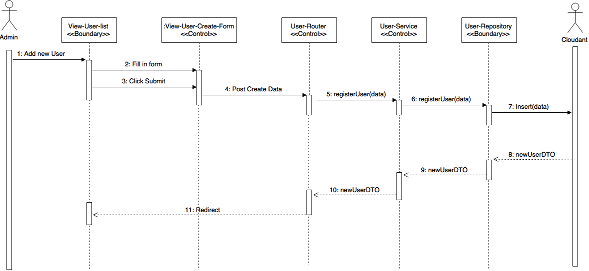](https://drive.draw.io/#G0Bz2XhRgCMcv3d0VhRmZ6MVpwOFU)

**User Story #889** Change bolo email to no-reply

* No diagrams

**User Story #931** Create script to reset DB Schema

* Figure sp3-6

[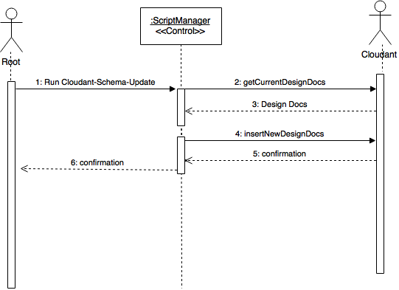](https://drive.draw.io/#G0B6lyftNa8t_PRFkzeUtEeGh2NDQ)

**User Story #985** Enhance ImageService

* No diagrams

**User Story #986** Unsubscribe from BOLO emails

* Figure sp3-7

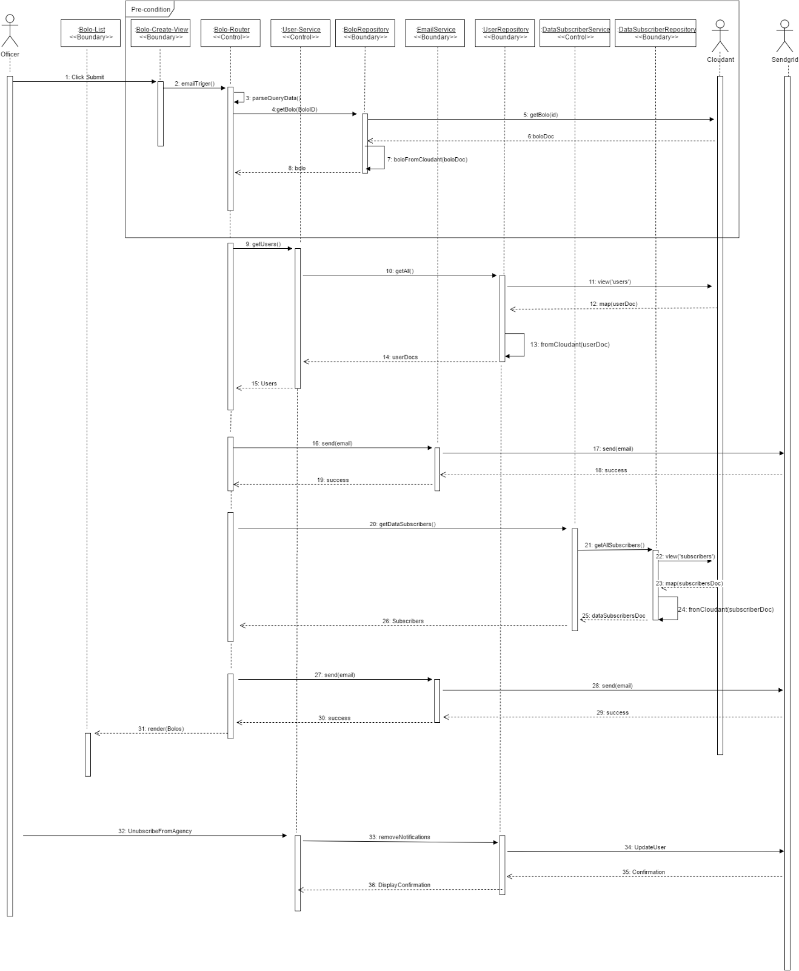

**User Story #1001** Implement routes with authentication

* Figure sp3-8

[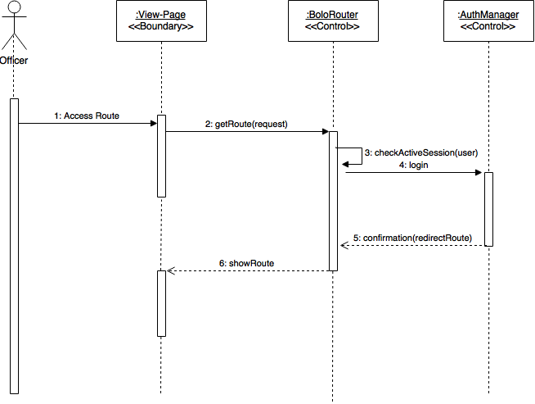](https://drive.draw.io/#G0B6lyftNa8t_PZWxRcGoyUGhrZ0U)

**User Story #1007** Redesign Filter by Agencies in Home page

* Figure sp3-9

[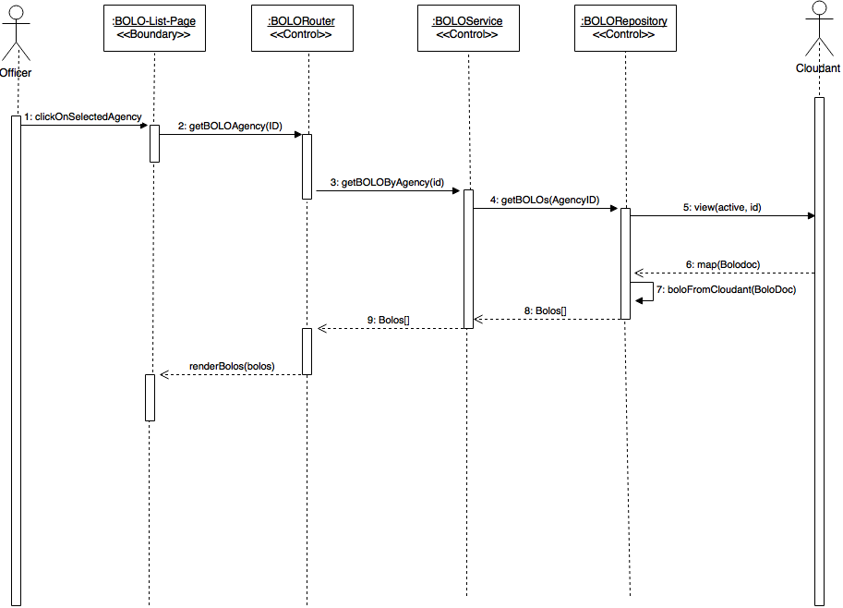](https://drive.draw.io/#G0B6lyftNa8t_PaDRXMmw3X3Uydlk)

**User Story #1033** Fix several bugs

* No diagrams

**User Story #990** Redesign and add validations for General Bolo Template

* Figure sp3-10

[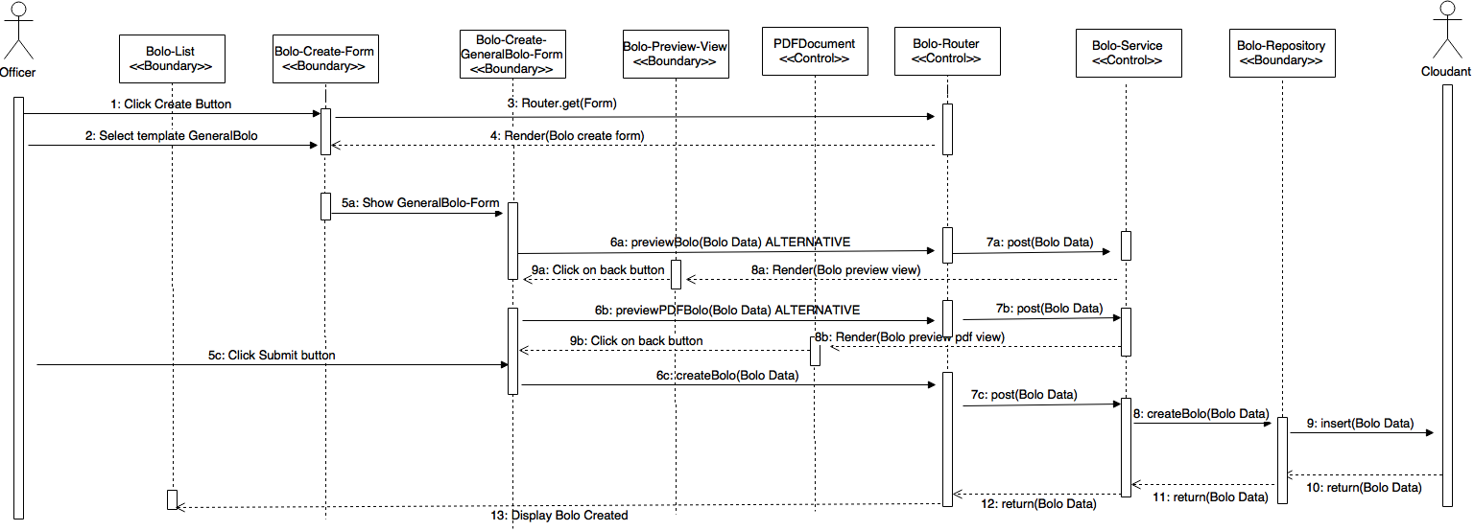](https://drive.draw.io/#G0B4S5V3PqnCmPSktadVdSd1NyYjQ)

**User Story #981** Implement Search for New Bolo Templates

* Figure sp3-11

[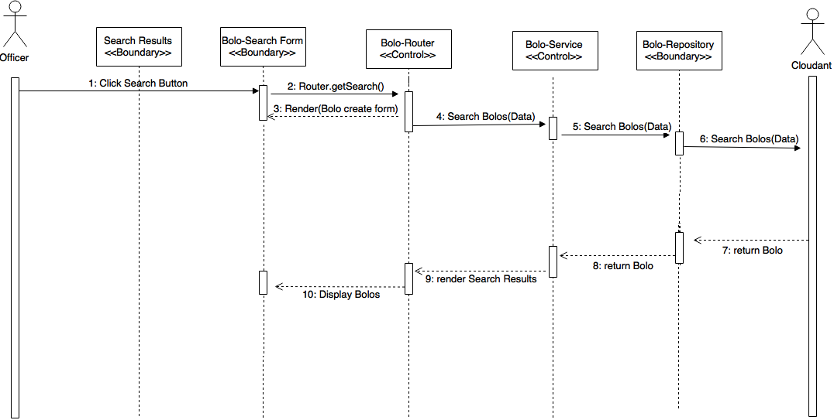](https://drive.draw.io/#G0B4S5V3PqnCmPWVFEcFBfckQwVEk)

**User Story #991** Redesign and add validations for Theft Auto Template

* Figure sp3-12

[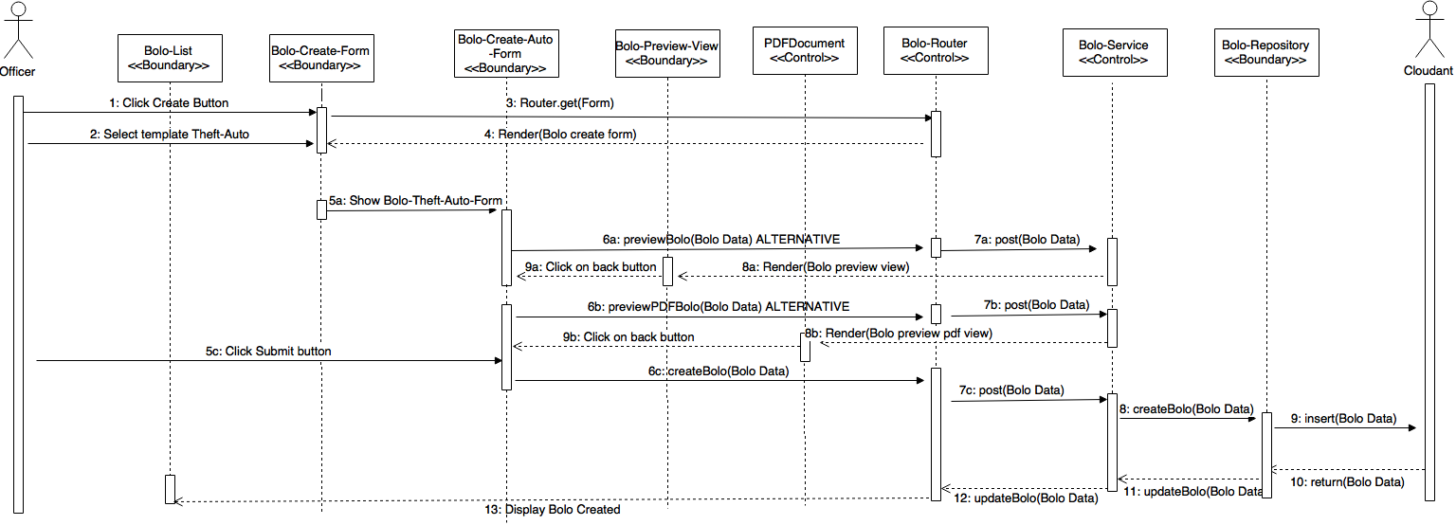](https://drive.draw.io/#G0B4S5V3PqnCmPemRucGt5OFRra0E)

**User Story #992** Redesign and add validations for Theft Boat Template

* Figure sp3-13

[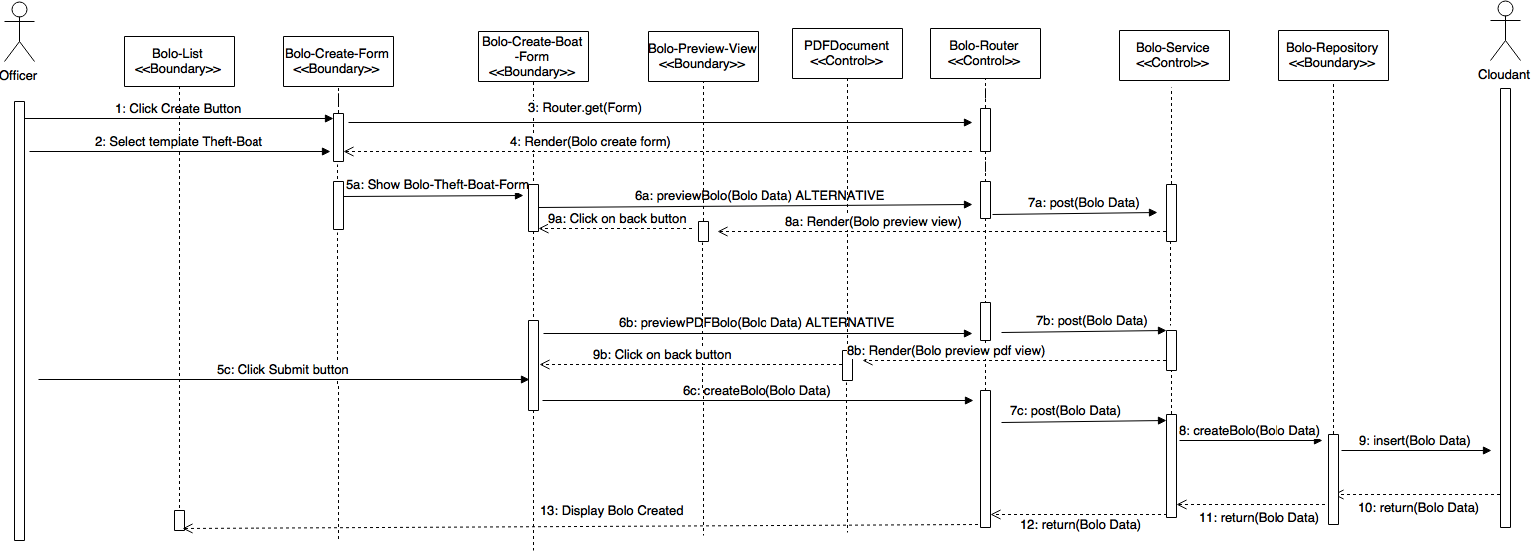](https://drive.draw.io/#G0B4S5V3PqnCmPdlJZNVNuMzlDYm8)

**User Story #1030** Delete the Ongoing Status from Bolo

* No diagrams

### Sprint 4

(07/04/2016 – 07/17/2016)

**User Story #1010** Create a front end page for root to customize system settings

* Figure sp4-1

[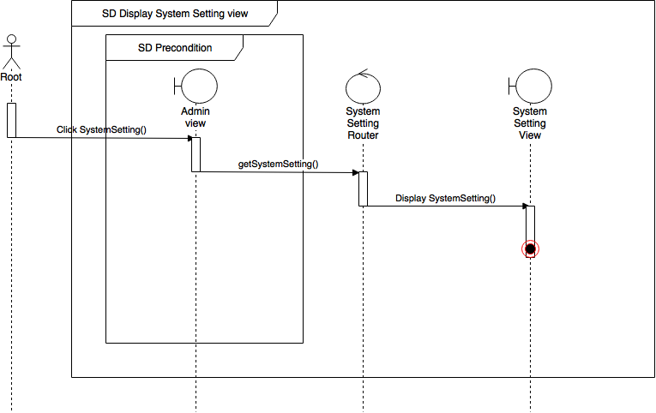](https://drive.draw.io/#G0Bw0gfTN_oxKseFJaemlUWnRlN3M)

**User Story #1096** Implement a link to download a PDF of the user's guide based on user's tier

* Figure sp4-2

[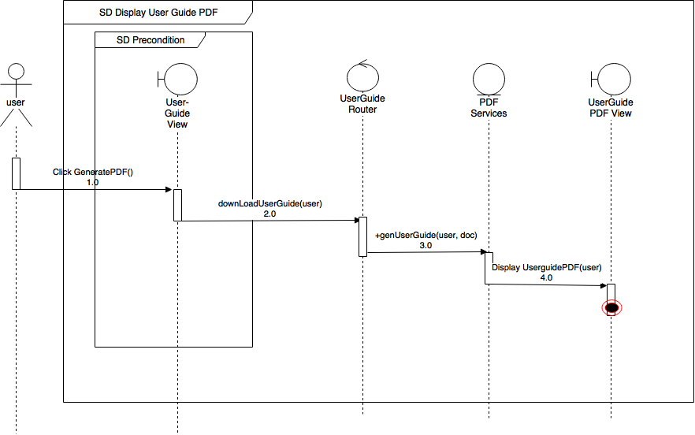](https://drive.draw.io/#G0Bw0gfTN_oxKsR3dIaXVkVXRHMGc)

**User Story #1097** Implement an About Miami Dade County Association of Chief of Police (MDCACP) page

* Figure sp4-3

[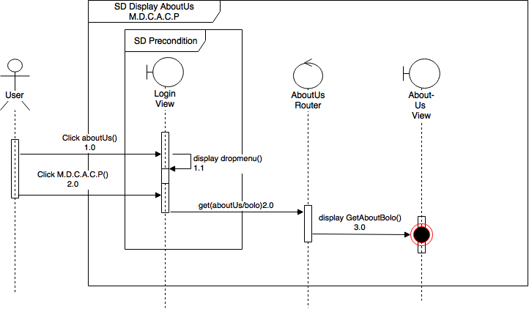](https://drive.draw.io/#G0Bw0gfTN_oxKsTnFBb19KNWliWmM)

**User Story #1098** Create an about us page for Florida International University's (FIU) contribution

* Figure sp4-4

[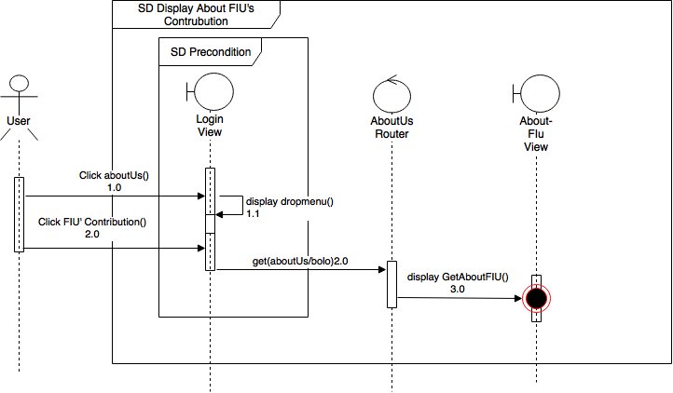](https://drive.draw.io/#G0Bw0gfTN_oxKsbWVYVHVweUlqNzg)

**User Story #1099** Create an about us page for IBM's contribution

* Figure sp4-5

[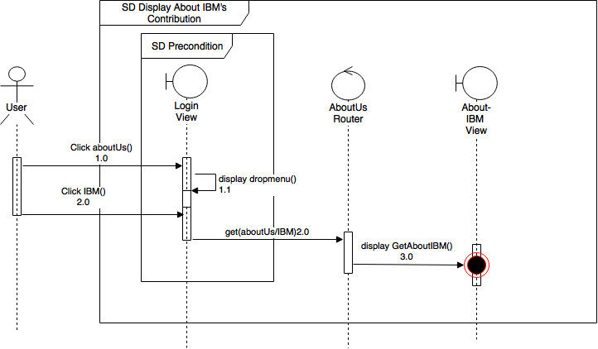](https://drive.draw.io/#G0Bw0gfTN_oxKsNTEyQUxOc19pMjQ)

**User Story #1100** Create a page where root can retrieve data for analysis

* Figure sp4-6

[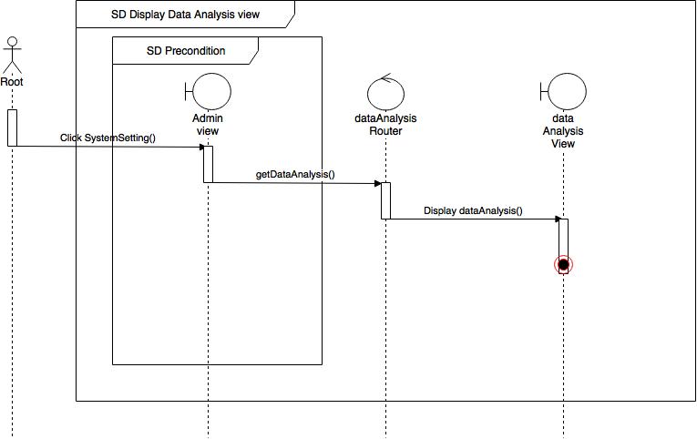](https://drive.draw.io/#G0Bw0gfTN_oxKsc1JFeGhZMmYxMjg)

**User Story #1014** Lock user account after 10 incorrect login attempts

* Figure sp4-7

[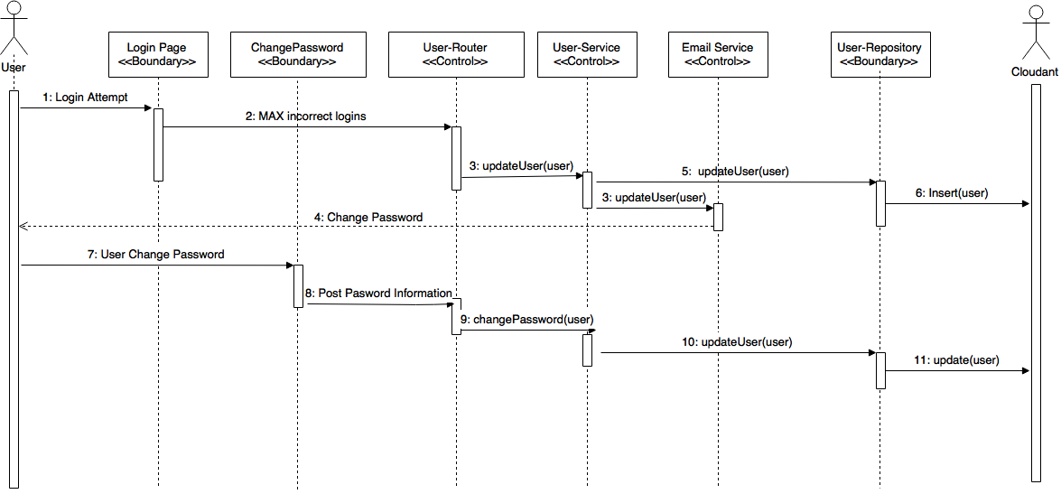](https://drive.draw.io/#G0Bz2XhRgCMcv3TU9JYkd1anZtb00)

**User Story #1038** Filter by multiple agencies in bolo list page

* Figure sp4-8

[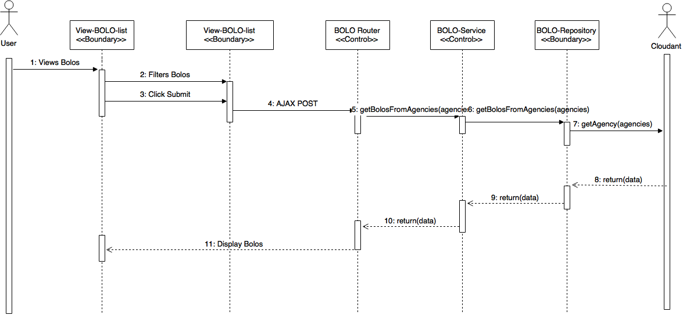](https://drive.draw.io/#G0Bz2XhRgCMcv3SkduR0Z3SE1LMHM)

**User Story #890** Implement Watermarks for agencies

* Figure sp4-9

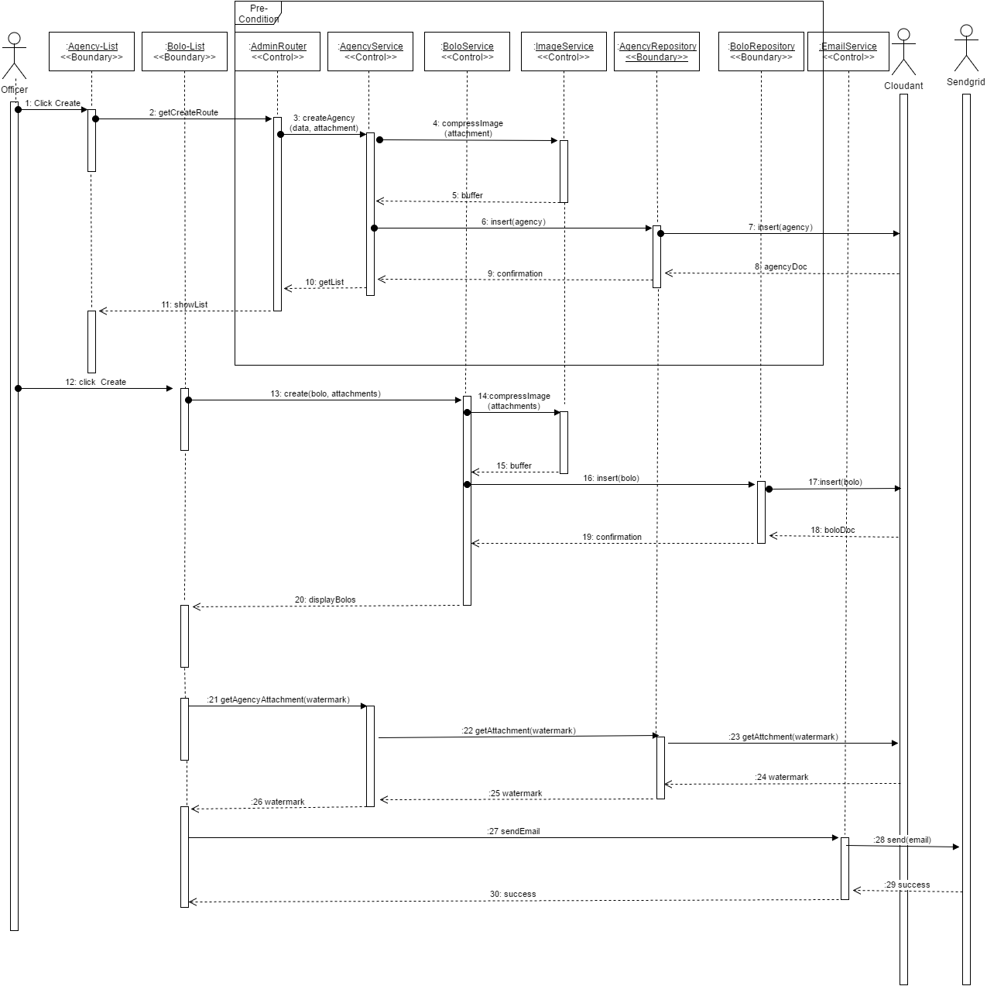

**User Story #1037** Allow Tier 3 users to control Agency settings

* Figure sp4-10

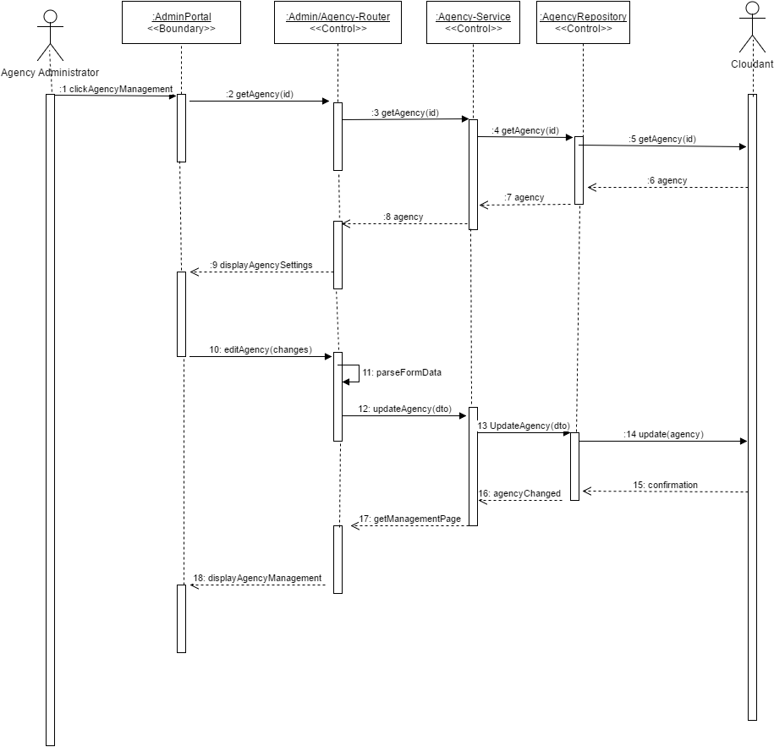

**User Story #1081** Prevent Tier 3 users from granting Root access

* Figure sp4-11

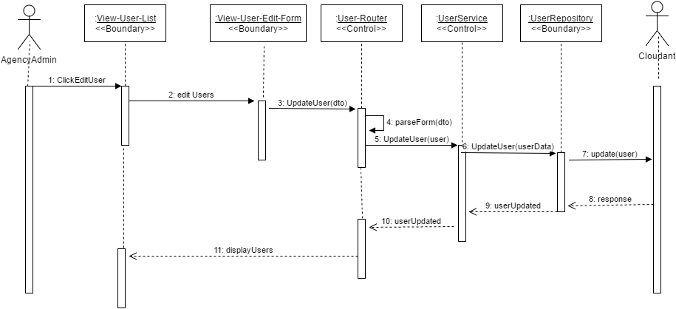

**User Story #1083** Prevent Officers from previewing PDFs before confirmation

* Figure sp4-12

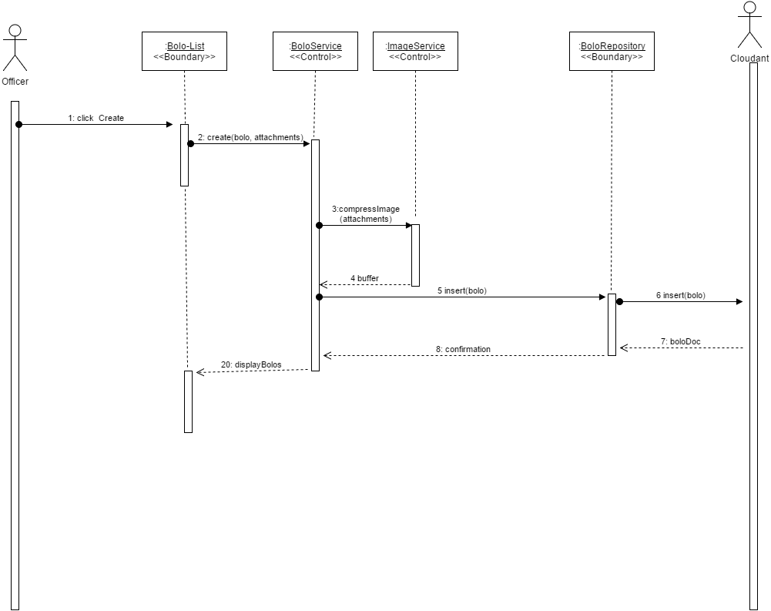

**User Story #1087** Implement time retrieval points for data analysis for Create Bolo (General - Auto - Boat)

* Figure sp4-13

[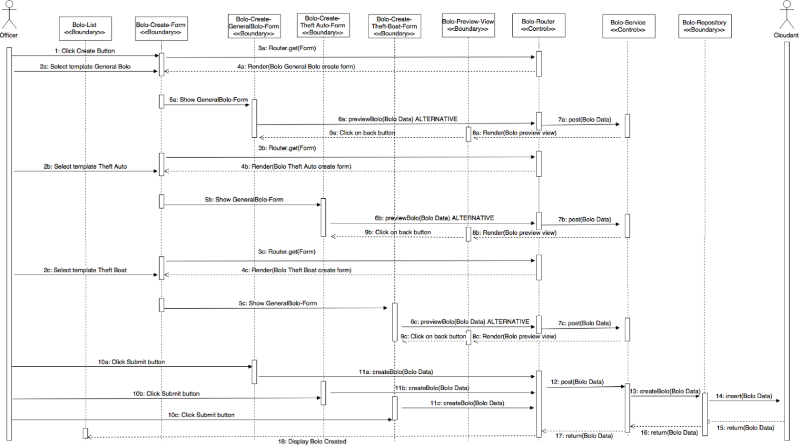](https://drive.draw.io/#G0B4S5V3PqnCmPYWs2M0M5WjlnUDg)

**User Story #1119** Implement time retrieval points for data analysis for Edit Bolo (General - Auto - Boat)

* Figure sp4-14

[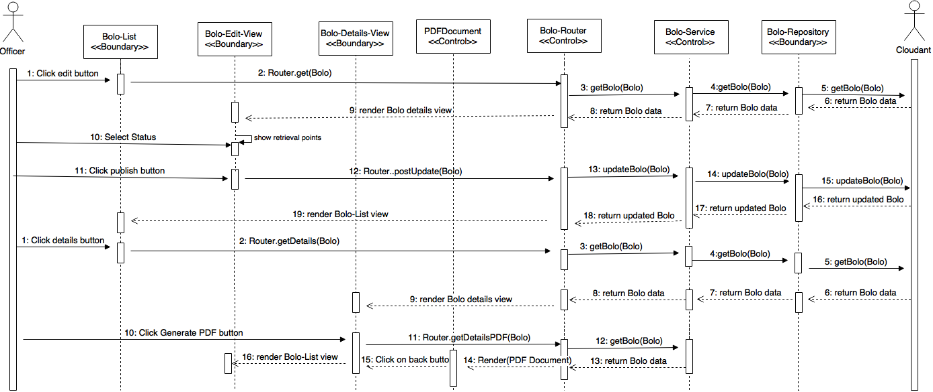](https://drive.draw.io/#G0B4S5V3PqnCmPUWNrczhyZFFGeVk)

**User Story #1088** Deactivate and Activate User Accounts from Root and Administrator

* Figure sp4-15

[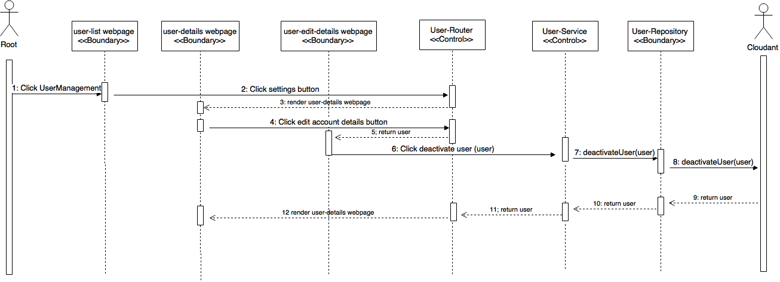](https://drive.draw.io/#G0B4S5V3PqnCmPT1ljSjlQcE1HNXc)

### Sprint 5

(07/18/2016 – 07/31/2016)

**User Story #1094** Implement confirmation of BOLO updates

* Figure sp5-1

[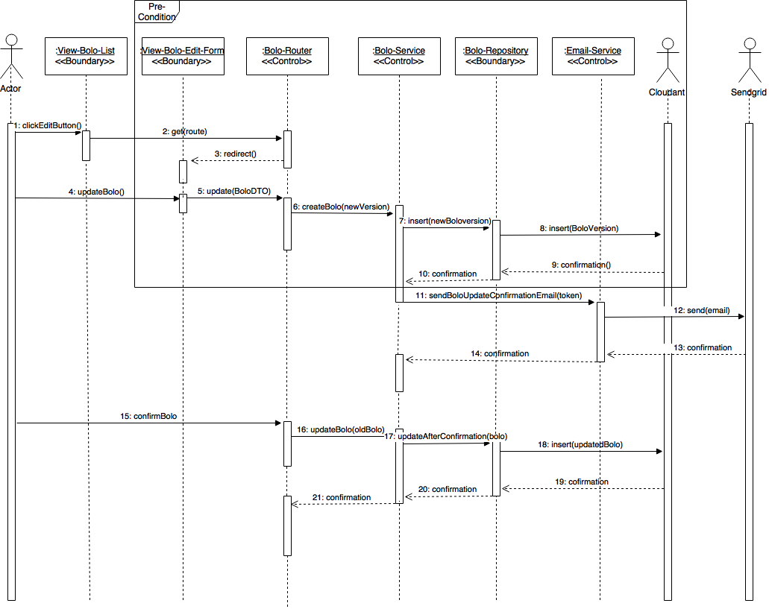](https://drive.draw.io/#G0B6lyftNa8t_PZ2VfM1RMNVFIa0U)

**User Story #1155** Change PDF labels

* Figure sp5-2

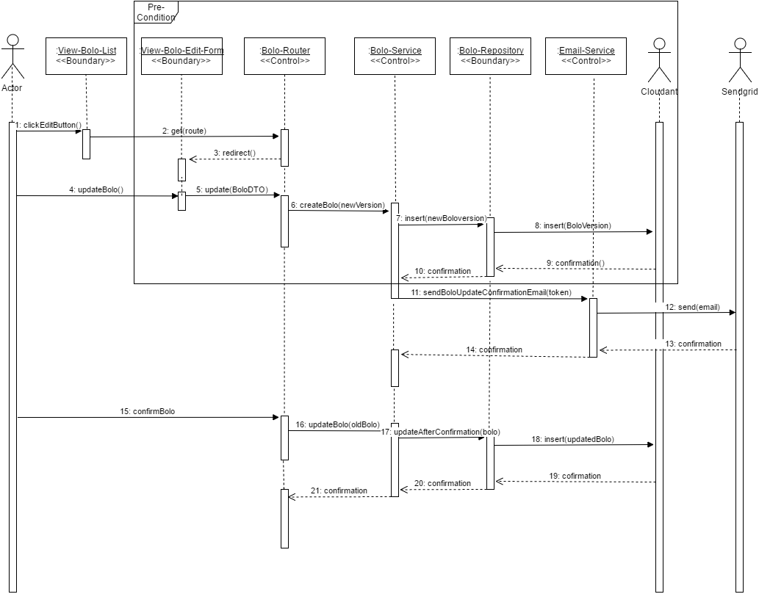

**User Story #1086** Change Interactive Edit Menu to Static Label for Status. Keep Data Field Contents After Validations When a New User and a New Agency is Created. Add New Aesthetic for Bolo Buttons

* No diagrams

**User Story #1089** Show Edit and Archive only for Root and Administrators and Only View for Users. Create the functionality to go back for Details for Bolos (General, Auto and Boat). Create the ability for view a Bolo when it is Archived, and show edit and restore for Root

* No diagrams

**User Story #1163** Connect system setting page to backend

* No diagrams

**User Story #1164** connect data analysis page to backend

* No diagrams

## Appendix B – User Interface Design

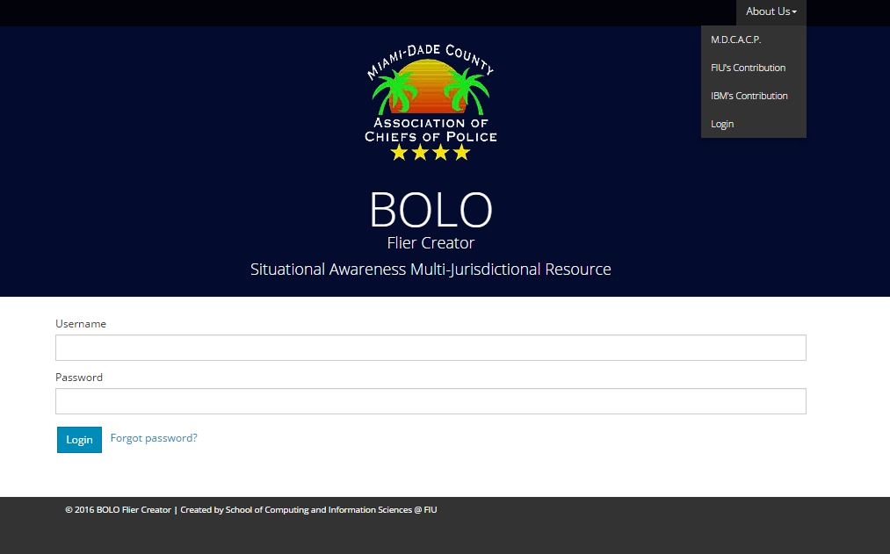

Figure UI01 – About us

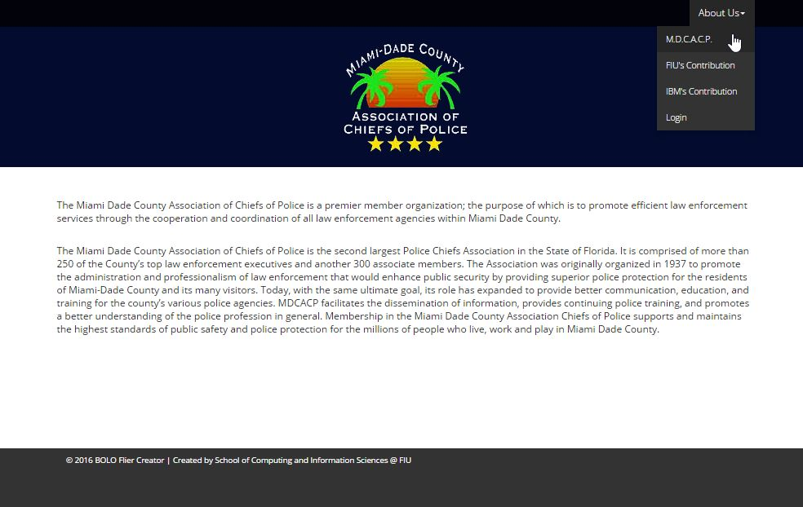

Figure UI02 – About us Miami Dade Association of Chiefs of Police



Figure UI03 – About us FIU

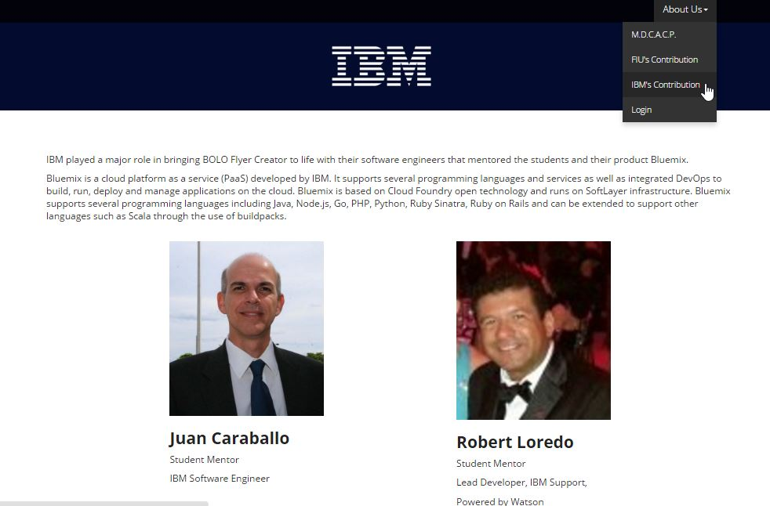

Figure UI04 – About us IBM

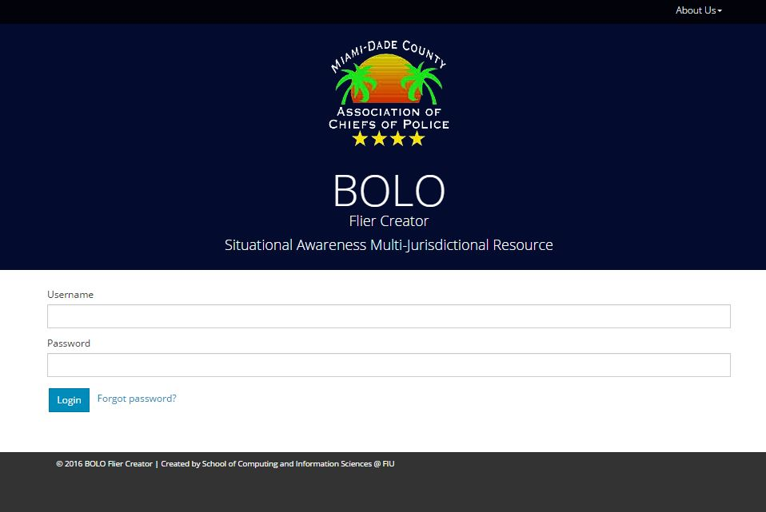

Figure UI05 – Login

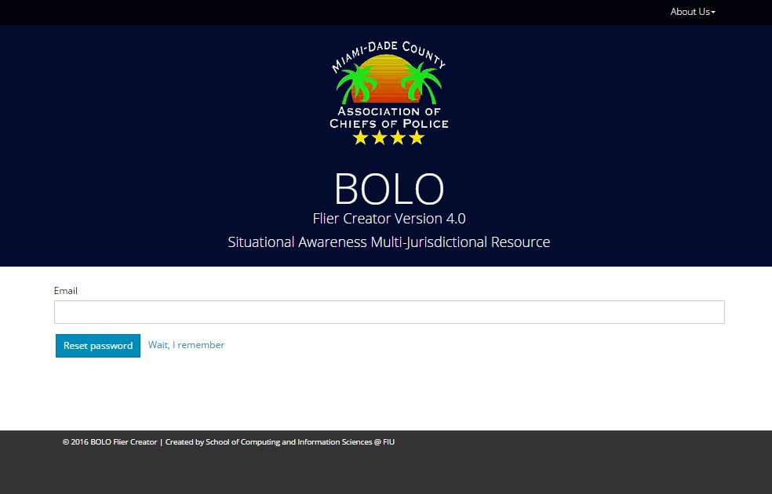

Figure UI06 – Forgot Password

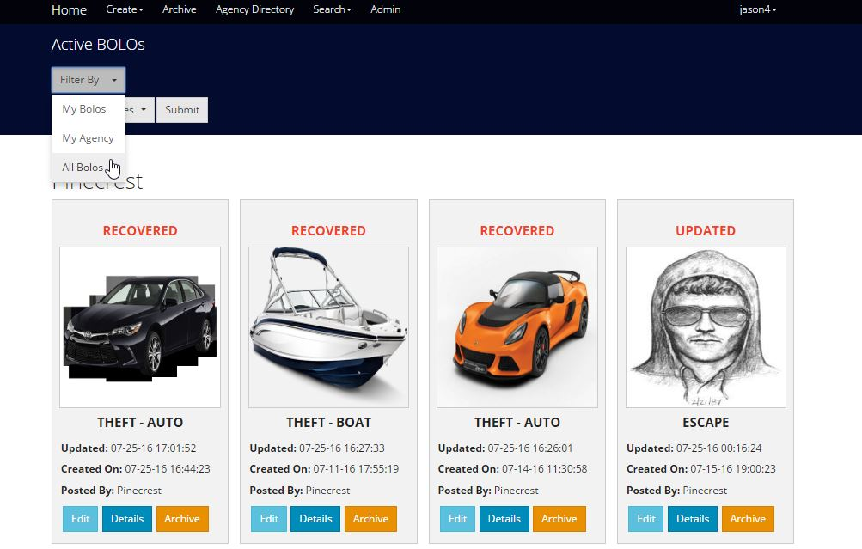

Figure UI07 – Filter Bolos

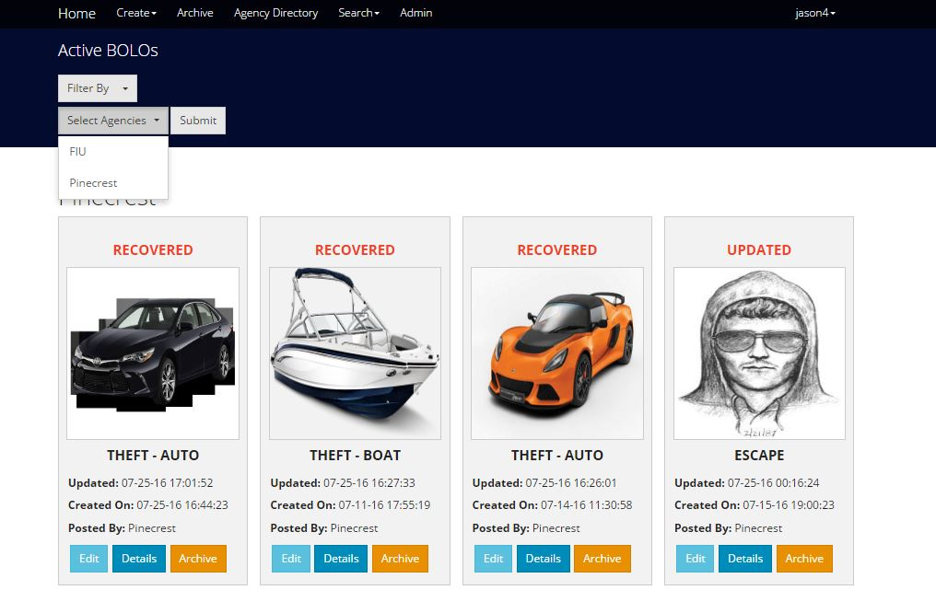

Figure UI08 – Multi select agencies

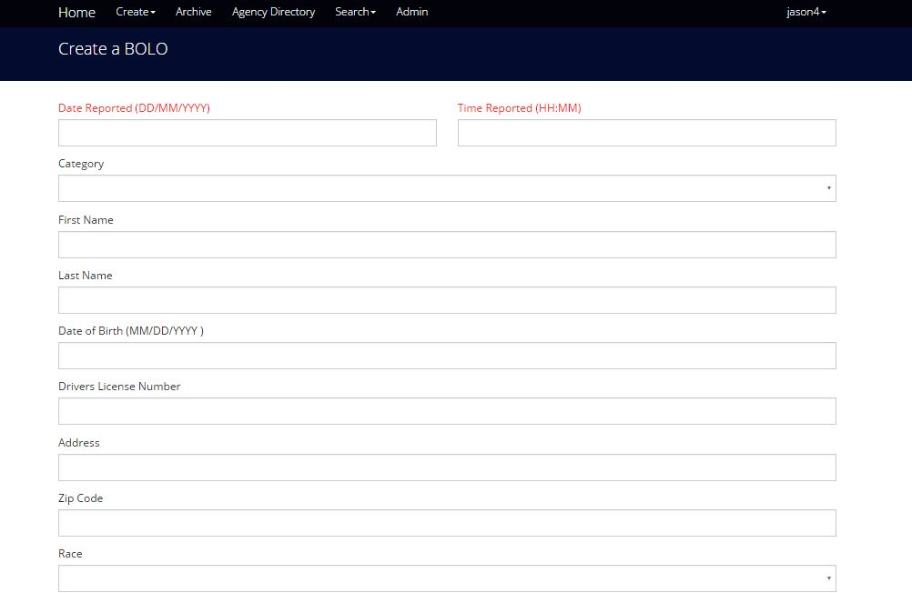

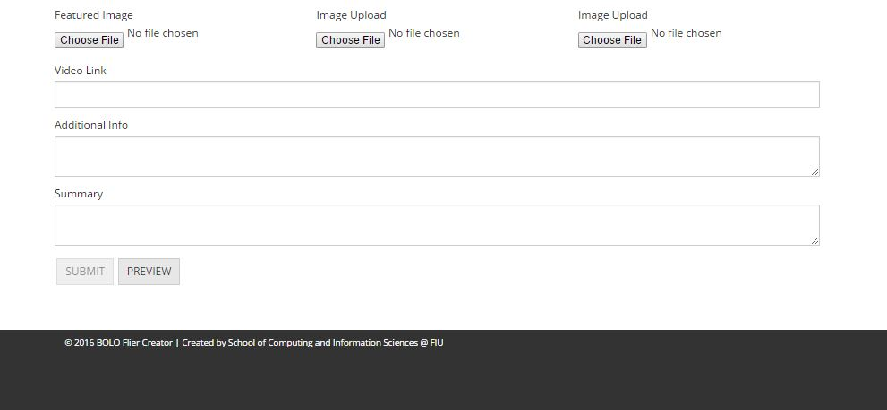

Figure UI09 – Create General Bolo

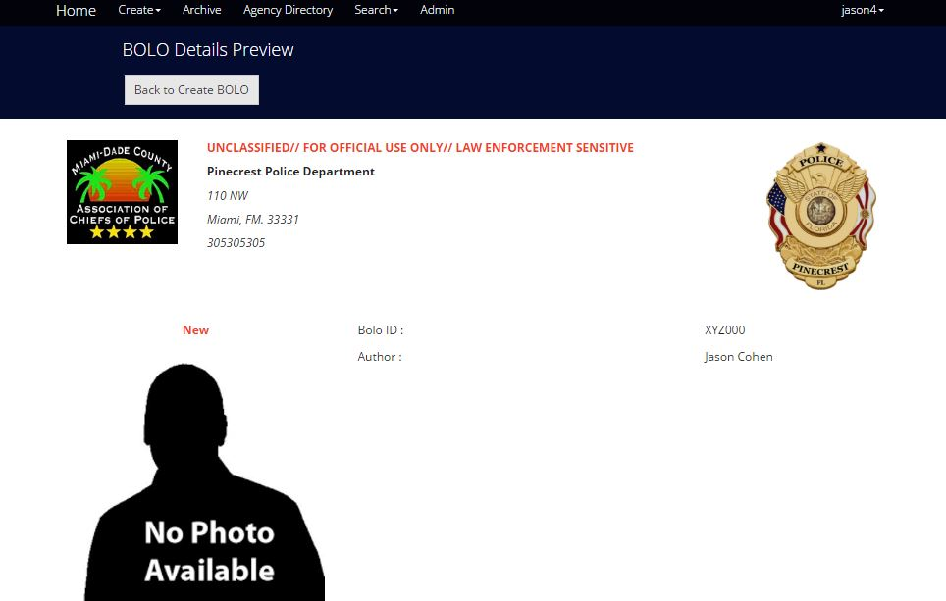

Figure UI10 – Preview General Bolo

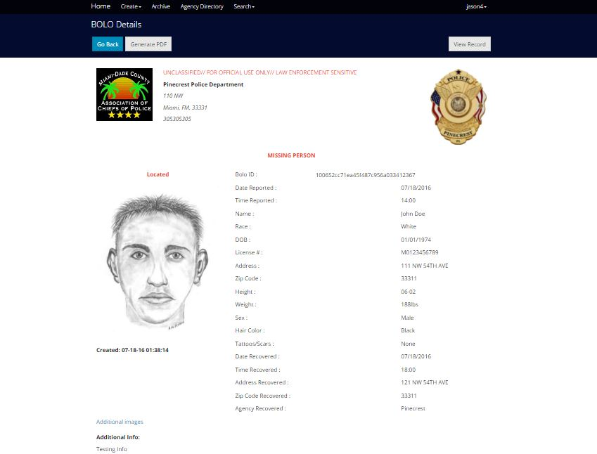

Figure UI11 – Details General Bolo

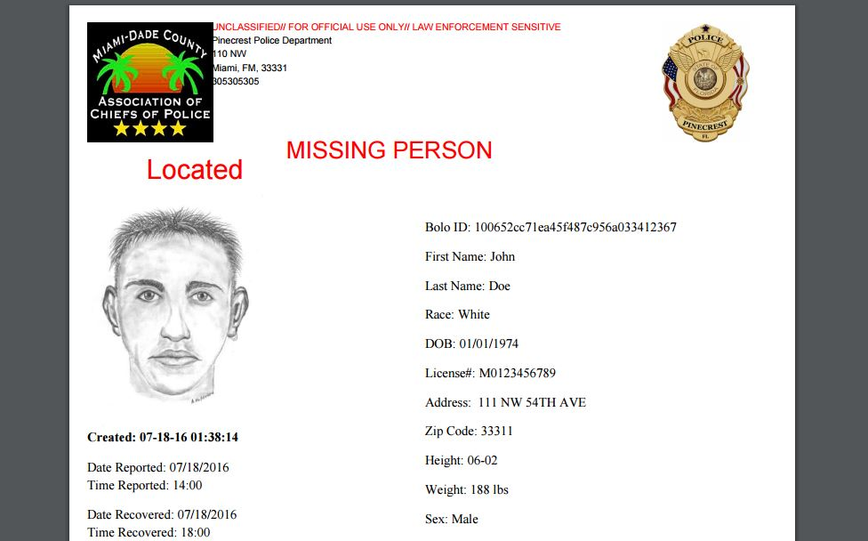

Figure UI12 – PDF General Bolo

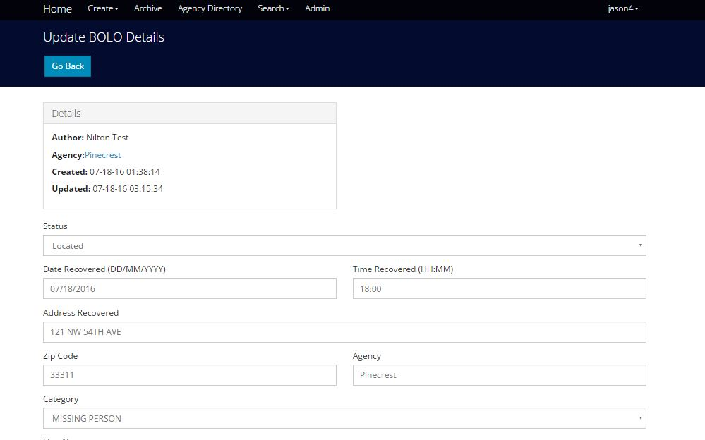

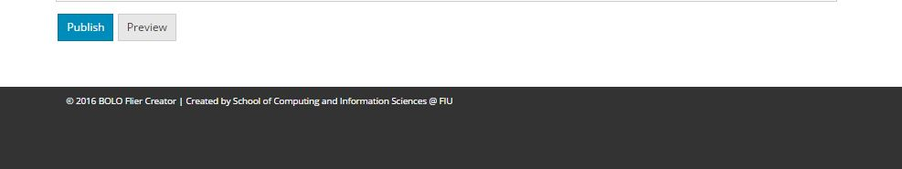

Figure UI13 – Edit General Bolo

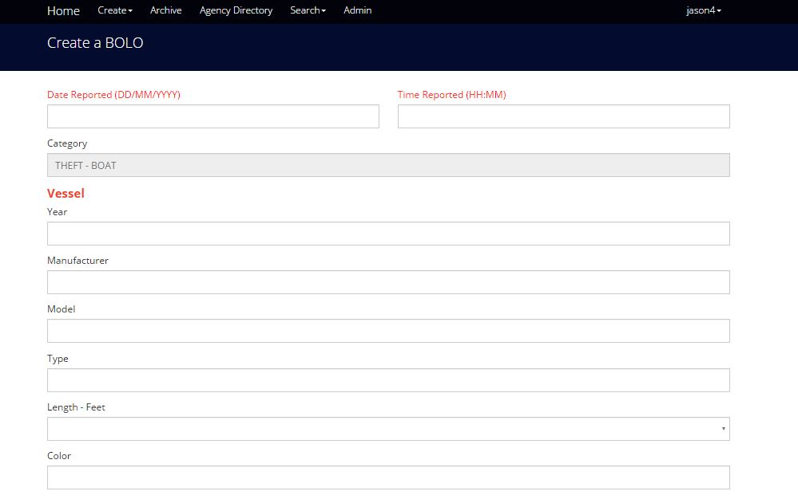



Figure UI14 – Create Theft Boat Bolo

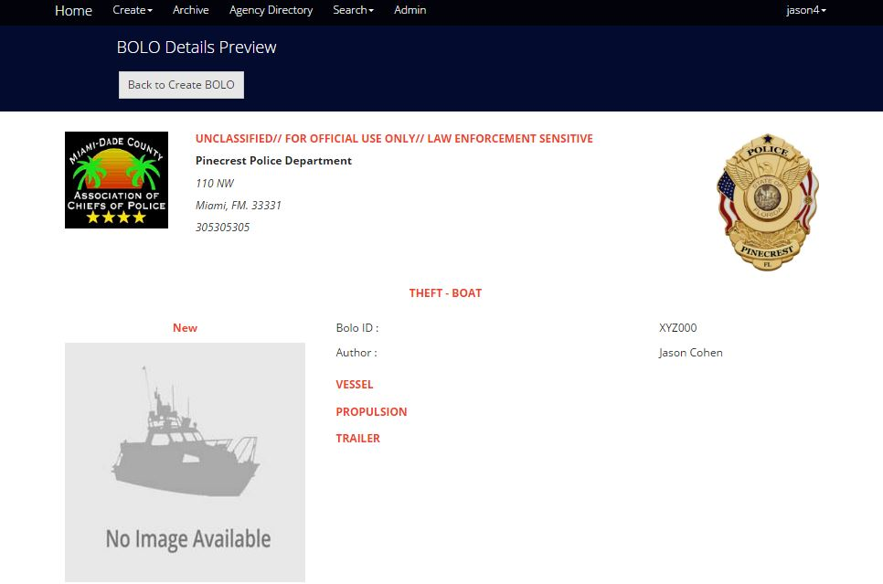

Figure UI15 – Preview Theft Boat Bolo

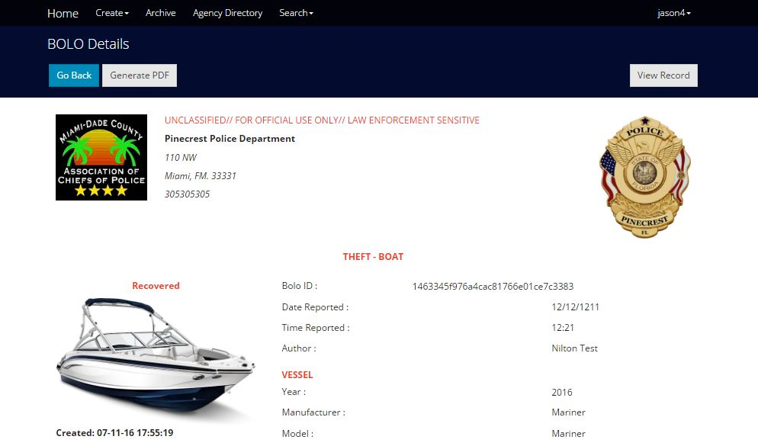

Figure UI16 – Details Theft Boat Bolo

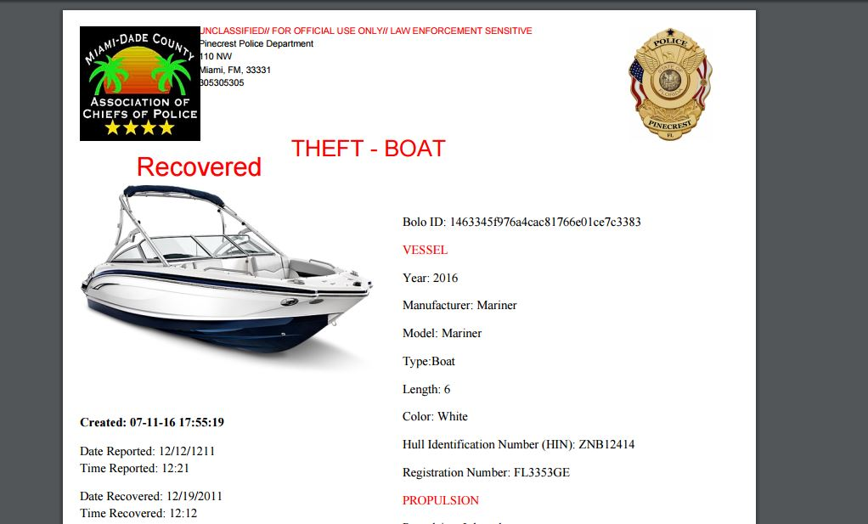

Figure UI17 – PDF Theft Boat Bolo

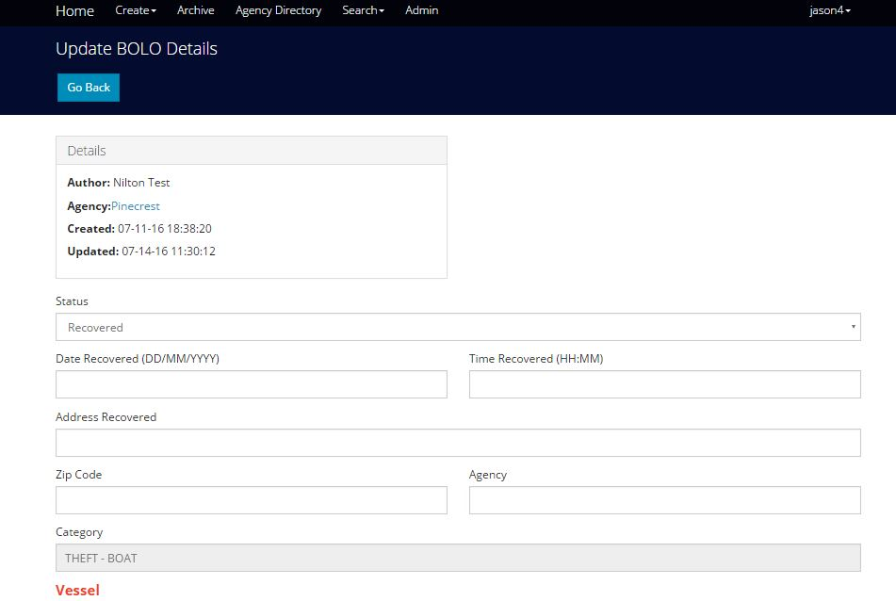



Figure UI18 – Edit Theft Boat Bolo

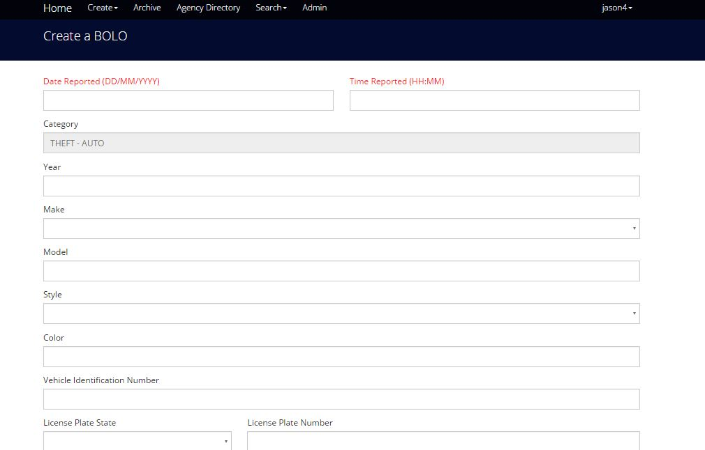



Figure UI19 – Create Theft Boat

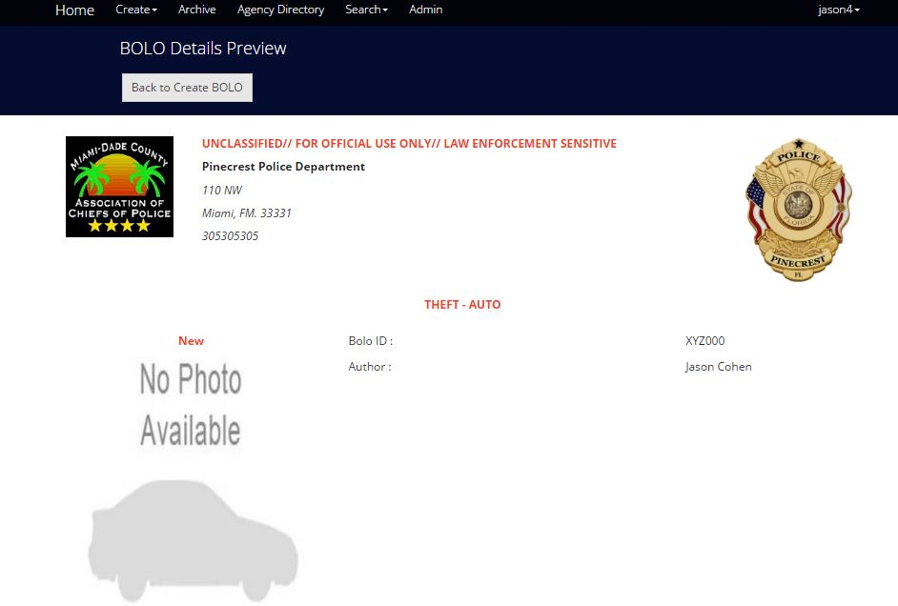

Figure UI20 – Preview Theft Boat

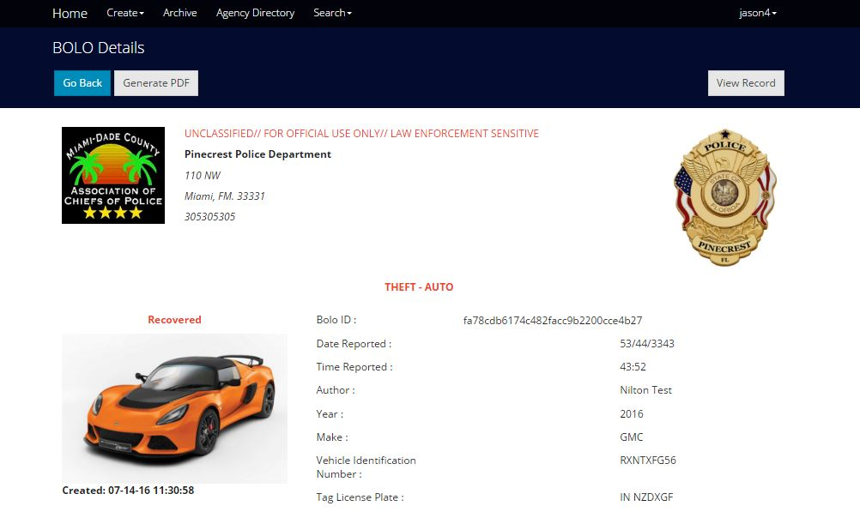

Figure UI21 – Details Theft Boat

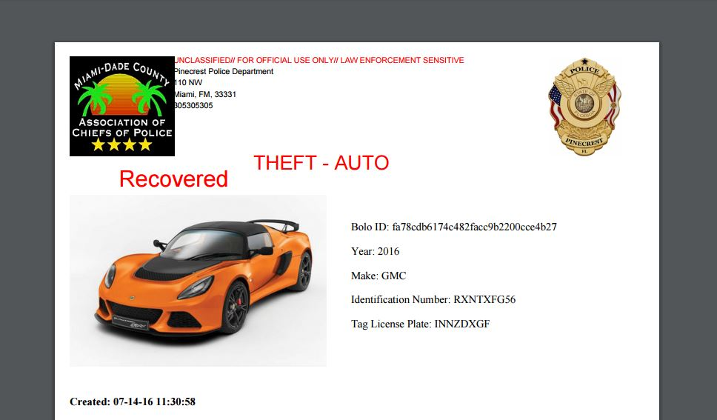

Figure UI22 – PDF Theft Boat

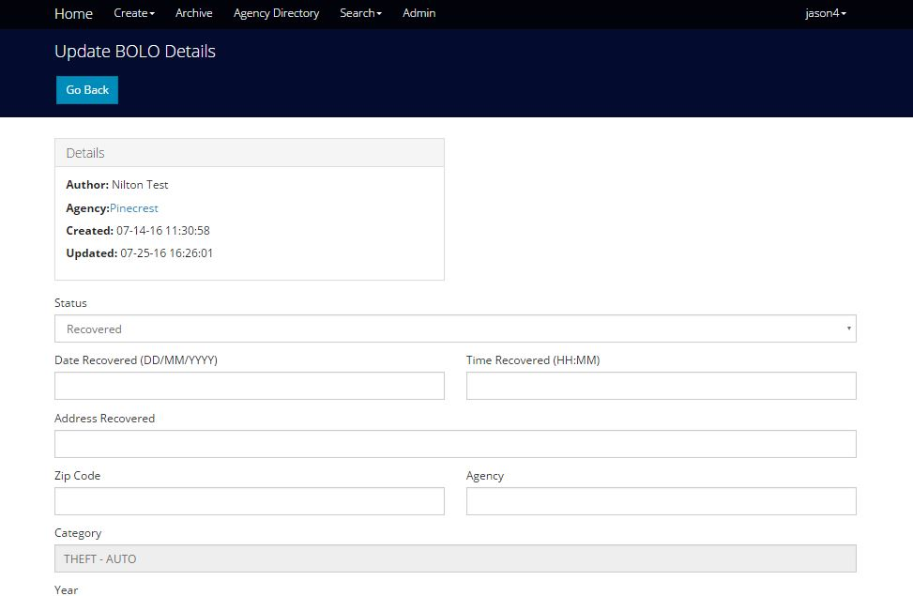



Figure UI23 – Edit Theft Boat

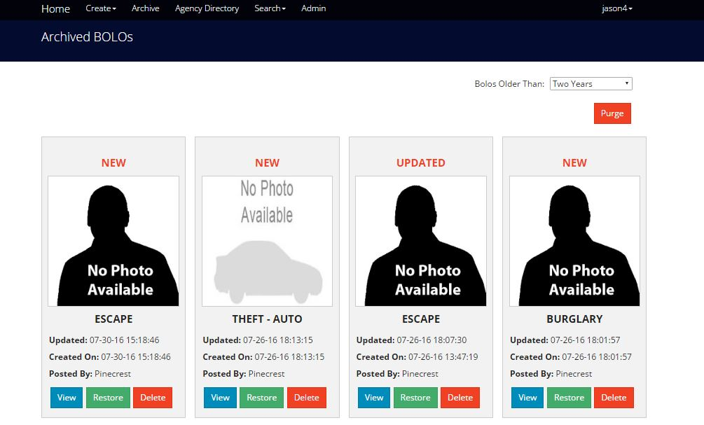

Figure UI24 – Archived Bolos

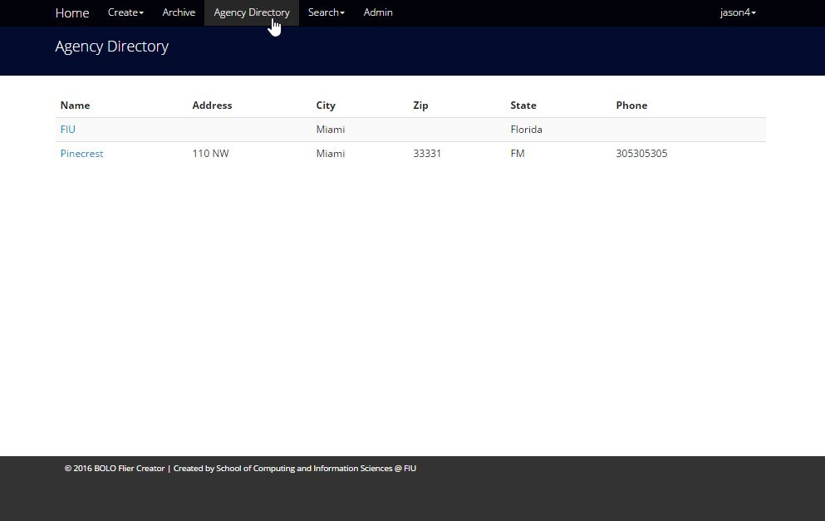

Figure UI25 – Agency Directory

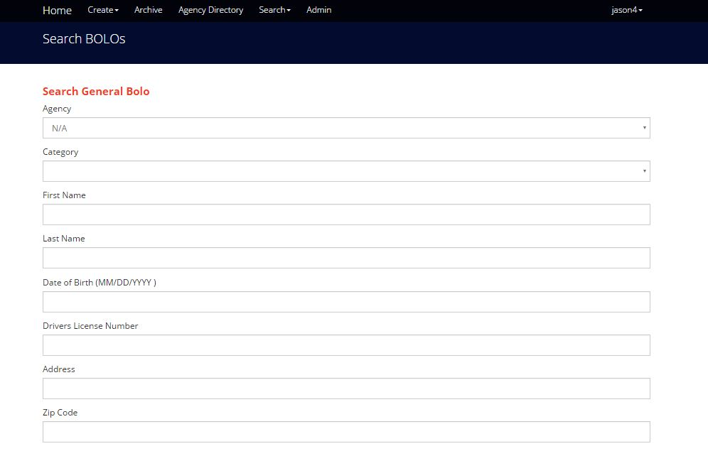

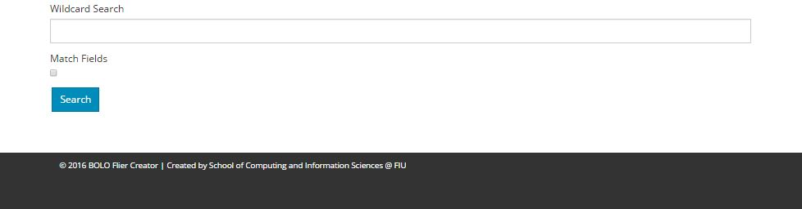

Figure UI26 – Search General Bolo

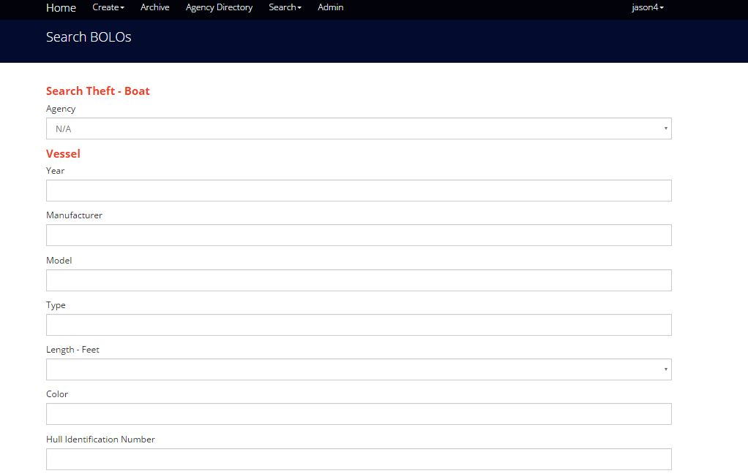



Figure UI27 – Search Theft Boat Bolo

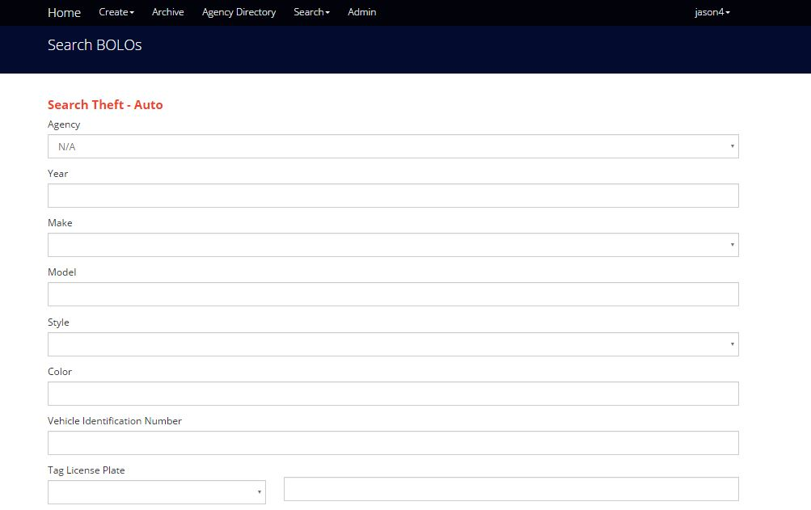



Figure UI28 – Search Theft Auto Bolo

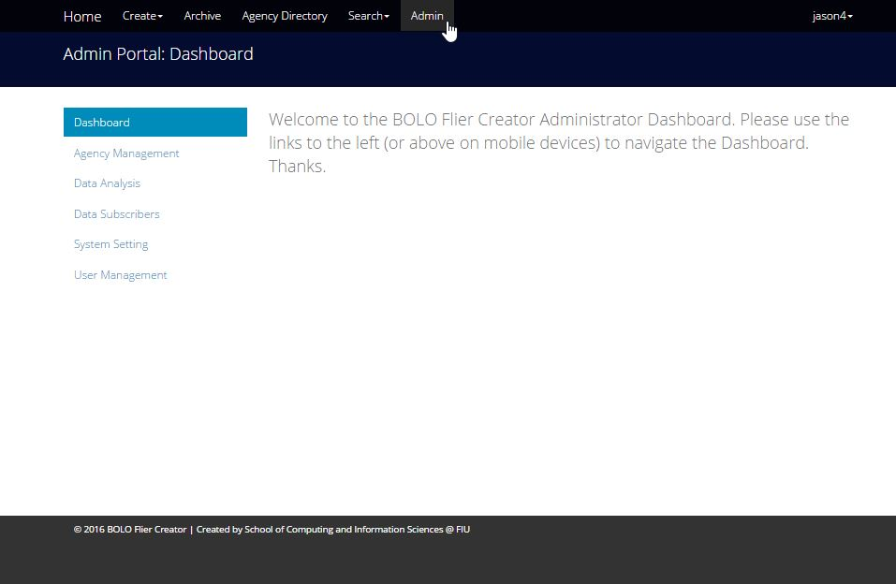

Figure UI29 – Admin Dashboard

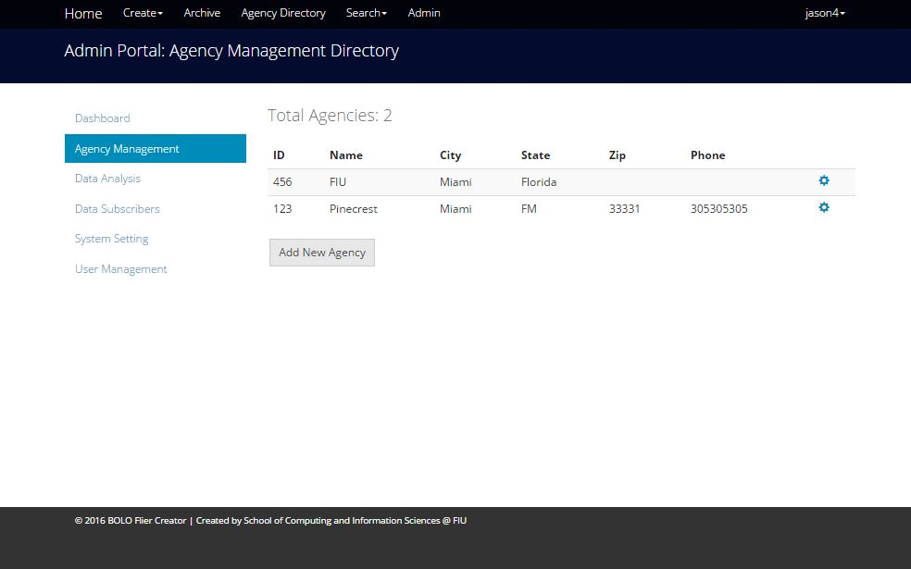

Figure UI30 – Agency Management

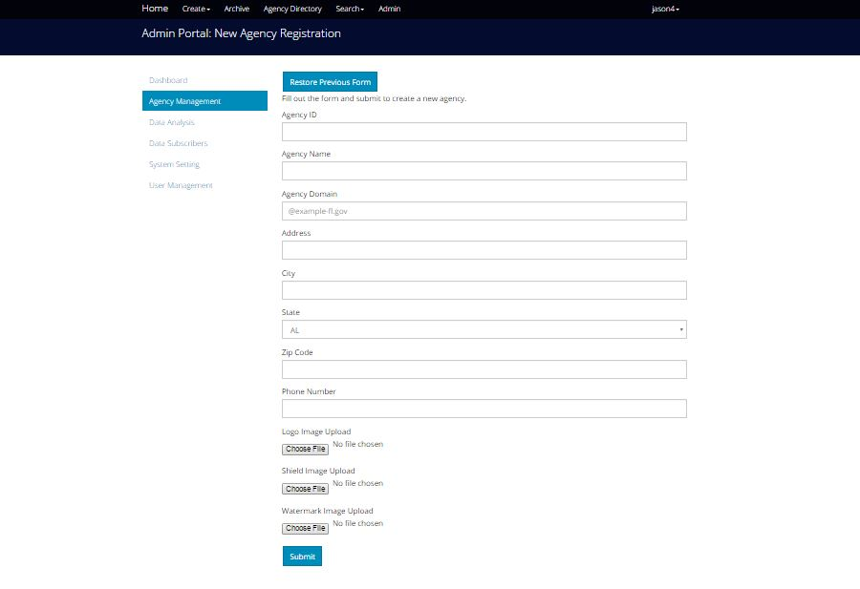

Figure UI31 – Create New Agency

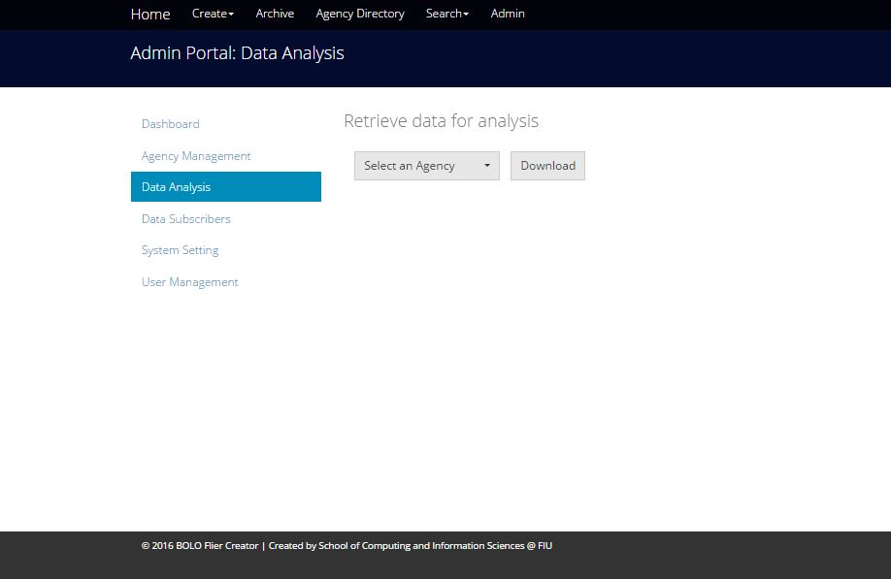

Figure UI32 – Data Analysis

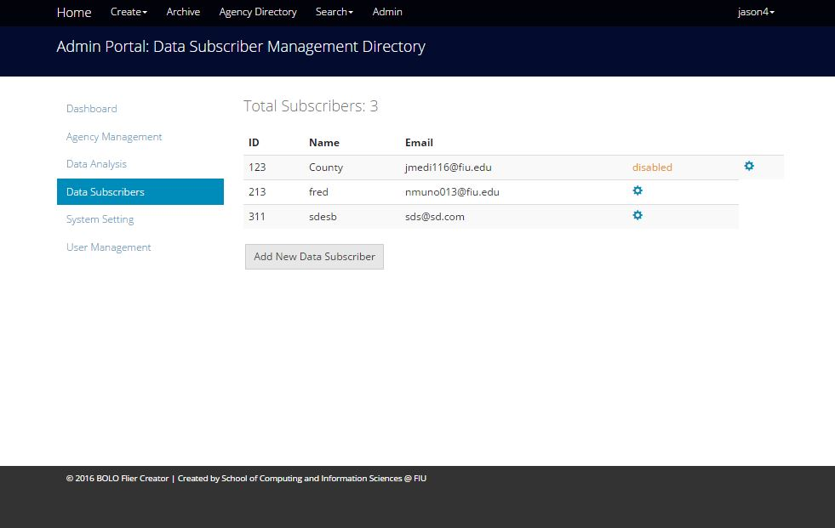

Figure UI33 – Data Subscribers

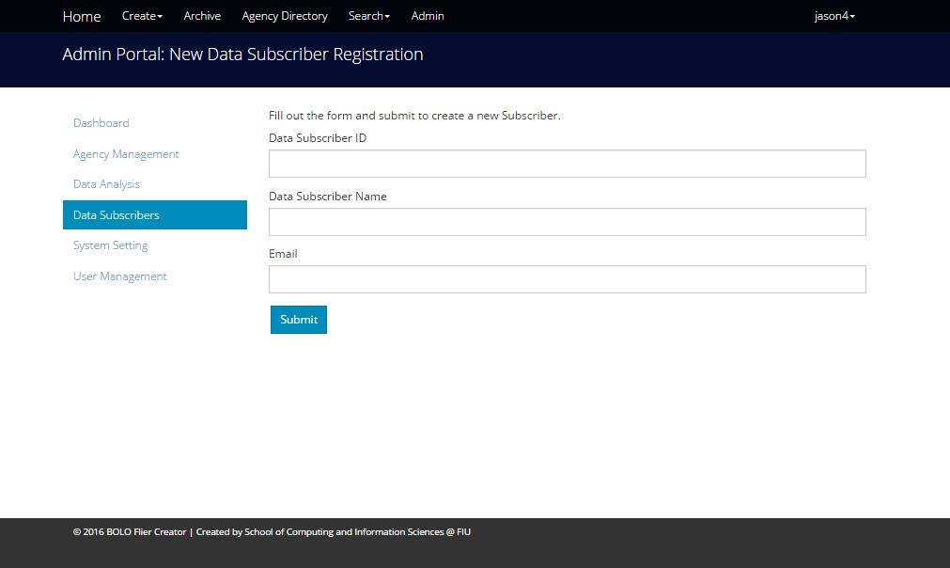

Figure UI34 – Create Data Subscriber

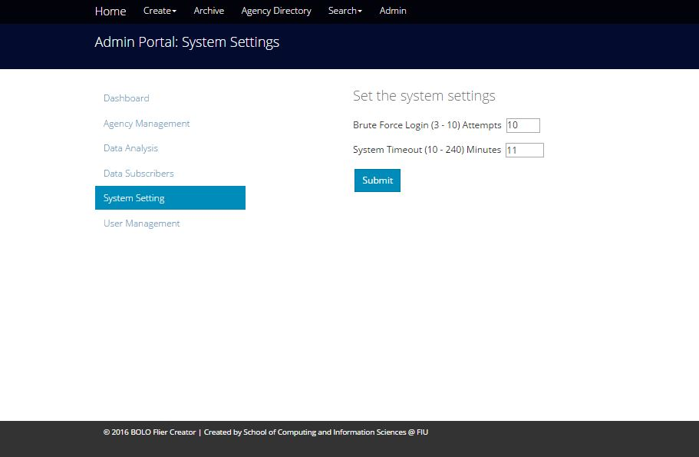

Figure UI35 – System Settings

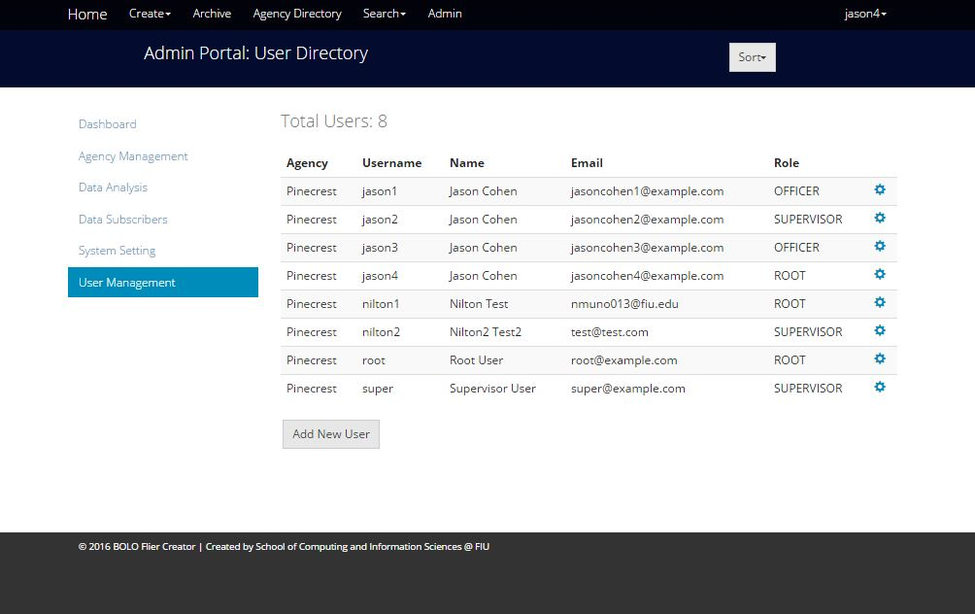

Figure UI36 – User Management

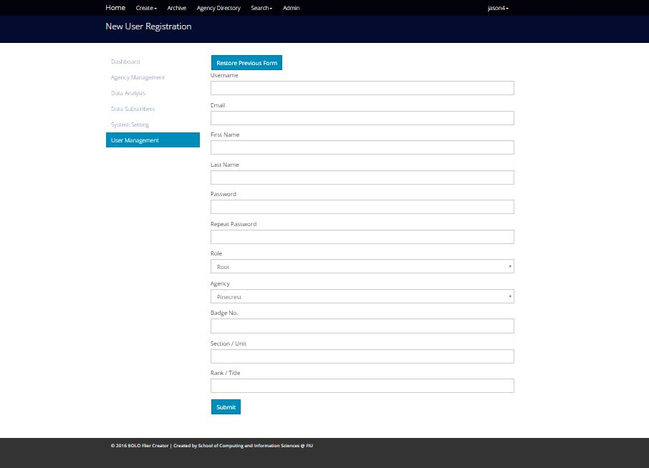

Figure UI37 – Create New User

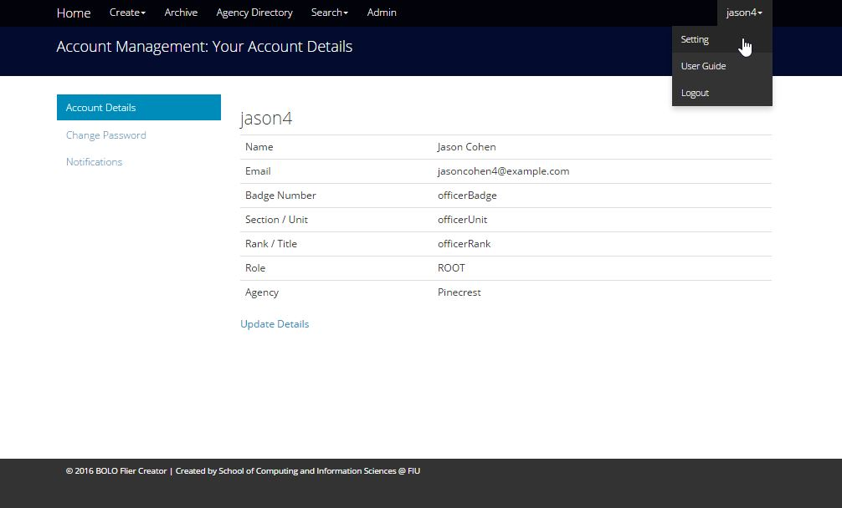

Figure UI38 – Account Details

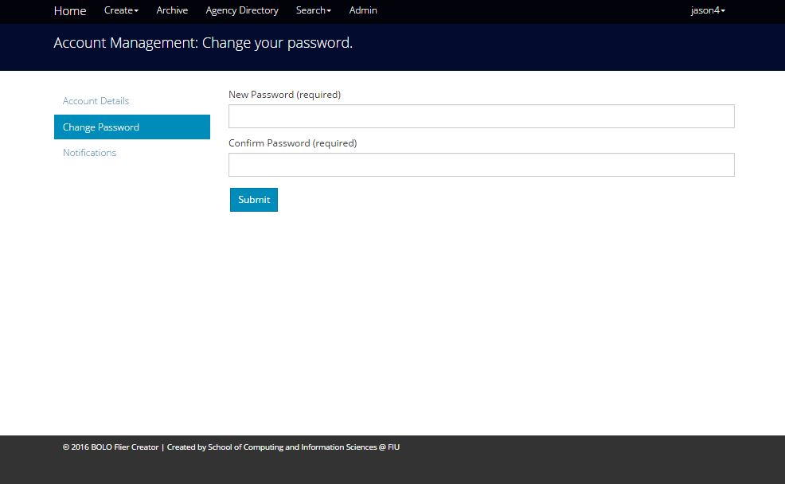

Figure UI39 – Change Password

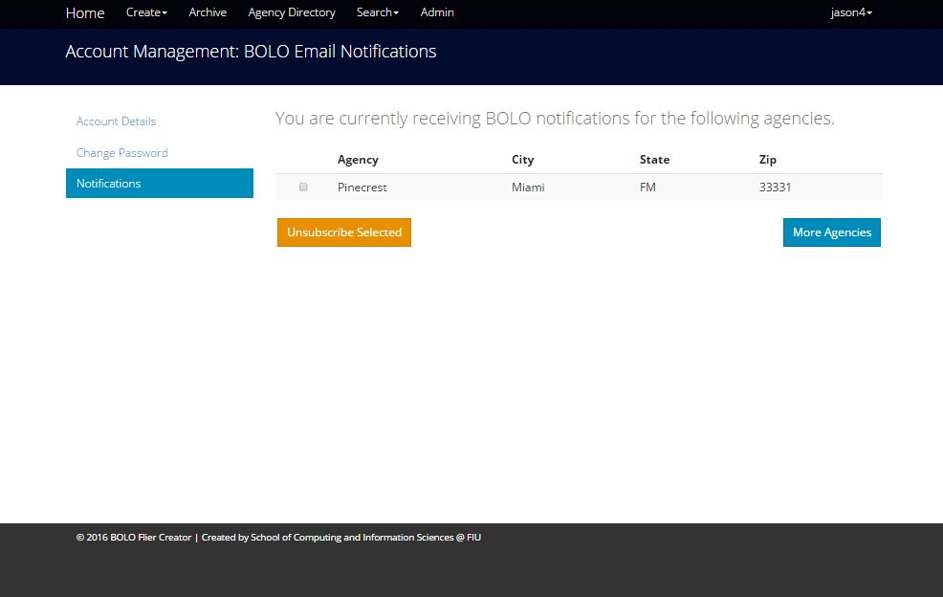

Figure UI40 – Notifications

## Appendix C – Sprint Review Reports

**Sprint 1 Report**

Date: 3 June 2016

Time: 6:00 - 6:15 pm

Burke, John

Gonzalez, Emmanuel

Medina, Jorge

Munoz, Nilton

After a show and tell presentation, the implementation of the following user stories were accepted by the product owners: All.

* User Story 892, Expire passwords in 90 days.
* User Story 887 Remove unnecessary details from email alert
* User Story 882, Implement Wildcard search field
* User Story 888, Open PDFs document in new tab
* User Story 894, Update all pages to BOLO v5.0
* User Story 881, Create template for Theft-Auto Bolo
* User Story 895, Create template for Theft-Boat Bolo

The following ones were rejected and moved back to the product backlog to be assigned to a future sprint at a future Spring Planning meeting.

* User Story 879, Confirm BOLO via email after creation
* How this should be reflected on the user story definition in Mingle:
  + User story was moved to sprint 2
* User story 891, Prevent password from displaying in the url
* How this should be reflected on the user story definition in Mingle:
  + User story was moved to sprint 2
* User Story 880, Send feed of BOLOs as JSON documents
* How this should be reflected on the user story definition in Mingle:
  + User Story was moved to Sprint 2

**Sprint 2 Report**

Date: 17 June 2016

Time: 6:00 - 6:15 pm

Burke, John

Gonzalez, Emmanuel

Medina, Jorge

Munoz, Nilton

After a show and tell presentation, the implementation of the following user stories were accepted by the product owners: All.

* User Story 983 use the authentication of the confirmation for resetting a password
* User Story 919 Adjust the timeout secession to ten minutes
* User Story 930 As a user I would like to receive an email notification when my password is reset so that I know if someone else has reset my password
* User Story 879, Confirm BOLO via email after creation
* User Story 891, Prevent password from displaying in the url
* User Story 880, Send feed of BOLOs as JSON documents
* User Story 920, Compress images upon upload
* User Story 896, Create specific bolo for Theft-Auto
* User Story 932, View Bolo details for Theft-Auto
* User Story 933, Edit Bolo for Theft-Auto

The following ones were rejected and moved back to the product backlog to be assigned to a future sprint at a future Spring Planning meeting.

* None

**Sprint 3 Report**

Date: July 2 2016

Time: 6:00 - 6:15 pm

Burke, John

Gonzalez, Emmanuel

Medina, Jorge

Munoz, Nilton

After a show and tell presentation, the implementation of the following user stories were accepted by the product owners: All.

* User Story 934 Remove empty fields from PDF bolo for display
* User Story 935 Add drop down menu for links such as settings, user guide, logout and others to be added at a later time
* User Story 1006 Add a user guide page for each tier
* User Story 1010 Give root access to customize lower tier settings
* User Story 931 Create Script to reset Database Schema
* User Story 985 Enhance Image Service
* User Story 986 Unsubscribe from BOLO emails
* User Story 1001 Implement routes with authentication
* User Story 1007: Redesign Filter by Agencies on the Home Page
* User Story 1033: Fix several bugs
* User Story 990: Redesign and add validations for General Bolo Template
* User Story 981: Implement Search For New Bolo Templates
* User Story 991: Redesign and add validations for Theft Auto Template
* User Story 992: Redesign and add validations for Theft Boat Template
* User Story 1030: Delete the Ongoing Status from Bolo
* User Story 1009: Automate database creation scripts
* User Story 1011: Filter BOLOS by author and reformat the dropdown
* User Story 1008: Prevent user from registering with email domain outside of his agency’s domain
* User Story 1014: Lock user account after 10 incorrect logins
* User Story 889:  Modify bolo email to no reply

The following ones were rejected and moved back to the product backlog to be assigned to a future sprint at a future Spring Planning meeting.

* About us pages (moving to sprint 4)
* Sent text
* Toward the bolos
* Have the bolos in a list to view
* Automatic switch of an agency when a user switches agency.
* User Story 1037 Allow Tier 3 users to control Agency subscriptions
* How this should be reflected on the user story definition in Mingle:

Moved to Sprint 4

* User Story 1038 Filter by multiple agencies in bolo list page
* How this should be reflected on the user story definition in Mingle:

Moved to Sprint 4

**Sprint 4 Report**

Date: July 16 2016

Time: 6:00 - 6:15 pm

Burke, John

Gonzalez, Emmanuel

Medina, Jorge

Munoz, Nilton

After a show and tell presentation, the implementation of the following user stories were accepted by the product owners: All.

* User Story 890 Implement Watermarks for agencies
* User Story 1037 Allow Tier 3 users to control Agency settings
* User Story 1038 Filter by multiple agencies in bolo list page
* User Story 1014 Lock user account after 10 incorrect login attempts
* User Story 1010 Create a page with root access to customize system settings
* User Story 1096 Implement a link to download a PDF of the user’s guide based on user’s tier
* User Story 1097 Implement an About Miami Dade County Association of Chief of Police (MDCACP) page.
* User Story 1098 Implement an About us page for FIU’s contribution
* User Story 1099 Create an About us page for IBM’s contribution
* User Story 1100 Create a page where Root can retrieve data for analysis
* User Story 1081 Prevent Tier 3 users from granting Root access
* User Story 1083 Prevent Officers from previewing PDFs before confirmation
* User Story 1087 Implement time retrieval points for data analysis for Create Bolo
* User Story 1119 Implement time retrieval points for data analysis for Edit Bolo
* User Story 1088 Deactivate and Activate Users Accounts from Root

The following ones were rejected and moved back to the product backlog to be assigned to a future sprint at a future Spring Planning meeting.

* User Story 1094 Implement confirmation of BOLO updates
* How this should be reflected on the user story definition in Mingle:

Moved to Sprint 5

**Sprint 5 Report**

Date: July 30 2016

Time: 6:00 - 6:15 pm

Burke, John

Gonzalez, Emmanuel

Medina, Jorge

Munoz, Nilton

After a show and tell presentation, the implementation of the following user stories were accepted by the product owners: All.

* User Story 1094 Implement confirmation of BOLO updates
* User Story 1155 Change PDF labels
* User Story 1086 Change Interactive Edit Menu to Static Label for Status. Keep Data Field Contents After Validations When a New User and a New Agency is Created. Add New Aesthetic for Bolo Buttons
* User Story 1089 Show Edit and Archive only for Root and Administrators and Only View for Users. Create the functionality to go back for Details for Bolos (General, Auto and Boat). Create the ability for view a Bolo when it is Archived, and show edit and restore for Root
* User Story 1163 Connect system setting page to backend
* User Story 1164 Connect data analysis page to backend

The following ones were rejected and moved back to the product backlog to be assigned to a future sprint at a future Spring Planning meeting.

* None

## Appendix D – Sprint Retrospective Reports

**Sprint 1 Retrospective**

Date: 06/07/2016

Attendees: Emmanuel Gonzalez, Jorge Medina, Nilton Muñoz, John Burke

Start time: 9:00 PM

End time: 10:00PM

What went wrong?

* Did we do a good job estimating our team's velocity?
  + The team is moving along the user story completion rate at 1 per week, given the fact that our first meeting with product owner was absent.
* Did we do a good job estimating the points (time required) for each user story?
  + Most user stories implemented on time
* Did each team member work as scheduled?
  + Yes, every group member dedicated the hours that were agreed towards the project.

What went right?

* We implemented user stories approved by the product owner. He was satisfied with our process.

How to address the issues in the next sprint?

* How to improve the process?
  + Having a better understanding of the entire process of the documentation, mingle and the code will improve our next sprint. The product also requires a sufficient amount of testing from the previous semester.
* How to improve the product?
  + Maintain communication with the product owners, the mentors and each other.

**Sprint 2 Retrospective**

Date: 17 June 2016

Time: 6:15 - 6:30 pm

Burke, John

Gonzalez, Emmanuel

Medina, Jorge

Munoz, Nilton

What went wrong?

Nothing. No issues.

* Did we do a good job estimating our team's velocity?
  + Yes, all stories were finished on time.
* Did we do a good job estimating the points (time required) for each user story?
  + Yes, we were more efficient this time in estimating our user stories
* Did each team member work as scheduled?
  + Yes.

What went right?

* Everything, we had a stellar week.

How to address the issues in the next sprint?

* How to improve the process?
  + Having a better understanding of the entire process of the documentation, mingle and the code will improve our next sprint. The product also requires a sufficient amount of testing from the previous semester.
* How to improve the product?
  + Maintain communication with the product owners, the mentors and each other.

**Sprint 3 Retrospective**

Date: July 2 2016

Time: 2:45 - 3:00 pm

Burke, John

Gonzalez, Emmanuel

Medina, Jorge

Munoz, Nilton

What went wrong?

No major issues this sprint

* Did we do a good job estimating our team's velocity?
  + Yes 3 user stories per week was appropriate.
* Did we do a good job estimating the points (time required) for each user story?
  + Yes, user stories were appropriately estimated
* Did each team member work as scheduled?
  + Yes.

What went right?

* We completed more user stories than last sprint as a group.
* Delivered application to production server

How to address the issues in the next sprint?

* How to improve the process?
  + Get more user features from the product owners and we need to recommend more as well
* How to improve the product?
  + Maintain communication with the product owners, the mentors and each other.

**Sprint 4 Retrospective**

Date: July 16 2016

Time: 2:45 - 3:00 pm

Burke, John

Gonzalez, Emmanuel

Medina, Jorge

Munoz, Nilton

What went wrong?

No major issues this sprint

* Did we do a good job estimating our team's velocity?
  + Yes, all stories finished on time, around 2 stories per week
* Did we do a good job estimating the points (time required) for each user story?
  + Yes, user stories were appropriately estimated based on team’s scale
* Did each team member work as scheduled?
  + Yes.

What went right?

* We completed and delivered all the stories from the sprint planning

How to address the issues in the next sprint?

* How to improve the process?
  + Get more user features from the product owners.l
* How to improve the product?
  + Maintain communication with the product owners, the mentors and each other.

**Sprint 5 Retrospective**

Date: July 30 2016

Time: 2:45 - 3:00 pm

Burke, John

Gonzalez, Emmanuel

Medina, Jorge

Munoz, Nilton

What went wrong?

No major issues this sprint

* Did we do a good job estimating our team's velocity?
  + Yes, all stories finished on time, around 2 stories per week
* Did we do a good job estimating the points (time required) for each user story?
  + Yes, user stories were appropriately estimated based on team’s scale
* Did each team member work as scheduled?
  + Yes.

What went right?

* We completed and delivered all the stories from the sprint planning

# References

Wilson, Doug (2016) body-parser source code (Version 1.13.2) [Source code]. <https://www.npmjs.com/package/body-parser>,

Mueller, Patrick (2016) cfenv source code (Version 1.0.3) [Source code]. <https://www.npmjs.com/package/body-parser> ,

Smith, J (2016) cloudant source code (Version 1.4.1) [Source code]. <https://www.npmjs.com/package/cloudant> ,

Smith, J (2016) cfenv source code (Version 1.0.3) [Source code]. <https://www.npmjs.com/package/cfenv> ,

**Libraries:**

"blob": "0.0.4",

"blob-stream": "^0.1.3",

"blob-util": "^1.2.0",

"body-parser": "^1.13.2",

"brfs": "^1.4.3",

"browserify": "^13.0.0",

"cfenv": "1.0.x",

"cloudant": "*",

"connect-flash": "^0.1.1",

"cookie-parser": "*",

"csurf": "^1.8.3",

"dotenv": "^1.2.0",

"errorhandler": "1.4.1",

"express": "4.12.x",

"express-session": "1.7.6",

"gm": "^1.21.1",

"gulp": "latest",

"gulp-confirm": "latest",

"gulp-exec": "latest",

"iframe": "^0.3.1",

"imagemin": "^4.0.0",

"jade": "^1.11.0",

"jimp": "^0.2.9",

"json2csv": "^3.6.2",

"lodash": "^3.10.1",

"method-override": "2.3.3",

"moment": "*",

"moment-timezone": "^0.5.5",

"morgan": "1.6.1",

"multiparty": "^4.1.2",

"node-phantom": "^0.2.5",

"node-uuid": "^1.4.3",

"node-wkhtml": "^0.1.0-alpha1",

"nodepdf": "1.2.1",

"passport": "^0.3.0",

"passport-local": "^1.0.0",

"pdfkit": "^0.7.2",

"phantomjs": "^2.1.3",

"promise": "^7.0.4",

"request": "^2.64.0",

"sendgrid": "^2.0.0",

"serve-favicon": "^2.3.0",

"socket.io": "^1.0.0",

"socket.io-express-session": "^0.1.3",

"validate.js": "^0.9.0",

"wkhtmltopdf": "^0.1.5"

"chai": "^3.3.0",

"istanbul": "^0.3.22",

"jsdoc": "^3.3.3",

"jshint": "^2.8.0",

"mocha": "^2.3.3",

"mockery": "^1.4.0",

"nock": "^2.13.0",

"sinon": "^1.17.0"

"node": "0.12.x"